Mikhail Zapolskiy

Candidate number: 3090

Centre Number: 18321

Gresham's School

School Library Website

Computer Science A-level NEA

# Contents

Table of Contents

School Library Website 0

Contents 1

1 Analysis 6

1.1 Project Problem Definition 6

Clients: 6

• Gresham's School Library 6

• Mrs Corder (Librarian) 6

• Students doing library services 6

1.2 Background to the problem 6

1.3 Interview with Mrs Corder 6

1.4 Observation of the existing system. 7

1.5 Alternative systems 8

1.5.1 Oliver v5 (Softlink) 8

1.5.2 Follett Destiny Library Manager 9

1.5.3 Koha (Open-Source) 9

1.6 Acceptable Limitations 9

1.6.1 Students accounts are not added automatically 9

1.6.2 Limited dataset for machine learning 9

1.6.3 Invalid ISBN in the existing books 9

1.6.4 Complexity constraints 10

1.7 Target Audience 10

1.8 Objectives 10

1.8.1 Provide user-friendly UI 10

1.8.2 Authentication system 11

1.8.3 Book catalogue 11

1.8.4 Edit existing books 11

1.8.5 Rating system 11

1.8.6 Recommendation system 11

1.8.7 Barcode scanner 11

1.8.8 Adding new books 11

1.8.9 Automatic cataloguing 11

1.8.10 Borrowing/return system 12

1.8.11 Borrowing history 12

1.9 Proposed solutions - Environment/Languages 12

1.9.1 PHP with Object-Orientated-Programming for Backend Development 12

1.9.2 JavaScript for Frontend Interactivity 12

1.9.3 Python for Machine Learning and Data Processing 12

1.9.4 MySQL for Database management 13

1.10 Security measures 13

1.10.1 User Authentication & Role-Based Access Control (RBAC) 13

1.10.2 SQL Injection Prevention 13

1.10.3 Cross-Site Scripting (XSS) Protection 13

1.10.4 Cross-Site Request Forgery (CSRF) Protection 14

1.10.5 API Handling 14

1.10.6 Data Protection & Encryption 14

1.10.7 Logging & Monitoring 14

1.11 Website Map 15

1.11.1 User Not Logged In 15

1.11.2 User is Logged in as a student 16

1.11.3 User is Logged in as a librarian 17

2 Design 18

2.1 Library Database 18

2.1.1 Database Relationship Diagram 18

2.1.2 Database Tables and Their Roles 18

2.1.3 Database design 21

2.2 Entity Relationship Diagram 21

2.3 Class relationship diagram 22

2.4 Class Design 22

2.4.1 Dbh Class 22

2.4.2 SignupContr Class (extends Signup) 22

2.4.3 Signup Class 23

2.4.4 LoginContr Class (extends Login) 23

2.4.5 Login Class 23

2.4.6 Book Class 23

2.4.7 BorrowBooks Class 23

2.4.8 ReturnBooks 24

2.4.9 Catalogue Class 24

2.4.10 BorrowingHistory 24

2.5 JavaScript module dependencies 25

2.6 Sign-up Flowchart 26

2.7 Login Flowchart 27

2.8 Borrow books Flowchart 28

2.9 Return books Flowchart 29

2.10 Rate books Flowchart 30

2.11 Data validation 31

2.11.1 Input validation in JS using regular expressions: 31

2.11.2 Prepared statements to prevent SQL injections: 31

2.11.3 Setting an email type validating the format of the inputted text 31

2.11.4 Python validation of lengths and range of inputted values: 32

2.12 SQL Queries 32

2.12.1 Borrowing a book 32

2.12.2 Returning a book 33

2.12.3 Sign up 33

2.12.4 Login 33

2.12.5 Adding new books 34

2.12.6 Borrowing history 34

2.12.7 Catalogue 34

2.13 Libraries and imports 35

2.13.1 Python libraries 35

2.13.2 PHP libraries 35

2.13.3 JavaScript libraries 36

3 Technical Solution 36

3.1 System Overview 36

3.1.1 System Architecture and Design 36

3.1.2 Functionality and User Experience 36

3.1.3 Rationale for Object-Oriented Programming (OOP) 37

3.2 User-friendly UI (ref 1.7.1) 37

3.2.1 Guest users (not logged in) 38

3.2.2 Standard users (logged in and non-admin) 38

3.2.3 Administrative users (logged in and admin) 39

3.2.4 Access restrictions for admin pages 39

3.3 User Authentication System (ref 1.7.2) 39

3.3.1 User Registration (Sign-in) 39

3.3.2 User Login 40

3.3.3 Logout 40

3.4 Catalogue (ref 1.7.3) 40

3.4.1 Displaying Books 41

3.4.2 Displaying book details 43

3.4.3 Minimising/maximising summary 44

3.4.4 Search and filtering functionality 46

3.4.5 Rating system (ref 1.7.4) 47

3.5 Editing existing books (ref 1.8.4) 49

3.5.1 Screen Output 49

3.5.2 Frontend 50

3.5.3 Backend 50

3.6 Recommendation system (ref 1.7.5) 51

3.6.1 Potential solutions 51

3.6.2 Matrix factorisation 52

3.6.3 Eigenvalue-based decomposition 52

3.6.4 Explanation of Singular Value Decomposition 52

3.6.5 Why SVD 53

3.6.6 Data Collection and Preparation 54

3.7 Updating existing books 56

3.7.1 "update_books()" 57

3.7.2 Limitation Encountered 57

3.8 Barcode scanner (ref 1.7.6) 57

3.8.1 QuaggaJS 57

3.8.2 Integration example on the borrow books page 58

3.8.3 Screen Output 58

3.9 Automatic cataloguing (ref 1.7.7) 60

3.9.1 Screen Output 60

3.9.2 Potential API Solutions 61

3.9.3 Google Books API 61

3.9.4 Process 61

3.10 Borrowing books (ref 1.7.8) 64

3.10.1 Screen Output: 64

3.10.2 Frontend 64

3.10.3 Backend 65

3.11 Returning books (ref 1.7.8) 66

3.11.1 Screen Output 66

3.11.2 Frontend 66

3.11.3 Returning by barcode 67

3.11.4 Returning by ISBN 67

3.11.5 Returning via Borrow history 69

3.11.6 Frontend 69

3.11.7 Backend 71

3.12 Personal Borrow history (ref 1.7.9) 71

3.12.1 Frontend: 71

3.12.2 Backend: 72

3.12.3 Screen Output: 73

4 Testing 74

5 Evaluation 78

5.1 Met Objection 78

5.2 Areas for improvement 79

5.3 Interview 79

5.4 Conclusion 80

6 Code 82

6.1 Code structure 82

6.2 Web pages 83

6.2.1 addbooks.php 83

6.2.2 borrowbooks.php 84

catalogue.php 85

6.2.3 footer.php 89

6.2.4 header.php 90

6.2.5 index.php 91

6.2.6 login.php 91

6.2.7 profile.php 92

6.2.8 returnbooks.php 94

6.2.9 signup.php 96

6.3 Includes 96

6.3.1 addbooks.inc.php 96

6.3.2 borrowbooks.inc.php 97

6.3.3 login.inc.php 98

6.3.4 logout.inc.php 98

6.3.5 ratebooks.inc.php 98

6.3.6 signup.inc.php 99

6.4 Classes 99

6.4.1 addbooks.classes.php 99

6.4.2 borrowbooks.classes.php 101

6.4.3 borrowinghistory.classes.php 102

6.4.4 catalogue.classes.php 103

6.4.5 dbh.classes.php 106

6.4.6 login.classes.php 107

6.4.7 login-contr.classes.php 108

6.4.8 returnbooks.classes.php 109

6.4.9 signup.classes.php 112

6.4.10 sinup-contr.classes.php 113

6.5 JavaScript 115

6.5.1 addbooks.js 115

6.5.2 rating.js 118

6.5.3 returnbooks.js 119

6.5.4 scanner.js 120

6.5.5 show-more-less.js 123

6.6 Update existing books 124

6.6.1 update-books.py 124

6.7 Recommender 127

6.7.1 connector.py 127

6.7.2 filter.py 127

6.7.3 get-recommedations.py 128

6.7.4 recommend.py 128

7 SQL database structure 129

8 References 135

8.1 PHP documentation 135

8.1.1 PHP manual 135

8.1.2 Classes 135

8.1.3 Sessions 135

8.1.4 Error handling 135

8.1.5 Exceptions 135

8.1.6 PHP Post 135

8.1.7 htmlspecialchars 135

8.1.8 PHP Database interaction 135

8.1.9 Prepared statements 135

8.2 SQL manual 135

8.3 JavaScript 135

8.3.1 DOM manipulation 135

8.3.2 Event Listeners 135

8.3.3 Error handling 135

8.4 HTML Forms 136

8.5 Password operations 136

8.5.1 Hashing password 136

8.5.2 Verifying password 136

8.6 Recommender system 136

8.6.1 Theory 136

8.6.2 Surprise documentation 136

8.7 Bootstrap Modals 136

8.8 QuaggaJS 136

8.9 Google Books API integration 136

8.10 Python 136

8.10.1 Flask Documentation 136

8.10.2 JSON module 136

8.10.3 Polars documentation 136

8.10.4 MySQL connector 136

# Analysis

## Project Problem Definition

### Clients:

### Gresham's School Library

### Mrs Corder (Librarian)

### Students doing library services

## Background to the problem

Gresham's School library is used by senior students of in year 9-13 (13-18 years old). It offers a high variety of books, as well as quiet working conditions for studying. The collection of the books is being regularly updated, making it important to make the process of adding new books to the catalogue as easy and intuitive as possible for our librarian and students who volunteer in the library.

The current system used by Mrs Corder is uk.accessit.online, which allows students to easily find available books in the library and track their personal borrowing history. Whilst on the backend the librarian can add new books and set books as borrowed/returned.

## Interview with Mrs Corder

**Interviewer:** What system is currently used by the library?

**Mrs Corder:** We use Accessit, which is a web-based Library Management System (LMS).

**Interviewer:** What are the benefits of the current system?

**Mrs Corder:** It allows to add, store, and borrow/return books. It can also be used for renewals and overdues but is not currently used to its full capacity. Also, it interfaces with SIMS so can extract new pupil data automatically without the need for manual entry.

**Interviewer:** What are the drawbacks of the current system?

**Mrs Corder:** Yes, there are a few. It has limited use by students and thus does not reach its full potential. As an off-the-shelf product, it incurs costs, and all our data is stored online by Accessit. This makes the system inaccessible without an internet connection. Additionally, the provided interface is not the most user friendly and requires a special staff training to achieve its full potential. Pre 2020 data was transferred from a previous LMS (Eclipse Reading Cloud) which had many flaws and some of the data and categories are therefore not ideal. Staff training was also limited as transfer was during Covid 19.

**Interviewer**: Do students currently use the system to search for books?

**Mrs Corder**: Some do, but the majority still prefer to browse physically. The search functionality in Accessit is not very intuitive, which discourages students from using it. A more user-friendly search system with filters for genre, author, and availability would make it easier for students to find books they are interested in.

**Interviewer:** Which new features would be most important to you?

**Mrs Corder:** Automating book cataloguing would be a major improvement. Currently, entering book details manually is time-consuming and inefficient. A feature that fetches book details automatically using an ISBN or barcode scanner would be very useful. Additionally, implementing book ratings and recommendations would personalize the library experience, encouraging students to engage with books beyond their usual preferences. A system that provides real-time book availability updates would also help users make better borrowing decisions.

**Interviewer:** Which existing features do you find most useful?

**Mrs Corder:** Barcode and ISBN scanning using a library laser scanner drastically simplify the cataloguing process, as long numbers do not need to be entered manually. Also, the ability to access the school’s book catalogue digitally is very useful, as it allows both staff and students to see which books are available without needing to physically check the shelves. Another key feature is the ability to store borrowing history, as it helps us track which books are popular and manage book circulation more effectively.

**Interviewer:** Thank you for sharing your insights!

## Observation of the existing system.

Having spoken with multiple students to find out their opinions on the current system, they highlighted access to the catalogue and searching for specific books as key features they rely on. However, they also noted that search functionality could be more precise and user-friendly. Additionally, the ability to track their borrowing history was seen as a useful feature.

Despite having a range of features, many aspects of the system are underutilized. For example, functions such as ‘Reserves,’ ‘Quick Lists,’ and ‘My List’ are not widely used. This suggests that these features either lack visibility, are not well understood, or do not effectively meet students’ needs.

From an administrative perspective, Mrs. Corder identified the lack of automatic cataloguing as a significant drawback. Currently, adding new books requires manual data entry, which is both time-consuming and prone to errors. Although ISBN scanning helps simplify the process, it does not fully automate the retrieval of book details, meaning a considerable amount of work is still required.

Furthermore, the current system (Accessit), though functional, is not used to its full potential. It offers integration with SIMS for automatic student data updates, which is beneficial. But the transition to this system occurred during COVID-19, limiting staff training and, consequently, the adoption of many useful features. Additionally, as an off-the-shelf solution, Accessit raises concerns regarding cost and dependence on internet access.

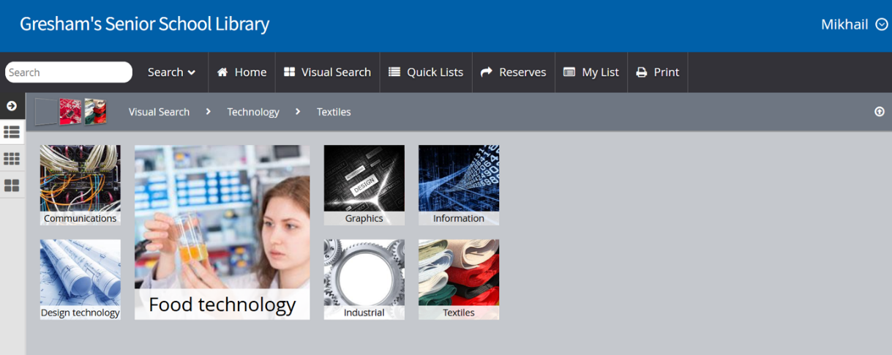

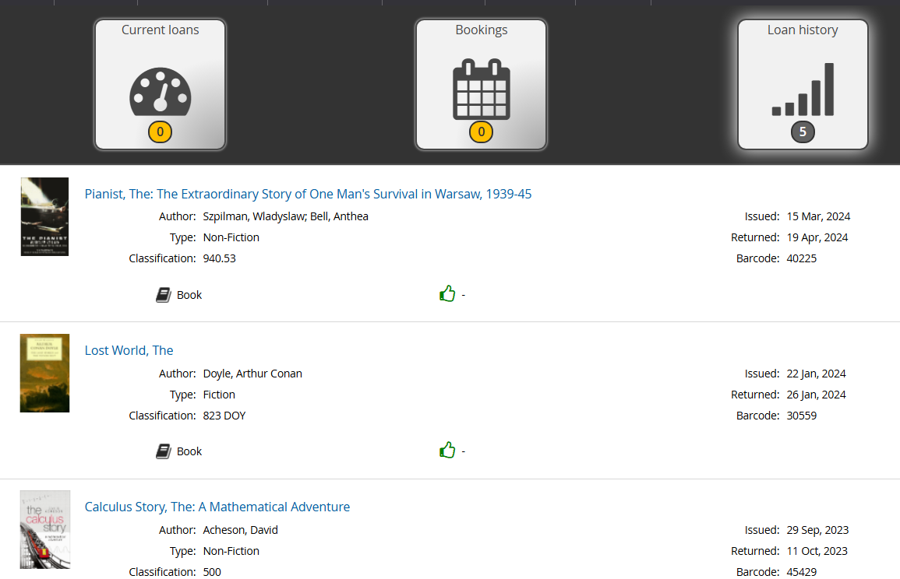

**Key areas for improvement of the current system include**:

* Enhancing search functionality for more precise results.
* Automating book cataloguing to reduce manual work.
* Improving usability and student engagement by adding features like book ratings and recommendations to personalize the experience.
* Increasing awareness and utilization of existing features.

## Alternative systems

### Oliver v5 (Softlink)

Oliver v5 is a cloud-based library management system designed for schools and educational institutions. It provides automated cataloguing, barcode scanning, borrowing and return management, and reporting tools.

This system was not chosen because of its subscription-based model, which comes with high annual costs. It also has limited customizability, meaning it cannot be modified to fit the specific requirements of the school. Furthermore, data access restrictions make it difficult to directly interact with the database structure or integrate an external recommendation system.

### Follett Destiny Library Manager

Follett Destiny is a widely used K–12 library system that offers cloud hosting and integration with school databases. It supports features such as student self-checkout, book recommendations, and access to digital resources.

This option was not selected because it is a proprietary system, preventing modifications to its built-in recommendation algorithms or database structure. Additionally, it requires expensive licensing fees, making it financially impractical. The system also lacks the flexibility to allow for full integration with a custom book recommendation system.

### Koha (Open-Source)

Koha is a fully open-source library management system used by public and academic libraries worldwide. It offers features such as automated cataloguing, barcode scanning, and user accounts.

Despite being open-source, Koha was not chosen due to its complex setup and maintenance, requiring advanced server administration. The system has a steep learning curve, as configuration and customisation demand knowledge of Perl and Linux server management. Additionally, it includes many features that are unnecessary for a school library, adding extra complexity without added benefit.

## Acceptable Limitations

### Students accounts are not added automatically

Instead of direct integration with SIMS, students must log in separately, as the school did not permit SIMS authentication due to privacy and data protection policies. This means users must manually create accounts or use alternative login methods, which may slightly reduce accessibility.

### Limited dataset for machine learning

Due to hardware constraints, the dataset used for the book recommendation system was restricted in size to ensure efficient processing. A larger dataset could improve the accuracy and diversity of recommendations, but doing so would require more powerful computing resources than were available.

### Invalid ISBN in the existing books

Some books in the library database were associated with incorrect or missing ISBNs. Since ISBN is required for retrieving book details from the Google Books API, books with invalid ISBNs were left unchanged, and their information was not updated. (3.5.2.)

### Complexity constraints

The system’s design and coding techniques were chosen based on a balance between functionality and feasibility. The project needed to be complex enough to demonstrate a strong understanding of software development while remaining manageable for implementation and maintenance. Overly advanced techniques that were impractical to maintain in a school setting were avoided.

## Target Audience

The website is primarily orientated for librarians, and students each with distinct roles and functionalities tailored to their needs.

Librarians, designated as administrators, have access to a suite of management features that streamline their workflow. They can add new books to the system and manage borrowings. By granting them administrative privileges, the system ensures that library staff can efficiently maintain an up-to-date and well-organized database, reducing manual workload and improving accessibility for all users.

Students and teachers, on the other hand, are the primary users of the library’s catalogue. They can browse the collection without needing to log in, allowing them to explore available books and search for resources relevant to their studies or personal interests. Those who choose to register and log in gain access to additional features, such as the ability to rate books and receive personalized recommendations. The recommendation system uses a matrix factorization technique, analysing user ratings and borrowing history to suggest books that align with their interests. This functionality enhances the user experience by making book discovery more intuitive and engaging, encouraging a culture of reading within the school community.

Beyond its core users, the website is also designed with usability and accessibility in mind. The interface ensures that users with varying levels of technical proficiency can navigate the system with ease, whether they are experienced librarians managing the database or students casually searching for books. The inclusion of borrowing history tracking helps students stay informed about their previous loans, while features like book ratings foster engagement by allowing users to share their opinions and influence recommendations for others. This creates an interactive, community-driven experience that promotes learning and knowledge sharing.

## Objectives

### Provide user-friendly UI

Develop a functional, intuitive, and visually appealing web-based system that allows students and staff to easily search, browse, and manage books. The interface should be accessible across different devices, including desktops, tablets, and mobile phones, ensuring smooth navigation and usability for all users.

### Authentication system

Implement a secure login/sign-in system that allows students and librarians to log in to their accounts. Librarians should have administrative privileges to manage books, borrowers, and returns, while students should be able to access personalised features such as borrowing history and book recommendations. Authentication should balance security and ease of access, possibly using email-based login or school-issued credentials.

### Book catalogue

A Create an efficient book catalogue that allows users to search, filter, and browse books in the library. The search function should be precise and flexible, allowing searches by title, author, ISBN, or genre, and ensuring that users can easily find books that match their interests.

### Edit existing books

Allow administrators (librarians) to edit book info in the catalogue to provide modifying options. Doing it right in the catalogue would be an intuitively easy and a quick way of doing it, as all the functions for finding books are already present in the catalogue.

### Rating system

Allow students to rate books on a numerical scale and leave feedback. These ratings will contribute to the recommendation algorithm and provide helpful insights for other readers looking for book suggestions.

### Recommendation system

Develop a machine learning-based book recommender that suggests books based on users’ previous ratings and borrowing history. The system should only suggest books available in the library and aim to make recommendations more relevant over time as users interact with the platform.

### Barcode scanner

Integrate a barcode scanner to speed up book management tasks, including adding books to the catalogue, borrowing, and returning. This will allow ISBN or unique book barcodes to be scanned instead of manually entered, minimising errors and improving efficiency.

### Adding new books

When new books are supplied, there must be an easy and intuitive way of adding them in the school catalogue.

### Automatic cataloguing

Reduce manual data entry by automatically fetching book details (title, author, genre, summary) using the Google Books API when a book is added. This feature will improve efficiency and reduce errors in book data entry.

### Borrowing/return system

Enable librarians to issue and return books through an administrative panel, linking each borrowed book to a user. The system should update book availability in real-time and ensure accurate records of borrowing transactions. In case the loan was not recorded correctly, there should be an option to access and manage all borrowings.

### Borrowing history

A tool to keep track of user’s who haven’t returned the books yet, how long they had the books for, and providing personal borrowing history for all users in their profile page.

## Proposed solutions - Environment/Languages

### PHP with Object-Orientated-Programming for Backend Development

* PHP was selected as the primary server-side language due to its wide adoption, extensive community support, and built-in compatibility with MySQL.
* The Object-Oriented Programming (OOP) paradigm enhances code reusability, maintainability, and modularity, making the system more scalable and efficient.
* PHP efficiently handles session management, user authentication, and database interactions, ensuring a secure and dynamic web application.
* Integration with Flask-based Python services enables communication between PHP and the recommendation system, ensuring smooth data exchange.

### JavaScript for Frontend Interactivity

* JavaScript enhances user experience by providing dynamic content updates and responsive elements.
* jQuery and AJAX allow for real-time updates without reloading the page, improving performance and user experience.
* QuaggaJS facilitates barcode scanning, enabling quick and accurate book entry using ISBN or unique barcodes.
* AJAX-based operations prevent unnecessary full-page reloads when users submit book ratings, search for books, or retrieve recommendations.
* Client-side form validation ensures data integrity before submission, reducing server load.

### Python for Machine Learning and Data Processing

* Python was selected for handling machine learning-based recommendations due to its extensive data science and AI capabilities.
* Surprise Library (SVD Matrix Factorization) provides collaborative filtering techniques for personalized book recommendations based on user preferences.
* Polars Library is used for efficient handling of large datasets (over one million records) with faster performance than Pandas.
* Flask Web Framework is implemented as a lightweight API, allowing seamless communication between the PHP web application and the Python-based recommendation system.
* NumPy and SciPy assist in numerical computations to optimize machine learning model performance.

### MySQL for Database management

* MySQL is chosen as the Relational Database Management System (RDBMS) for its ability to manage structured data efficiently.
* Foreign keys and relational constraints ensure data integrity and consistency, preventing orphaned records and improving database structure.
* Indexed queries improve performance when searching across over 20,000 records, reducing response times.
* phpMyAdmin provides a graphical user interface (GUI) to simplify database management and query execution.
* Stored procedures and triggers automate specific database tasks, improving efficiency and reducing redundancy.
* Regular backups and transaction logs ensure data reliability and recovery options in case of failure.

## Security measures

### User Authentication & Role-Based Access Control (RBAC)

* Secure login system using hashed passwords (bcrypt) ensures user credentials are protected from breaches.
* Role-based access control (RBAC) prevents unauthorized access by restricting admin-only features, such as book management and borrowing/return history.
* Session management ensures that only authenticated users can access protected areas, with automatic session expiration after inactivity.

### SQL Injection Prevention

* Prepared statements and parameterized queries are used for all database interactions, eliminating risks of SQL injection attacks.
* Escaping special characters in user inputs prevents malicious queries from being executed.
* Strict user input validation ensures that only valid data is processed.

### Cross-Site Scripting (XSS) Protection

* HTML entities encoding (htmlspecialchars) prevents XSS attacks by ensuring user-generated content (e.g., book reviews, search queries) is sanitized before rendering.
* Content Security Policy (CSP) restricts execution of inline JavaScript and external scripts to prevent malicious code injection.

### Cross-Site Request Forgery (CSRF) Protection

CSRF tokens are included in all form submissions, ensuring that only legitimate requests from authenticated users are processed.

### API Handling

* Input validation for API requests ensures only authorized API calls (e.g., Google Books API) are processed.
* Rate limiting and authentication for external API requests prevent excessive or unauthorized API usage.

### Data Protection & Encryption

* Passwords are hashed using bcrypt before storage, making them unreadable even if the database is compromised.
* Database access permissions are restricted to prevent unauthorized modifications.
* HTTPS (SSL/TLS encryption) ensures that all communication between the client and server is secure, preventing man-in-the-middle attacks.

### Logging & Monitoring

* Audit logs track key system activities, such as logins, book transactions, and user modifications.
* Error logs are disabled in production mode to prevent attackers from gaining insights into system vulnerabilities.
* Automatic logout after inactivity reduces risks of unauthorized access in case a session is left open.

## Website Map

### User Not Logged In

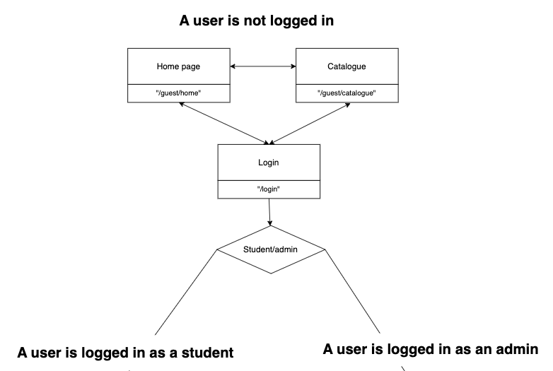

### User is Logged in as a student

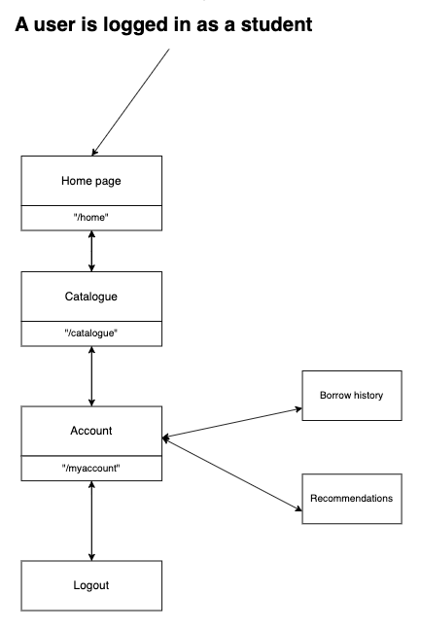

### User is Logged in as a librarian

­ 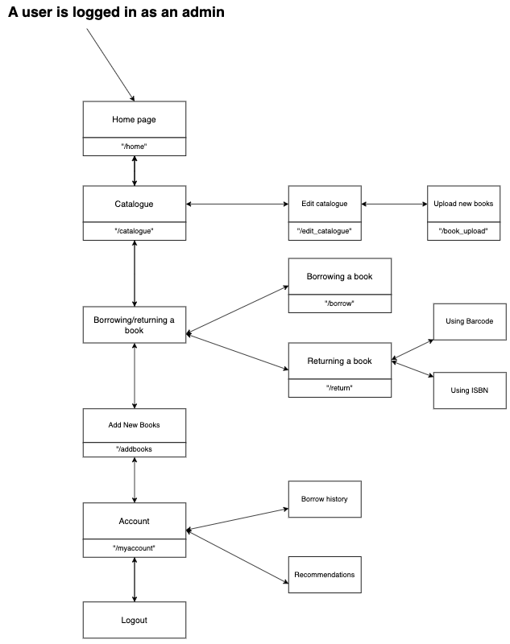

# Design

## Library Database

The Library Database is designed to manage books, users, borrowing records, ratings, and barcode-based book identification. It ensures data integrity using foreign keys and enforces security through structured relationships between tables.

### Database Relationship Diagram

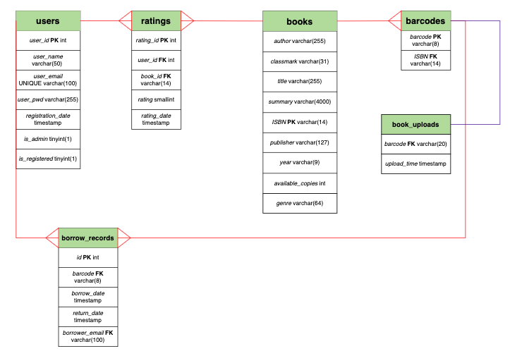

### Database Tables and Their Roles

#### barcodes

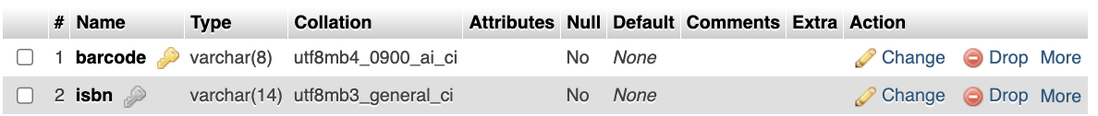

This table maps barcodes to their corresponding ISBNs to support barcode-based book identification.

* Primary Key: barcode (Unique barcode for each book)
* Foreign Key: isbn → books.isbn (CASCADE DELETE)

#### books

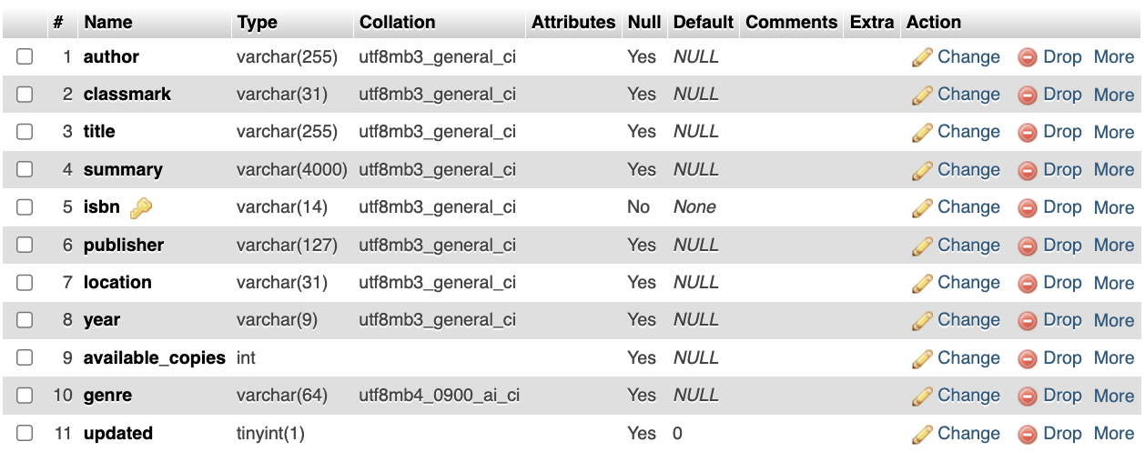

Stores book details, including author, title, summary, and genre.

* Primary Key: isbn (Unique identifier for each book)
* Tracks Availability: available_copies helps manage book stock
* Genre & Classmark: Used for classification and searching

#### book_uploads

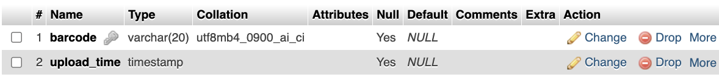

Tracks books that have been added via barcode scanning, logging upload time.

* Primary Key: None
* Foreign Key: barcode → barcodes.barcode

#### borrow_records

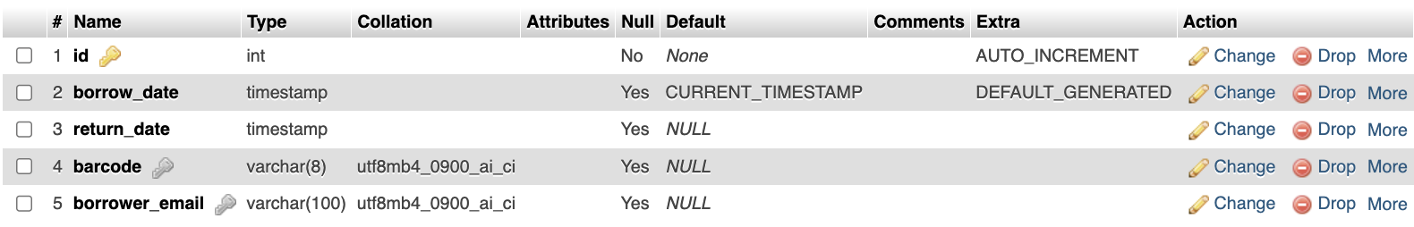

Maintains records of books borrowed by users, linking borrowers to books via barcode.

* Primary Key: id (Auto-incremented unique borrow transaction ID)
* Foreign Keys:

barcode → barcodes.barcode (Links borrowed book)

borrower_email → users.user_email (CASCADE DELETE, removing borrow records if user is deleted)

* Timestamps:

borrow_date (Defaults to current time when borrowed)

return_date (Tracks when the book is returned)

#### ratings

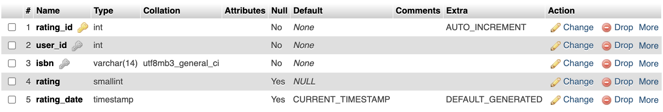

Stores user-submitted book ratings, enabling the recommendation system.

* Primary Key: rating_id (Unique rating ID)
* Foreign Keys:

user_id → users.user_id (CASCADE DELETE, removes ratings when user is deleted)

isbn → books.isbn (CASCADE DELETE, removes ratings if book is deleted)

* Tracks when a rating was given (rating_date defaults to the current timestamp)

#### users

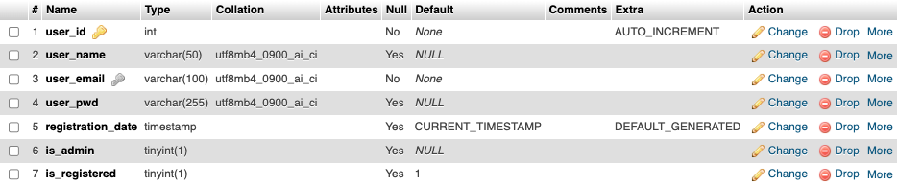

Stores user accounts, including authentication details and admin privileges.

* Primary Key: user_id (Auto-incremented unique user identifier)
* Unique Constraints:

user_email (Ensures each user has a unique email)

user_name (Optional, but must be unique if provided)

* Security Measures:

user_pwd stores hashed passwords

is_admin determines admin permissions

is_registered tracks user registration status

2. Database Integrity & Security Features

* Foreign Key Constraints ensure data consistency by enforcing CASCADE DELETE in key relationships.
* Auto-incrementing Primary Keys provide unique identifiers for users, ratings, and borrow records.
* Prepared Statements should be used for all queries involving user input to prevent SQL injection.

### Database design

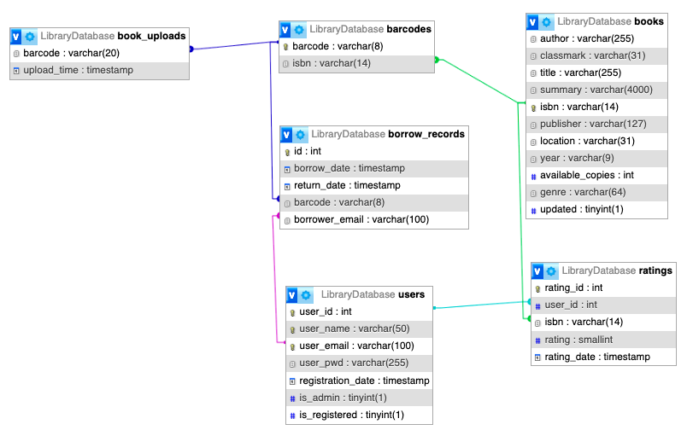

## Entity Relationship Diagram

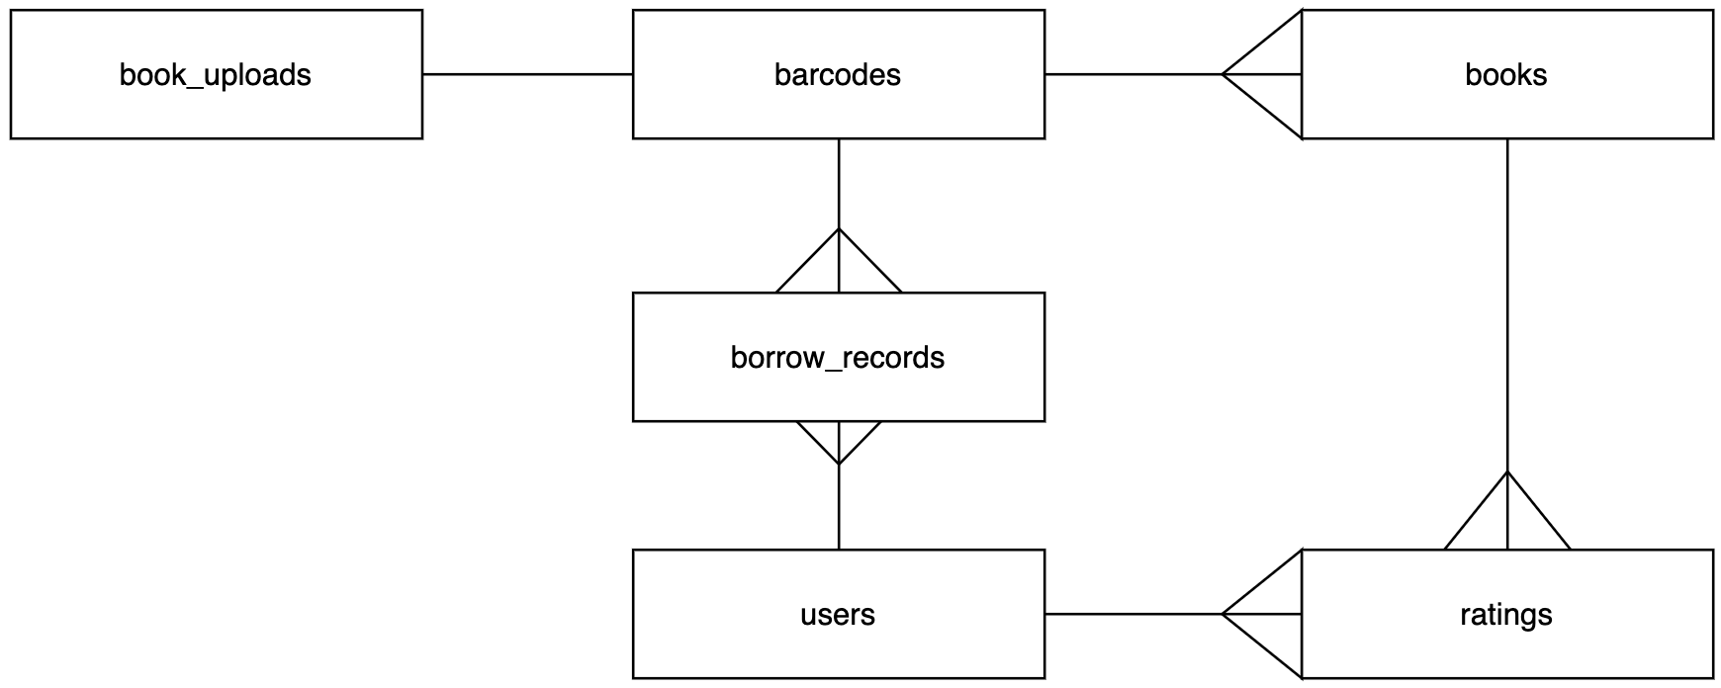

## Class relationship diagram

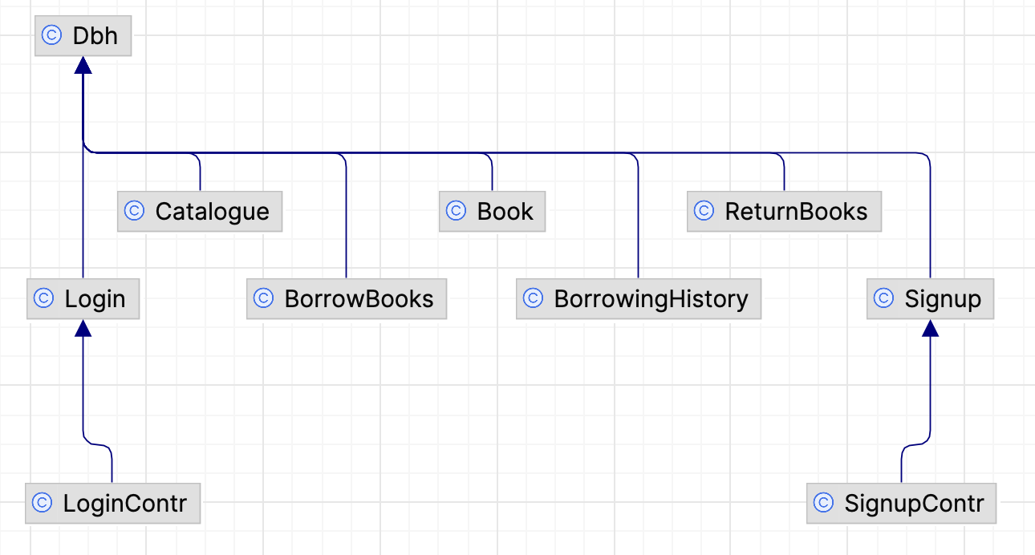

## Class Design

I used Object-Oriented Programming (OOP) for the library management system to improve code organization, maintainability, and scalability. OOP principles, such as encapsulation, inheritance, and polymorphism, provided clear benefits in structuring the system logically.

### Dbh Class

Establishes a connection with the library database

Inherited by all other classes requiring database access

Method:

* connect()

### SignupContr Class (extends Signup)

Handles user registration by validating input and checking for duplicate accounts.

Attributes:

* $name
* $email
* $pwd
* $pwdrepeat

Methods:

* __construct($name, $email, $pwd, $pwdrepeat) - initialises name, email, password, and repeated password values
* signupUser() – Registers a new user if validation passes.
* pwdMatch() - Verifies that the passwords match
* emptyInput() - Checks if any required fields are missing.
* userExists()– Verifies if the user is already registered.

### Signup Class

Stores user credentials in the database

Methods:

* setUser($name, $email, $password) - stores user data in the database
* updateUser($name, $password, $email) - checks if the user already exists

### LoginContr Class (extends Login)

Validates user credentials when authenticating

Attributes:

* $email
* $pwd

Methods:

* __construct($email, $pwd) - initialises email and password values
* loginUser() - Authenticates the user and starts a session.
* emptyInput()- Checks if email and password fields are filled.

### Login Class

Manages user login data retrieval from the database.

Method:

* getUser($email, $password)– Fetches user credentials from the database for authentication.

### Book Class

Manages new books in the database

Attributes:

* $isbn
* $barcode
* $title
* $author
* $genre
* $year
* $summary
* $classmark
* $quantity

Methods:

* addBook($isbn, $barcode, $title, $author, $genre, $year, $summary, $classmark, $quantity) - adds a new book in the database.

### BorrowBooks Class

Handles the borrowing process

Attributes:

* $barcode
* $borrower_name Methods:
* borrowBook($barcode, $borrower_email) - adds a borrow record and adds a new user if necessary

### ReturnBooks

Manages book returns and retrieves borrower information.

Attributes:

* $borrower_email
* $isbn

Methods:

* returnBookByBarcode($barcode)
* returnBookByISBN($isbn, $borrower_email)
* getBorrowers($isbn)

### Catalogue Class

Provides book search, sorting and rating functionality.

Attributes:

* $search
* $sort
* $order
* $offset

Methods:

* getBooks($search = '', $sort = '', $order = '', $offset = 0) - Retrieves books based on the search and sorting criteria
* getAvailableCopies($available_copies) - Checks available copies of a book.
* saveRating($isbn, $user_id, $rating) - Saves user-submitted book ratings.
* updateBook($isbn, $title, $author, $genre, $year, $summary, $classmark, $available_copies) - updates book data

### BorrowingHistory

Returns borrowing history on the profile page.

Attributes:

* $username
* $user_email

Methods:

* getUserBorrowHistory($useremail)
* getBorrowingHistory($limit = 20, $offset = 0)

## JavaScript module dependencies

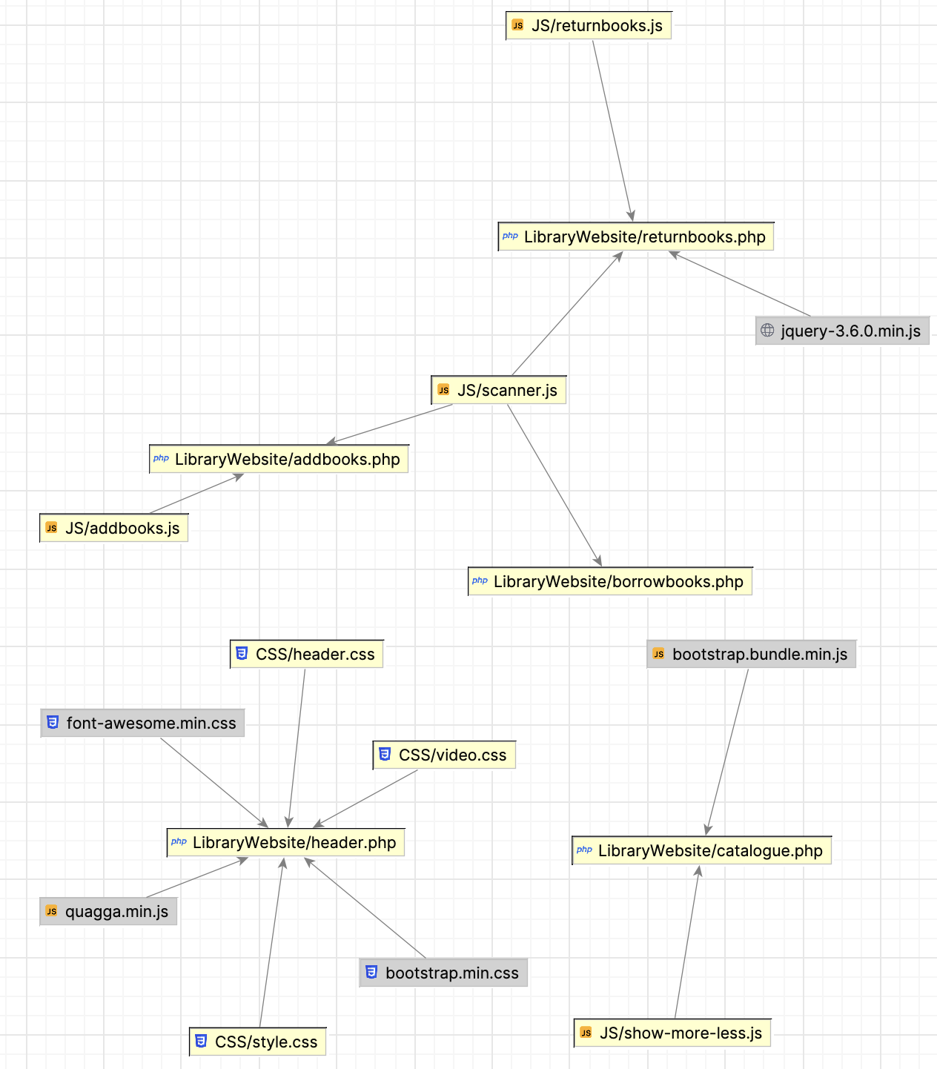

## Sign-up Flowchart

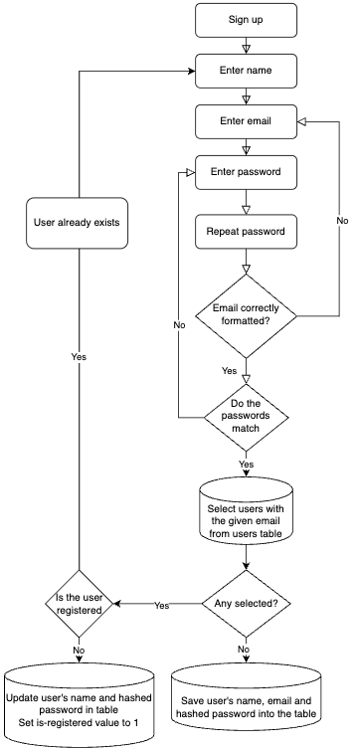

## Login Flowchart

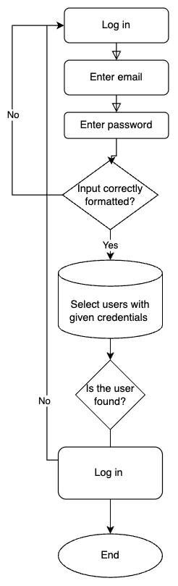

## Borrow books Flowchart

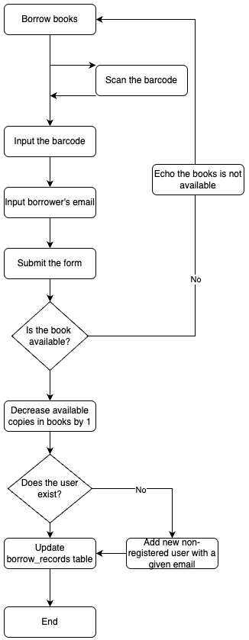

## Return books Flowchart

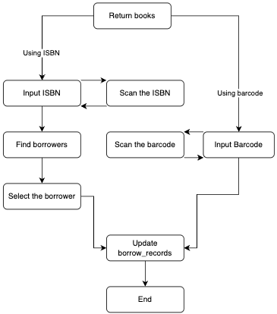



## Rate books Flowchart

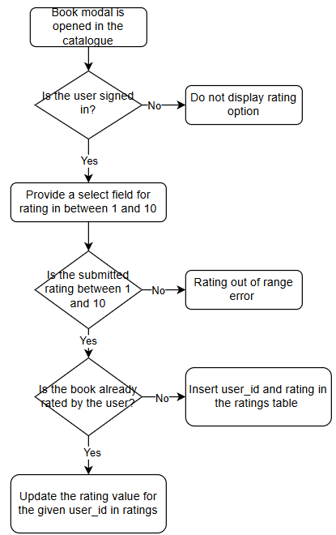

## Data validation

I used multiple validation techniques to validate the format of user inputs and prevent SQL injection attacks

### Input validation in JS using regular expressions:

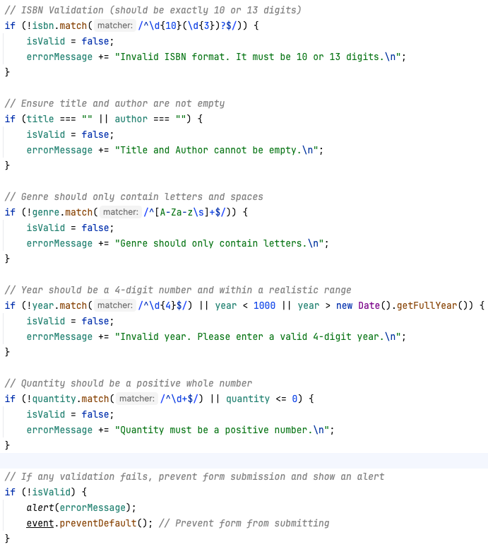

### Prepared statements to prevent SQL injections:



### Setting an email type validating the format of the inputted text



### Python validation of lengths and range of inputted values:

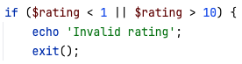

#### Limiting the length of fetched data from Google API



## SQL Queries

### Borrowing a book

Getting ISBN from a barcode

Checking if the book is available

Updating the number of available copies

Check if a user with a given email exists

Add a new not registered user to the users table

Insert a new borrow record



### Returning a book

#### Update a borrow record by adding a return date



#### Update a number of available copies



#### Finding barcodes linked to the ISBN



#### Update a record for a given user email and barcodes corresponding to the ISBN

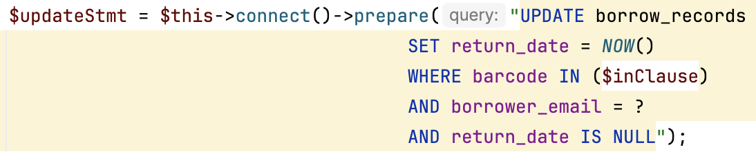

#### Get borrowers who haven't returned the book



### Sign up

Adding a new user to the table



Registering a not registered user



Check if the user is registered



Check if the user already exists



### Login

Retrieving user's hashed password



Fetching user's data if login is successful



### Adding new books

Check if a book with a given isbn already exists in the books table



Update the number of available copies



Inserting a new book record when a new book is added



Inserting a new record into the barcodes table

Inserting a new record into the book_uploads table



### Borrowing history

Getting user's borrowing history

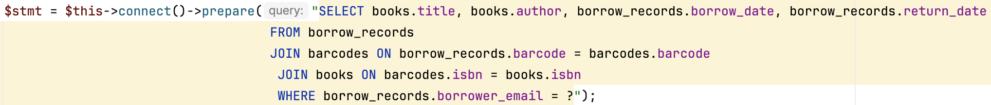

Getting general borrowing history

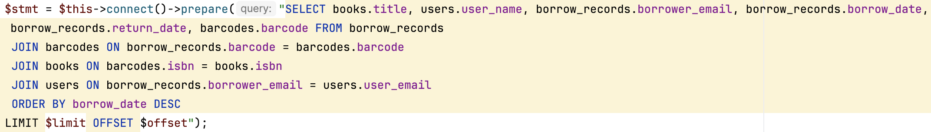

### Catalogue

Getting books for the catalogue

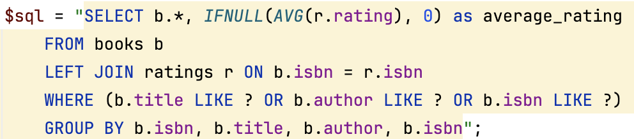

Updating books data

Checking if the user has already rated the book previously



Updating the rating



Creating a new rating record



## Libraries and imports

### Python libraries

#### Flask

User to create a lightweight web API for book recommendations

Flask is simple and fast for small RESTful APIs

#### requests

Efficiently handles HTTP requests from Google Books API

#### mysql.connector

Provides access to MySQL database

#### polars

Processes the large data set of books, ratings, and users

Faster and more memory-efficient than alternative Pandas library

#### surprise

Used for implementing the matrix factorisation recommendation system

Designed for collaborative filtering, making it an ideal choice for book recommendations

#### time

Used to add delays between API requests preventing rate limits

### PHP libraries

#### mysqli

Interaction with MySQL database

More secure and flexible than the older ‘mysql’ extension

#### PDO

Used for secure database connections and prepared statements

#### filter_var

Used to validate user input

### JavaScript libraries

#### Fetch API

Used for sending API requests to Flask

#### addEventListener

Validates client-side form before transmission, thus reduces server load by catching invalid inputs early

#### Regex

Validates user input formats

# Technical Solution

## System Overview

### System Architecture and Design

The system follows a structured class-based design to ensure efficient interaction between different components. At its core, the Dbh class establishes a connection with the MySQL database, which is inherited by other classes to enable seamless database operations. The system is structured using the Model-View-Controller (MVC) paradigm to separate logic from presentation, enhancing maintainability and scalability.

User authentication is managed through the SignupContr and LoginContr classes, which handle registration and login functionalities, respectively. These classes extend the Signup and Login classes, which perform database operations such as checking user existence and retrieving credentials securely. The BorrowingHistory class provides a dedicated method for users to view their borrowing history by fetching records from the database and displaying them on the profile page.

Book management is handled by the Book class, which includes methods for adding new books to the library database. The BorrowBooks and ReturnBooks classes facilitate the borrowing and returning of books by linking the book’s ISBN with a borrower's record. Additionally, the Catalogue class provides search and sorting capabilities, allowing users to filter books based on availability, genre, or author. The system also incorporates a rating mechanism, enabling users to rate books, which will be later used for generating personalized recommendations.

### Functionality and User Experience

The system allows students and staff to log in and interact with the digital catalogue efficiently. Users can search for books by title, author, or genre and check the number of available copies before borrowing. The borrow and return records are updated in real-time to reflect current book availability. By implementing barcode scanning integration, admins can easily check out and return books, reducing manual input errors and enhancing the overall efficiency of the library’s operations.

A key feature of the system is the borrowing history, which allows users to view details about previously borrowed books, including the borrow date and return date. If a book has not been returned, the system displays "Not Returned" to notify users of their outstanding returns. Additionally, an administrative panel can be integrated in the future to enable library staff to manage users, oversee overdue books, and generate reports.

### Rationale for Object-Oriented Programming (OOP)

The use of object-oriented programming in the development of this system enhances modularity and reusability. By encapsulating functionality within dedicated classes, the system is easier to maintain and extend. For example, the Dbh class centralizes database connectivity, preventing redundant code across multiple files. Inheritance is effectively utilized in authentication classes (SignupContr and LoginContr), ensuring shared behaviour while allowing specialized functionalities. Furthermore, encapsulation ensures that database operations are abstracted, reducing security vulnerabilities and improving code maintainability.

## User-friendly UI (ref 1.7.1)

To ensure seamless throughout the website, a consistent HTML header on every page. The header dynamically adjusts links based on user's registration and administrative status.

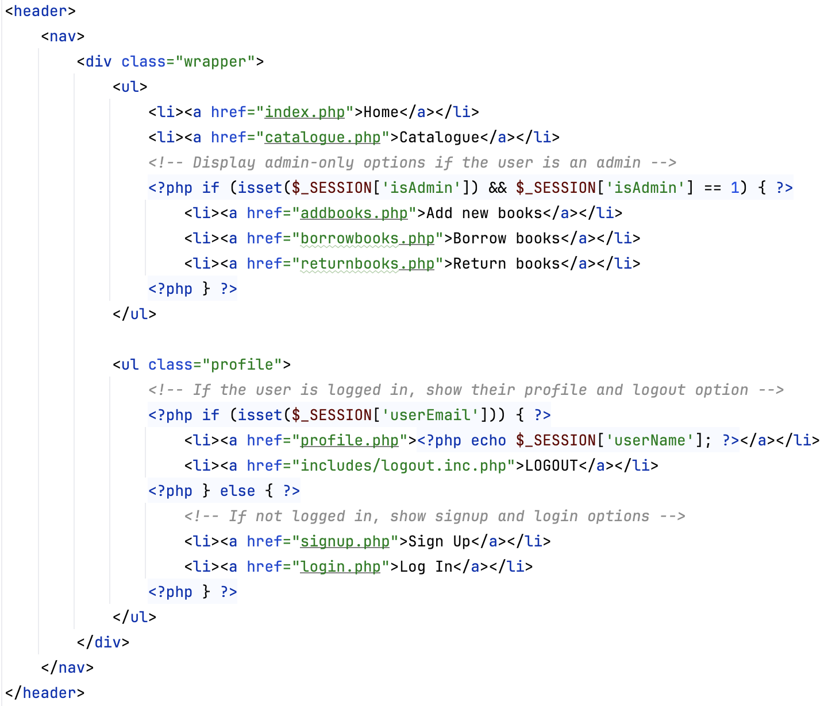

### Guest users (not logged in)

The navigation bar includes the following pages:

**Catalogue** does not contain any personalised information, so it can be accessible for all visitors who are willing to explore the library collection without logging in.

**Sign-up** and **Login** enable creating an account or accessing an existing one.

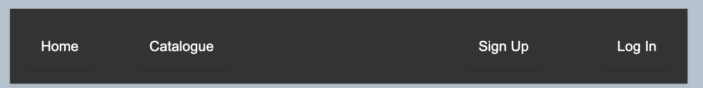

### Standard users (logged in and non-admin)

Once authenticated the users get access to additional pages:

**User Profile** displays user's borrowing history and provides a personalized book recommendation based on user's previous ratings.

**Logout** allowing to securely log out any time.



### Administrative users (logged in and admin)

In addition to all the listed features, admins have access to other functionalities required for library management

**Add Books** enables addition of new books to the database

**Borrow Books** and **Return Books** allows to manually register book borrowings and returns.

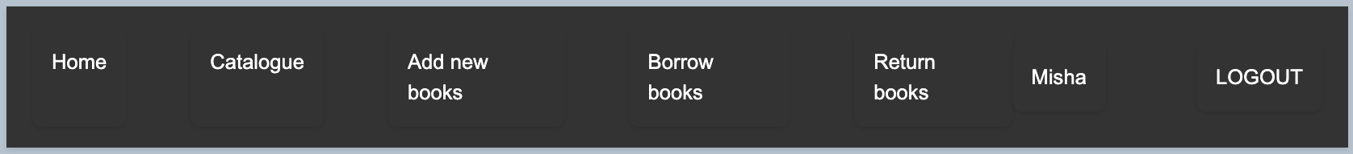

### Access restrictions for admin pages

Administrative pages, such as **Add books**, **Borrow books** and **Return books**, are opened, implement a SESSION-based validation method.

When a non-admin user is trying to access these pages, the entry is denied and an error message is returned, ensuring security and integrity of administrative functions.

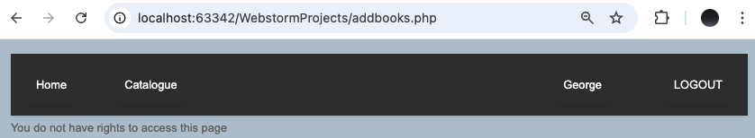

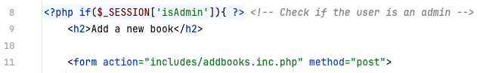



## User Authentication System (ref 1.7.2)

My website provides a secure authentication system ensuring controlled access to various features (3.1.) based on user's role.

### User Registration (Sign-in)

New users are required to provide the following details when creating an account:

**Name** providing personalised user identification

**Email address** working as a unique identifier (primary key)

**Password** required for further logging in and securely stored using a hashing algorithm.

To ensure data integrity, multiple data validation techniques are used:

**Email format validation** rejecting any emails of a wrong format

**Password double entry** ensures that there are no typos present in the input

**Email Uniqueness Check** verifies if an email already exists in the table to avoid repeated primary keys.



### User Login

Users are required to provide their email and password to authenticate.

The login system follows the following process (2.3.1):

**User Input Validation** checking if the input fields are empty and conform correct format

**Credential Verification** compares the entered credentials against the hashed data stored in the database.

**Session Initialisation** after successful authentication to maintain user's login state.

If an incorrect email or password is entered an error message is displayed.

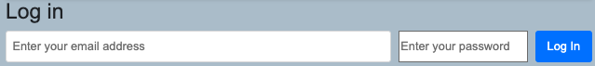

### Logout

Allows authenticated users to securely end their session by clearing the SESSION data and redirecting the user to the home page

## Catalogue (ref 1.7.3)

The catalogue page allows users to explore the library's book collection. It provides an intuitive interface enabling searching, browsing and interacting with book listings.

### Displaying Books

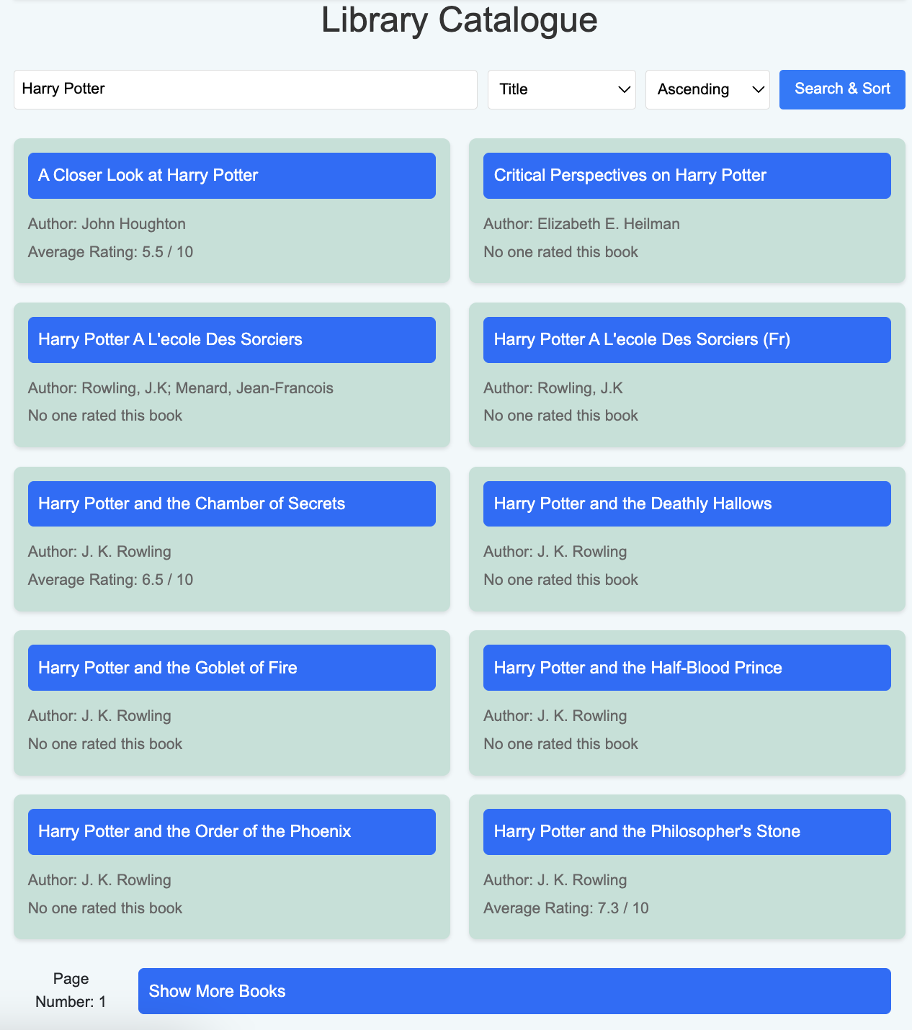

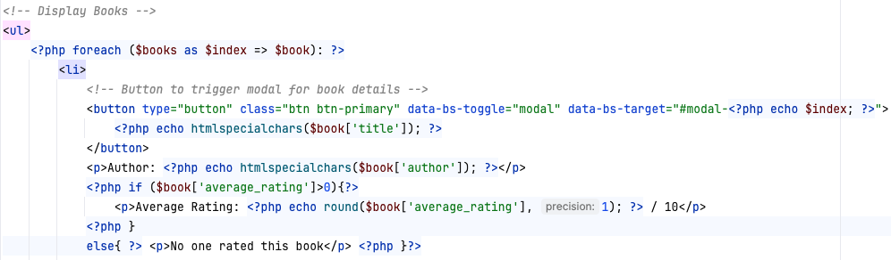

The catalogue dynamically retrieves and lists book information from the "books" table, including the most essential information on the main screen, i.e. the title, author, and average rating.

The number of books satisfying the searching criteria may often exceed a rational amount which can be displayed on one page, thus lowering optimisation and user experience. To prevent this, I limited the number of displayed books on a page to 10 and added buttons allowing to switch between pages containing books satisfying the criteria with a different offset.

#### PHP instantiation:

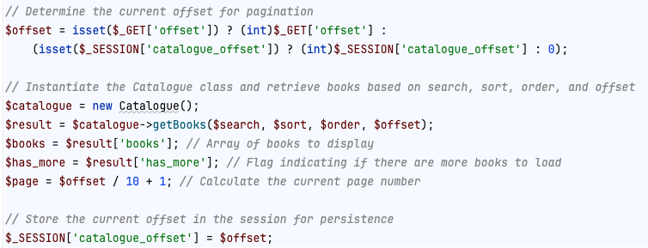

#### HTML:

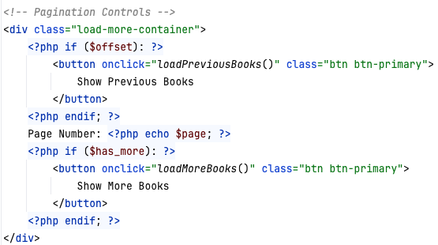

#### JavaScript:

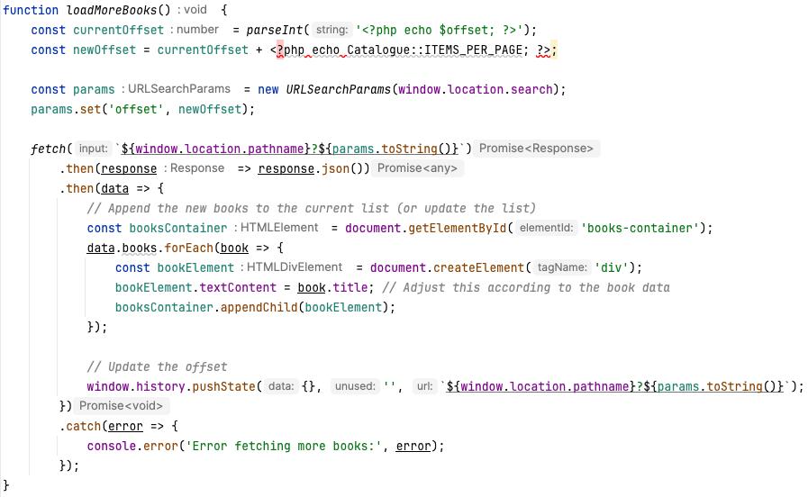

### Displaying book details

Most books have extra details the display of which on the main screen would result in a non-optimised use of the screen space. That is why I put attributes such as genre, year, summary, available copies and an option for rating a book in a modal, which can be opened by clicking of the book title.

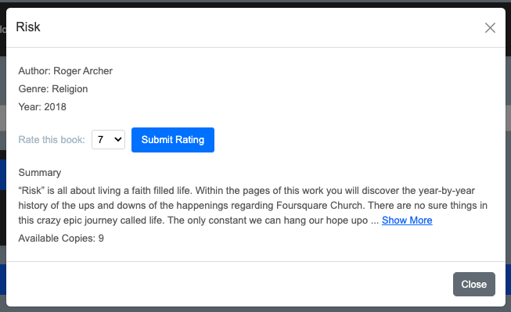

#### HTML:

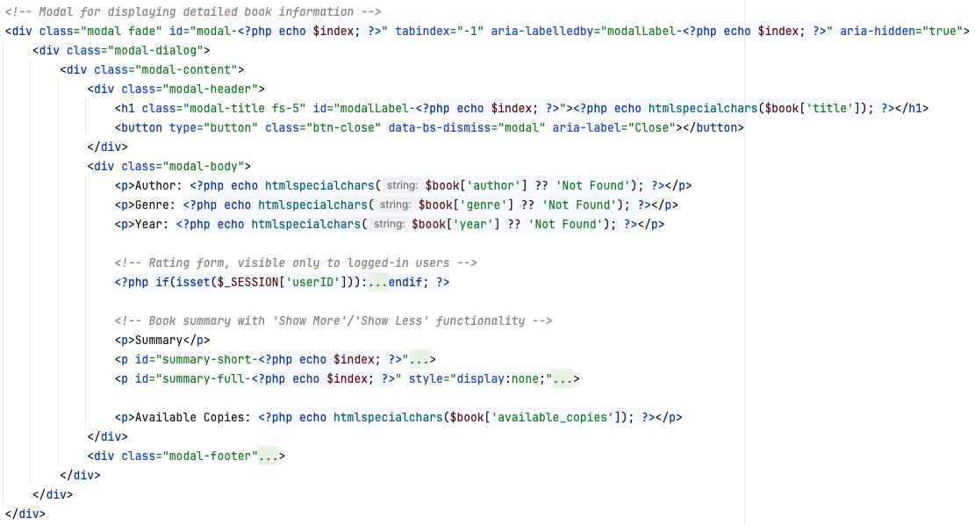

### Minimising/maximising summary

Some of the summaries fetched from google books API have an excessive number of symbols. To ensure that all data fits on one page and to make the orientation around the modal more sensible, I added "show-more" and "show-less" functions, minimising and maximizing the book's summary if it exceeds the set limit of 300 characters.

#### Minimized summary:

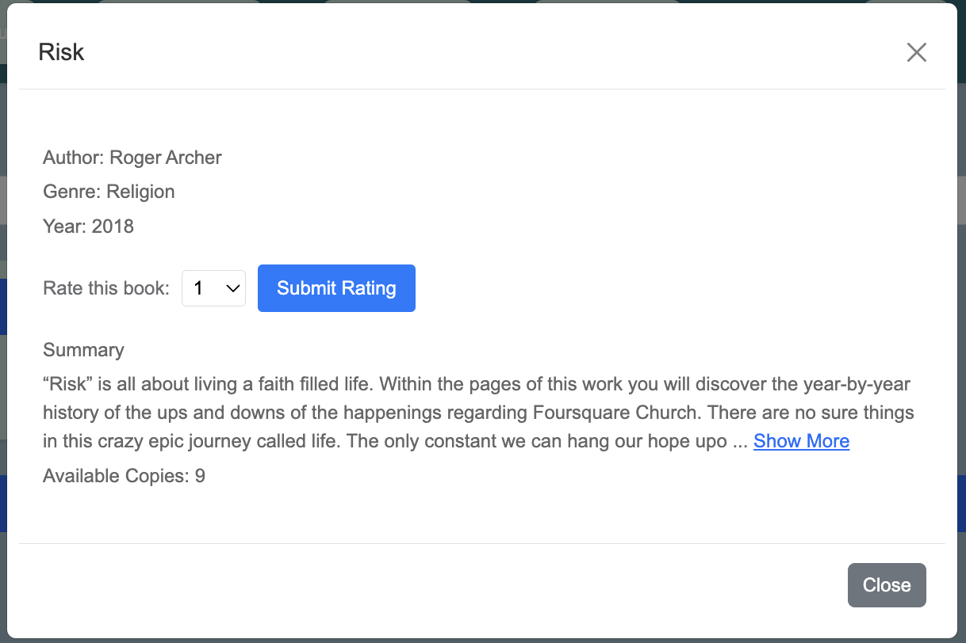

#### Maximised summary:

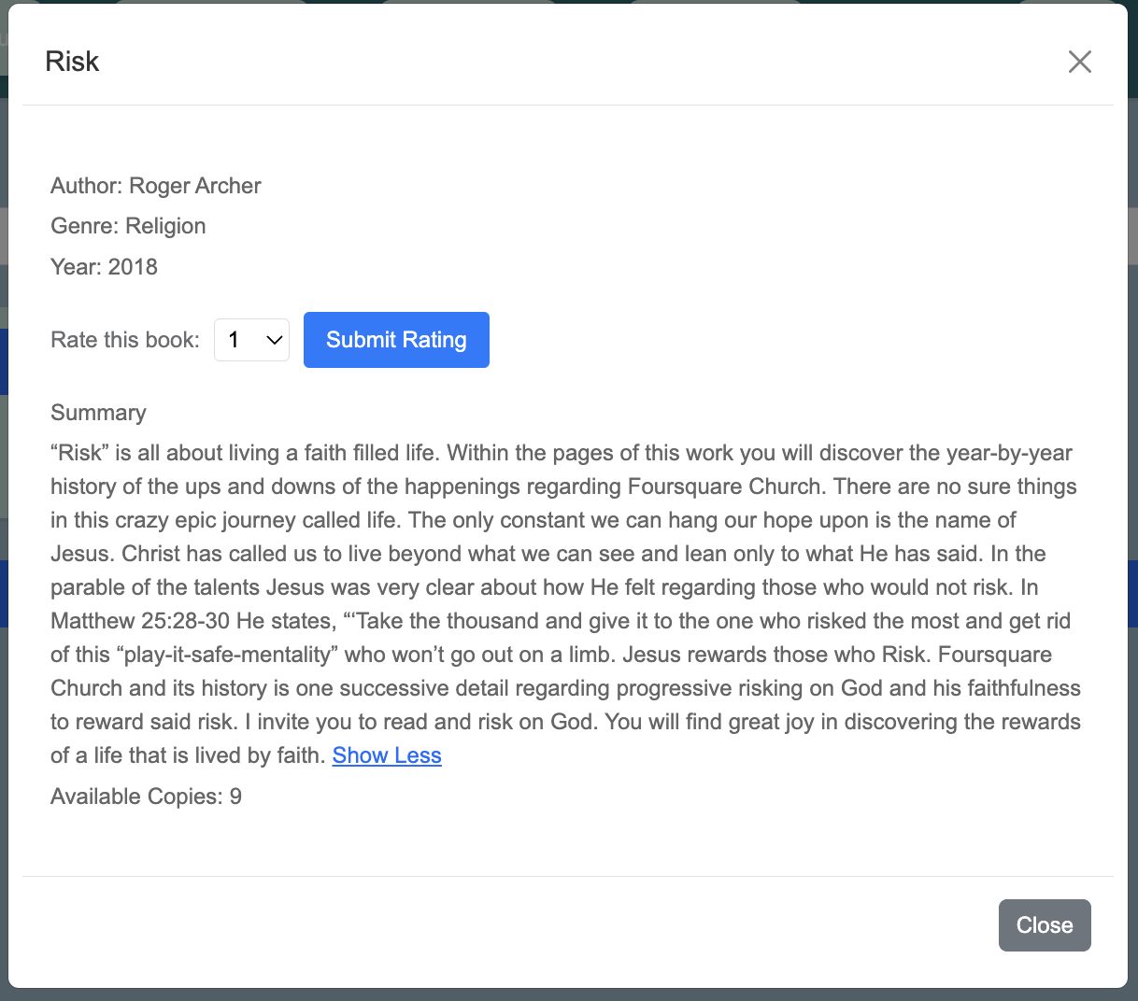

#### HTML:

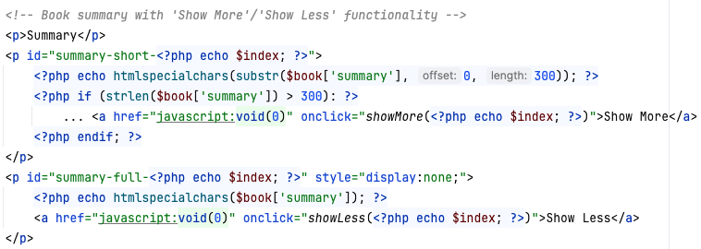

#### JavaScript:

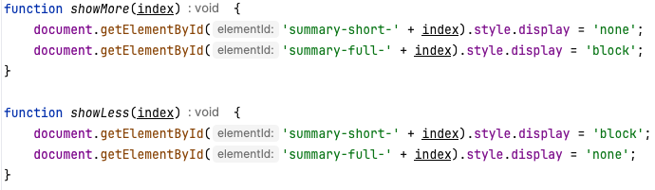

### Search and filtering functionality

An essential component of any catalogue is an option to easily filter and sort the needed information from a large dataset. On my website I managed this requirement by including options to sort books by the title, author, average rating, and year published, in ascending or descending orders.

#### PHP initialisation:

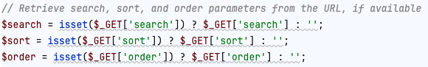

#### HTML code:

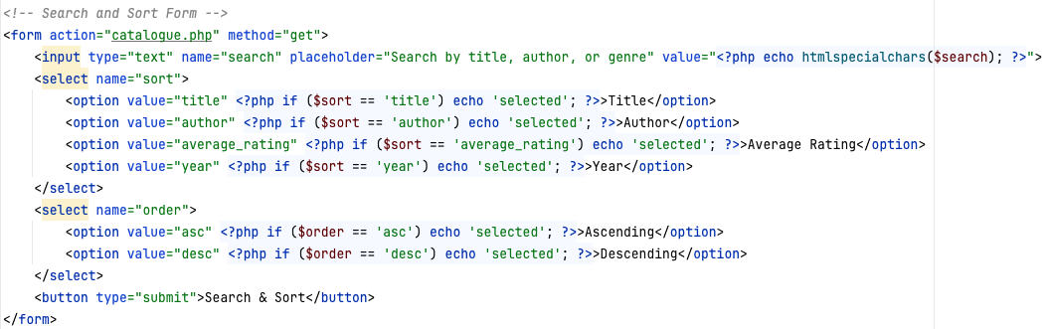

#### getBooks method (catalogue.classes.php)

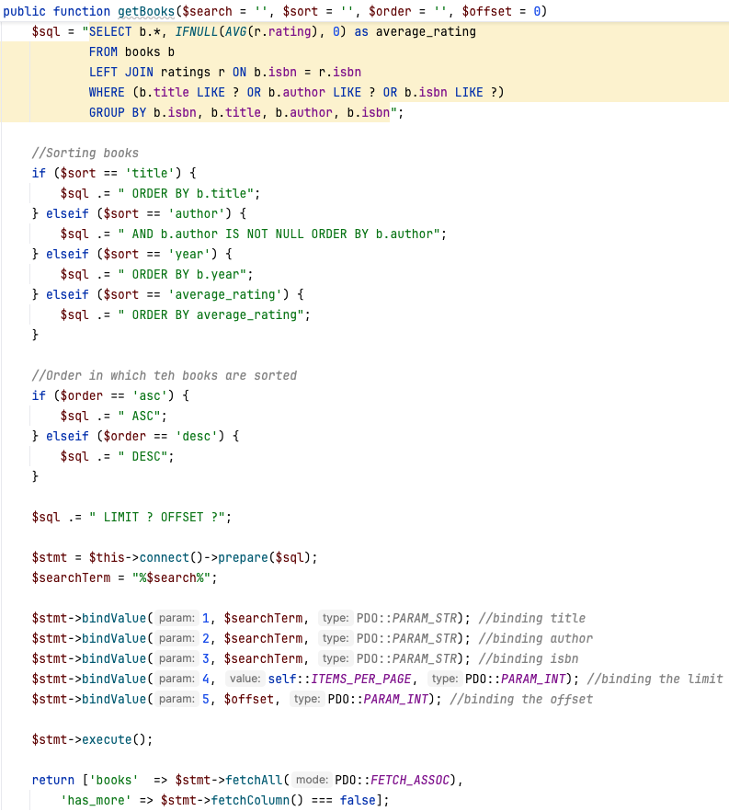

### Rating system (ref 1.7.4)

As mentioned in the interview, user ratings would be a valuable addition to existing functions, as it is expected to make to the experience of using the catalogue for engaging and creating a necessary basis for the recommendation system. Rating books is only available for logged in users (when $_SESSION['userID] is set).

#### Screen Output:

##### When a user is not logged in:

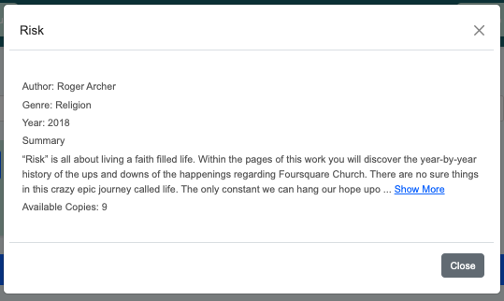

##### When a user is logged in:

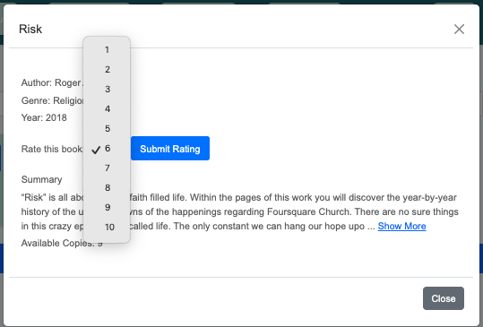

#### HTML Rating form:

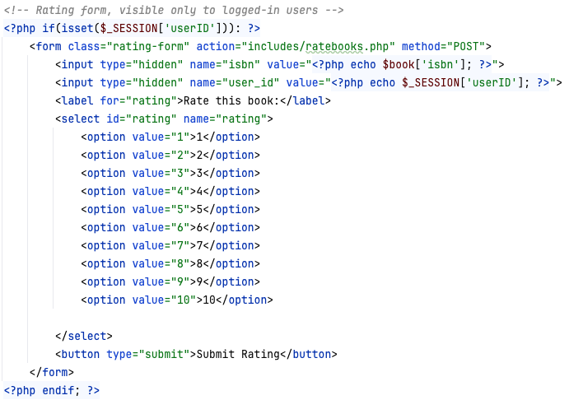

#### Method for saving ratings

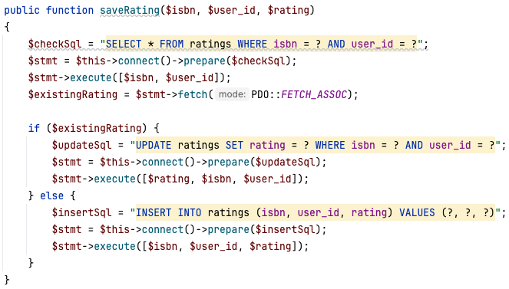

## Editing existing books (ref 1.8.4)

When a user is logged in as an admin, he can access editing options in the catalogue, which makes it an easy and a quick way of modifying information about a book just by opening its modal window.

### Screen Output

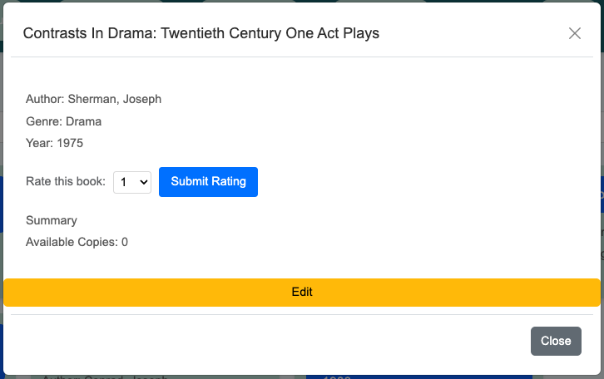

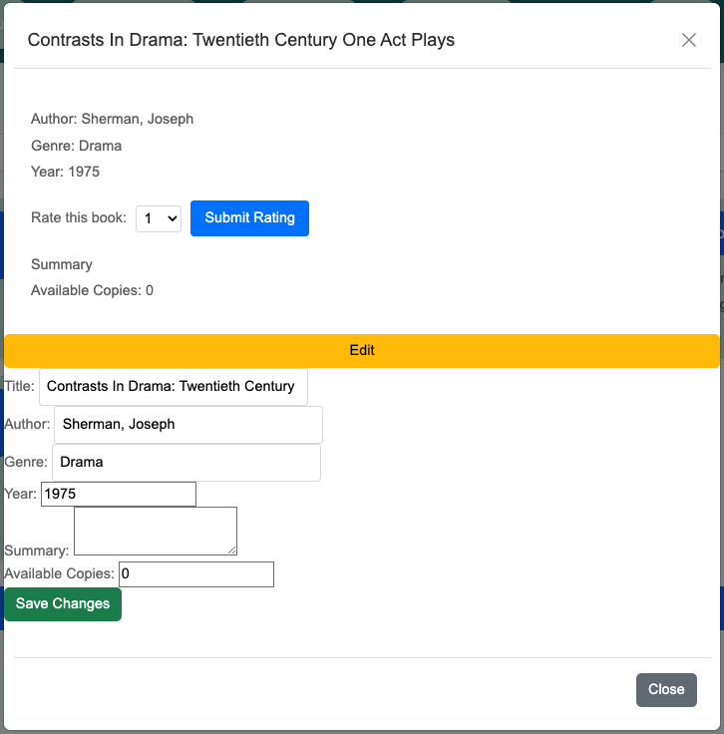

### Frontend

When a user is logged in (a session is running) and the user has an administrative status, there is an "edit" button displayed, which shows the hidden editing fields when pressed.

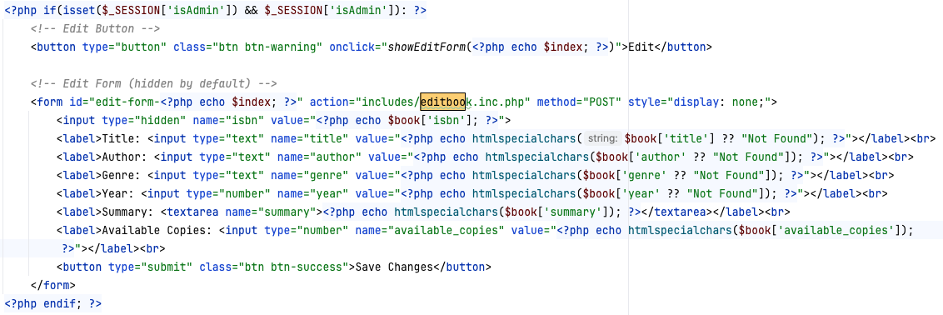

### Backend

When the form is filled in with all the required changes and submitted, the data from the input fields is delivered into editbooks.inc.php using POST method, where a new object of Class catalogue is created and method "updateBook" is used to update the books table.

editbook.inc.php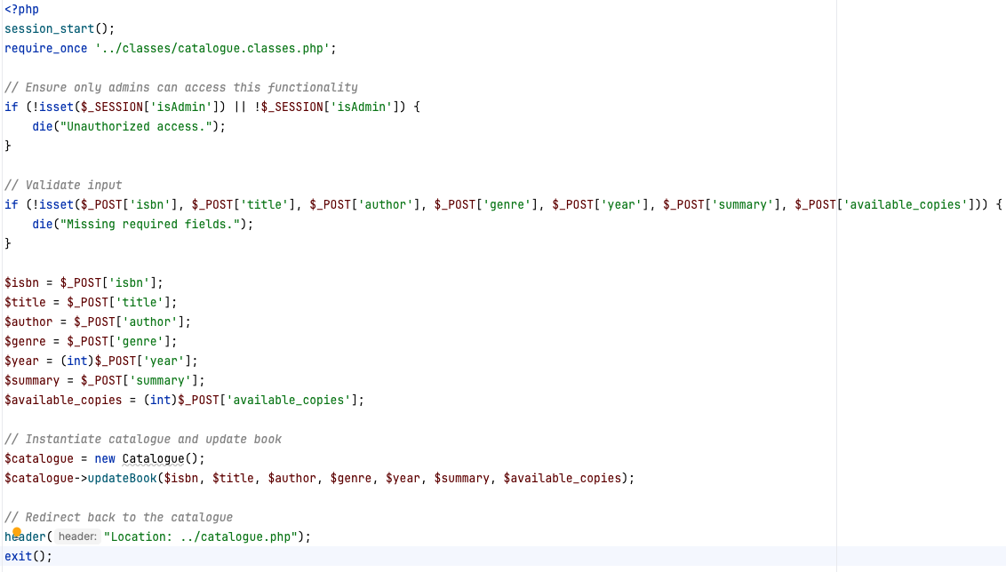

#### updateBook

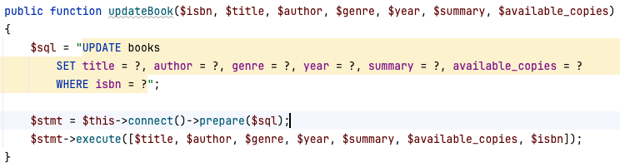

## Recommendation system (ref 1.7.5)

The recommender system enhances user experience by providing personalized book suggestions based on user ratings. The system leverages collaborative filtering techniques to predict and recommend books that align with a user’s reading preferences.

### Potential solutions

#### Content-Based Filtering

Recommends books based on their features, like genre and key words, and user's past preferences.

It relies on term frequency-inverse document frequency (TF-IDF) or word embeddings to measure book similarity.

Yet, it requires an extensive metadata for all books, which the library is unable to provide, making it difficult to calculate similarities.

#### Association Rule Mining (Apriori Algorithm)

This method identifies patterns in borrowing history. It finds books frequently borrowed together and suggests books based on previous borrowing trends.

Works well only for users with a large borrowing history and hence fails to generate recommendations for new users.

#### k-Nearest Neighbours (k-NN) for Collaborative Filtering

This method finds users with similar rating patterns and suggests books based on what similar users liked (user-based) or identifies books rated similarly and suggests them (item-based).

However, as the library contains many books and a relatively sparse rating dataset, k-NN would cause inefficient and inaccurate computations.

### Matrix factorisation

Matrix decomposition (or) matrix factorization is an approximation of a matrix into a product of matrices. They are used to implement efficient matrix algorithms.

### Eigenvalue-based decomposition

Mostly applicable to square matrices. where matrix decomposes into 3 parts(final rotation, scaling, initial rotation).

* PCA is a transform that uses eigen decomposition to obtain the transform matrix.
* Singular Value Decomposition(SVD) factorizes any matrix with any dimension as 3 parts USV’ .

### Explanation of Singular Value Decomposition

SVD is a factorization of a real (or) complex matrix that generalizes of the eigen decomposition of a square normal matrix to any **m x n**matrix via an extension of the polar decomposition.

In other words, SVD approximates any dimensional matrix into 3 lower dimensional matrices, preserving the maximum variance by ‘Rotation & Scaling’ in the form of the matrices USV’ having ‘top-k eigen vectors and eigen values’.

A = U S V’ (Final rotation || Scaling || Initial rotation)

where, U=left singular valued matrix , S=singular valued matrix, and V=right singular valued matrix.

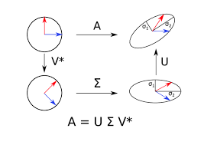

* The rotated matrices consist of transformed data points, whose eigen vectors make up singular matrices U or V.
* The Scaled matrix have values scaled by a factor

U, V are orthogonal matrices, represents the rotations or reflection of the space which are eigen vectors that are orthonormal to each other.

*Eigen vectors mainly aim to preserve the direction of vectors.*

S is diagonal matrix, represents the scaling of each value by value ‘σ ‘.

### Why SVD

Singular Value Decomposition (SVD) is a matrix factorization technique widely used in data analysis, linear algebra, signal processing, and machine learning. It provides valuable insights into the structure and properties of a matrix, allowing for dimensionality reduction, data imputation, matrix approximation, and more.

* Matrix factorization which separates a matrix into two other matrices that are typically much easier to solve than the original matrix. This not only makes the problem easy to solve, but it reduces the amount of time required by a computer to calculate the answer.
* Matrix factorization reduces a computers storage space for matrices, instead of storing the large non factorized matrix(A), We can use less storage for its factors(i.e B, C), some times even smaller when rank of matrix is small.

The chosen method is highly effective in handling sparse data, making it well-suited for a library system where users have rated only a small fraction of the available books.

Additionally, SVD is optimized for large datasets, efficiently computing recommendations without excessive processing time, even as the dataset scales. Given the availability of a substantial dataset containing millions of user ratings and book ISBNs across the internet, this method ensures accurate predictions by leveraging a rich pool of interactions, ultimately enhancing the recommendation quality and user experience.

### Data Collection and Preparation

#### User ratings are fetched

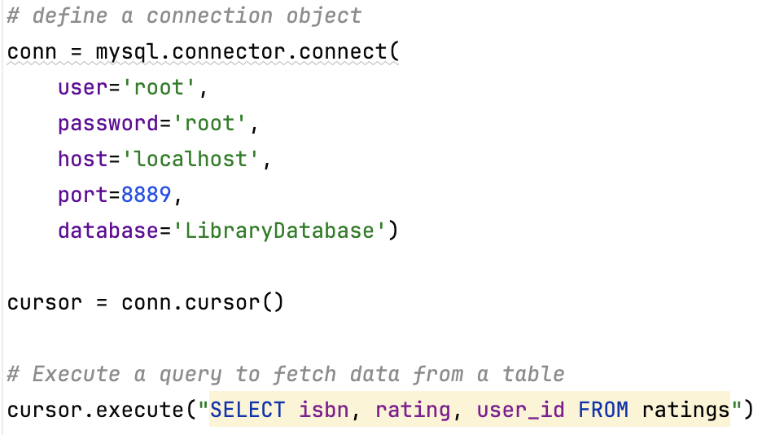

#### Filtering available books

Ensures that only available books are included in the recommendation process.

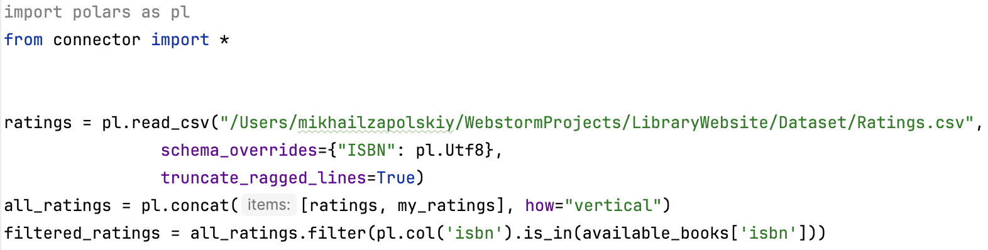

#### Collaborative Filtering model

A surprise library is used for training the SVD model on the filtered data, which is split into training and testing sets. After that, the model is evaluated using Root Mean Square Error (RMSE) to measure prediction accuracy.

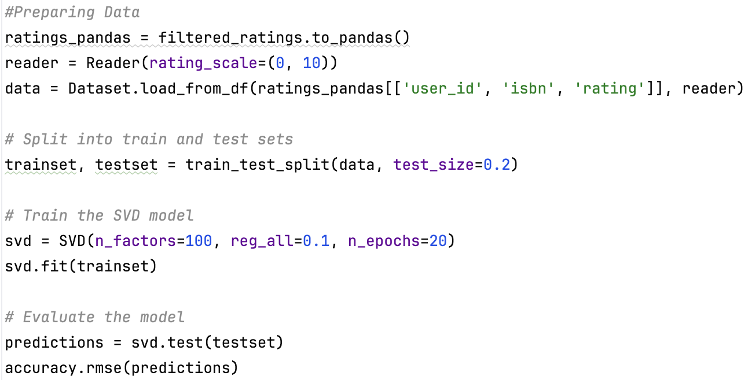

#### Generating Recommendations

Once the model is trained, the function "recommed_books()" iterates over all available books in the library, makes the rating predictions based on the SVD mode, sorts them in descending order prioritising the high-rated ones, and returns the top 5.

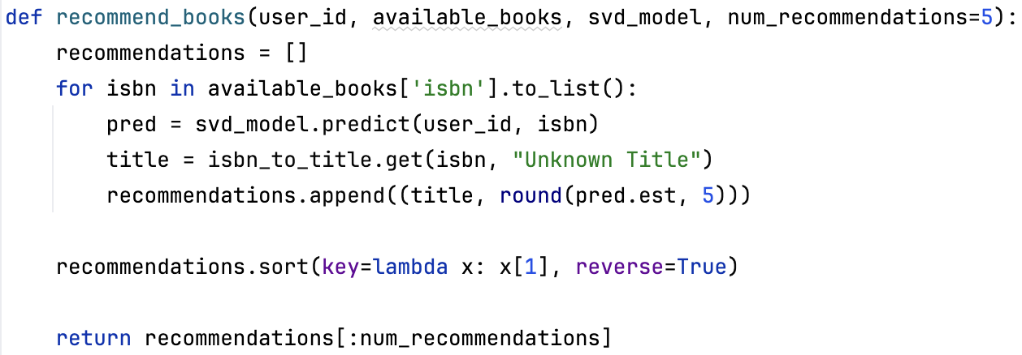

#### API Integration

Flask is used to ensure seamless integration with the library website, returning 10 recommended books in JSON format, making it accessible for the front-end interface.

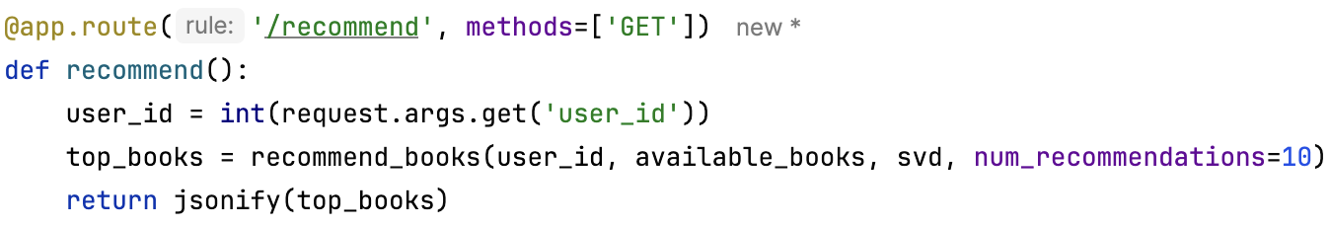

#### The final output

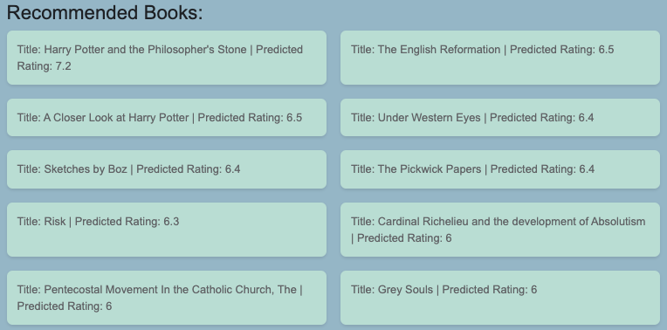

## Updating existing books

To enhance the completeness of the library's book database, I implemented an automated update system. It identifies books with missing metadata (such as title, author, publication year, or summary) and retrieves the necessary information using Google Books API.

### "update_books()"

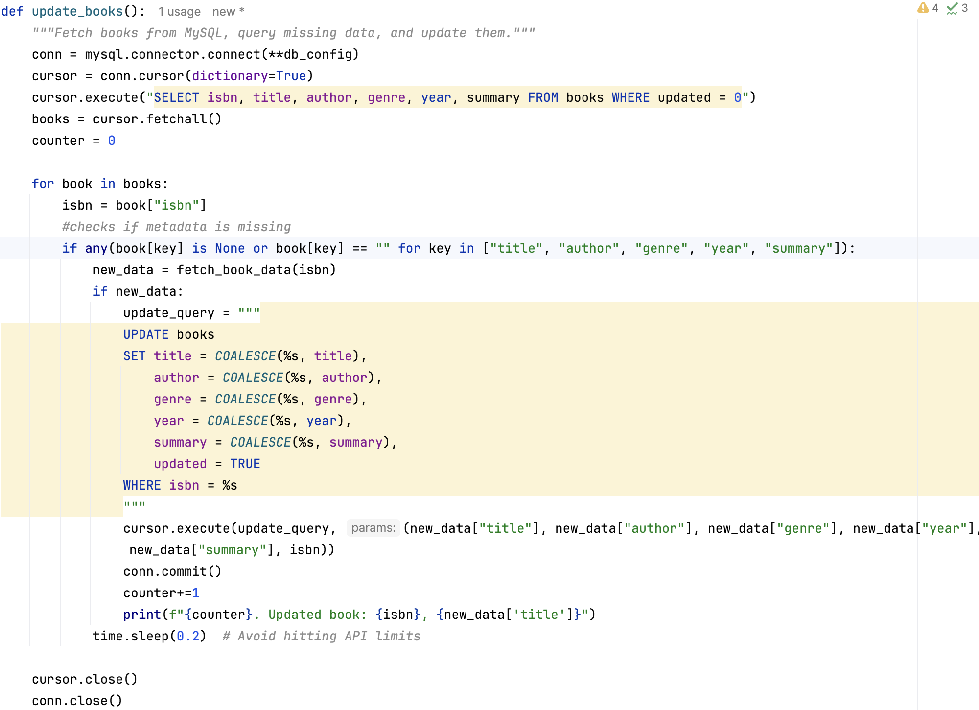

### Limitation Encountered

When running this code, I have observed that a number of books failed to retrieve the necessary metadata. Having done further investigation, I have noticed that some of the books contain an incorrectly formatted ISBN code in the existing library dataset. As the result, such books remain incomplete, as the API relies on accurate ISBN formatting to return relevant results.

## Barcode scanner (ref 1.7.6)

Some of the book managing processes (borrowing, returning and adding new books) require inputting ISBN and barcodes. Therefore, to reduce manual input errors and enhance the overall user experience, I have integrated a barcode scanner on the relevant pages of the website.

### QuaggaJS

I have chosen QuaggaJS, as it is a powerful, open-source JavaScript library designed for real-time barcode scanning. It is specifically optimized for use in web applications, making it an excellent choice for the library book management system.

Some of the key advantages it provides are:

* No externa hardware required - users can scan the barcodes using their device's built-in or external camera.
* Compatible with EAN barcode type, which is normally used for ISBNs and barcodes
* Runs entirely in browser - no extra software is required

### Integration example on the borrow books page

### Screen Output

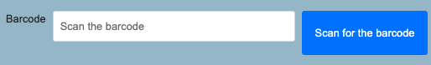

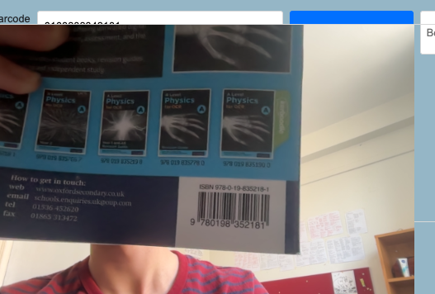

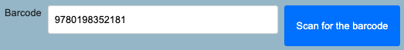

#### User interface

• Each page that requires barcode scanning includes an input field where the scanned barcode is automatically populated.

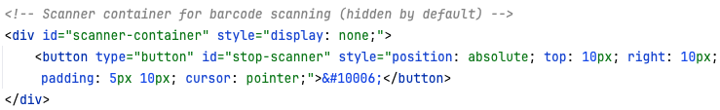

• A “Scan Barcode” button allows users to initiate the scanning process.

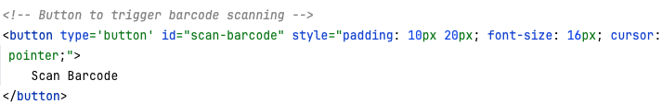

• A hidden scanner container is displayed when scanning starts, ensuring a clear interface without obstructing other page elements. 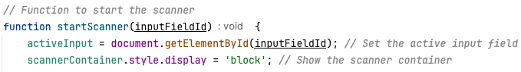

• A “Stop Scanner” button allows users to manually close the scanner if needed.

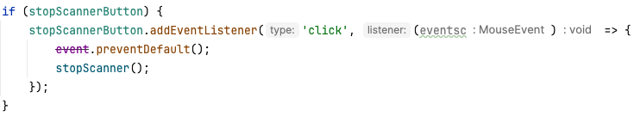

#### Processing the live camera feed

* When the scan button is clicked, the scanner container becomes visible, and QuaggaJS starts processing the live camera feed. 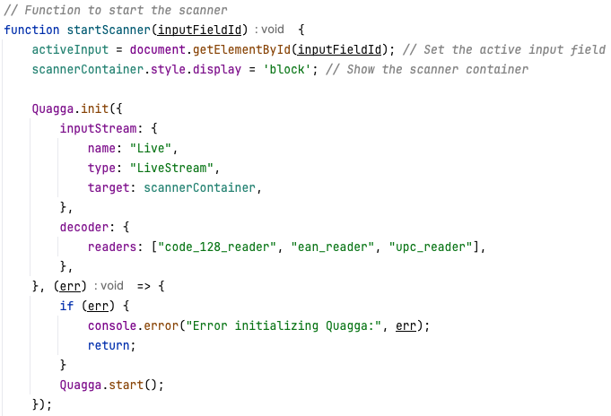
* Once a barcode is detected, the system automatically fills the corresponding input field with the scanned value. 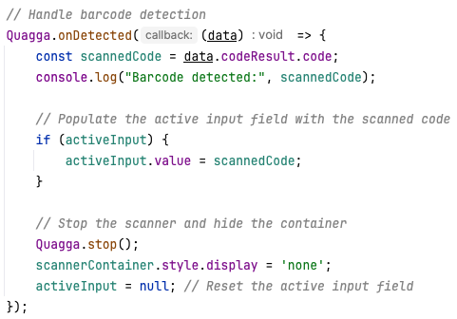
* The scanner then stops, and the scanning interface is hidden to maintain a clean user experience.

## Automatic cataloguing (ref 1.7.7)

Automatic cataloguing is an essential feature that streamlines the process of adding books to the library system. By integrating the Google Books API, the system can automatically fetch book details based on the ISBN number, reducing manual entry errors and improving efficiency.

### Screen Output

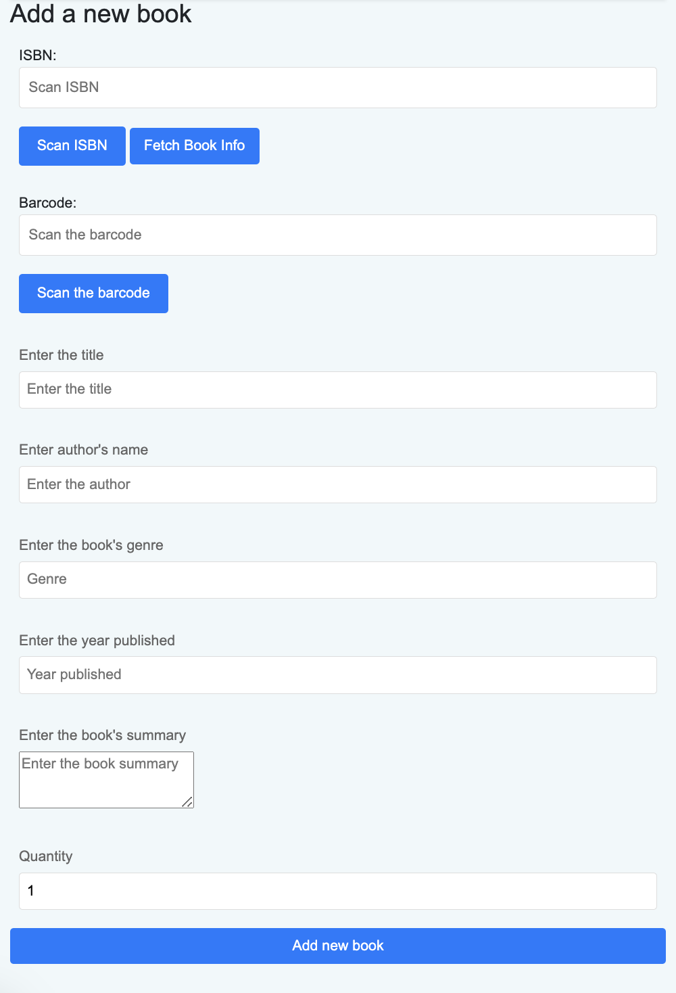

### Potential API Solutions

#### Open Library API

A free and open-source solution, yet the dataset is less comprehensive than Google Books with some missing book records

#### ISBNdb API

Whilst it provides a high-quality bibliographic accurate data, it requires a paid subscription and still covers a smaller range of books than Google Books.

#### Library of Congress API

Provides a free access with no authentication required to a large collection of books. However, it is primarily focused on academic and historical literature, and does not provide ISBN-based look-ups.

#### WorldCat API

Has one of the largest collections of books with over 2 billion records. However, it requires a paid membership and more complex it use than Google Books.

### Google Books API

Was chosen as it is free and covers one of the largest ranges of books. Also, it provides simple ISBN-based lookups, simplifying the integration, and returns all required metadata.

### Process

* User inputs or scans an ISBN (using method described in 3.6)
* Request to Google Books API - when " Fetch Book Data" is pressed, fetchBookData() function constructs an API request URL using the ISBN 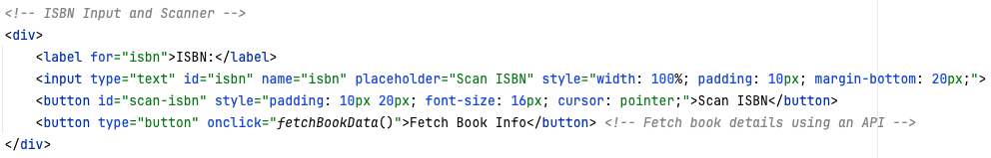
* The request return JSON data containing book details 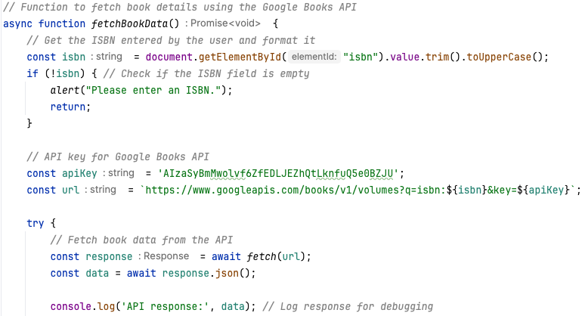
* Processing the API response - key details, i.e. title, author, genre, publication year, and summary are
* Extracted from the response 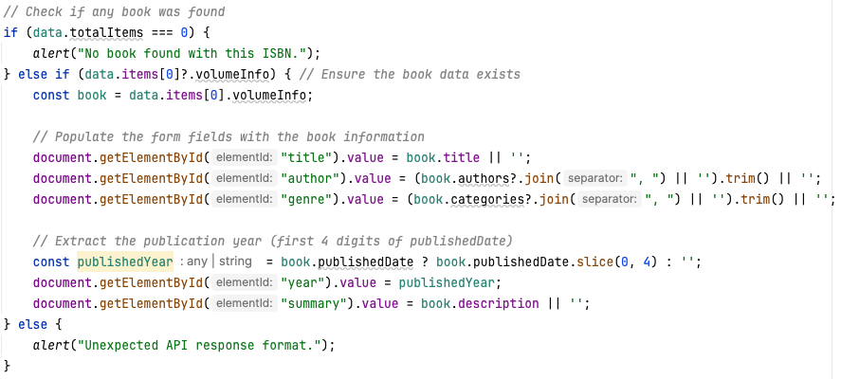
* Filled in into the form fields 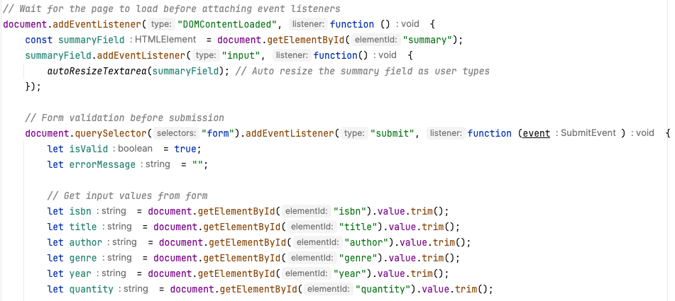
* Validating the data - before data submission, the system ensures the format of submitted data: ISBN is 10 or 13 digits

Title and Author fields are not empty

Genre contains only letters

Year is a valid four-digit number

Quantity is a positive number

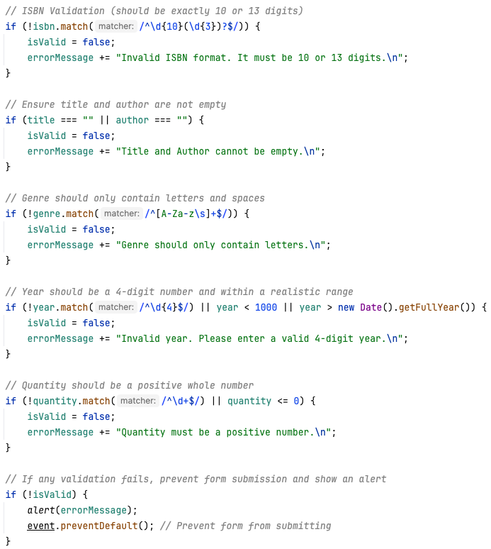

* Once the data is validated, the form can be submitted, creating or updating a record in the library database. 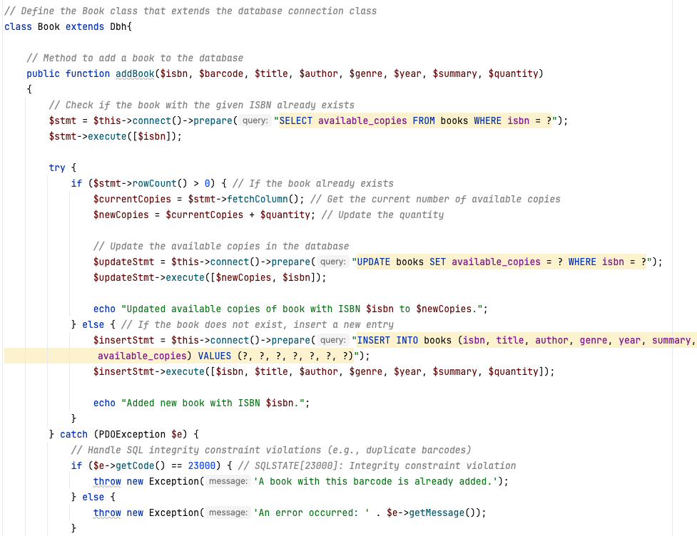

## Borrowing books (ref 1.7.8)

One of the required features of the website was an option for admins to manage borrowing and returning books. The process involves validating the book's availability, updating records and storing the borrowing transaction.

### Screen Output:

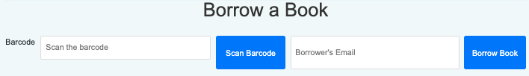

### Frontend

The Borrow Books provides an interface allowing can enter a barcode and borrow a book for a user.

* The page is only accessible by admins, which is regulated using SESSION method: 
* The form sends the entered data to "includes/borrowbooks.inc.php" using the POST method. The form requires book's barcode, uniquely identifying the book, and user email, uniquely identifying the user. The barcode can be entered either manually or using barcode scanner (3.6).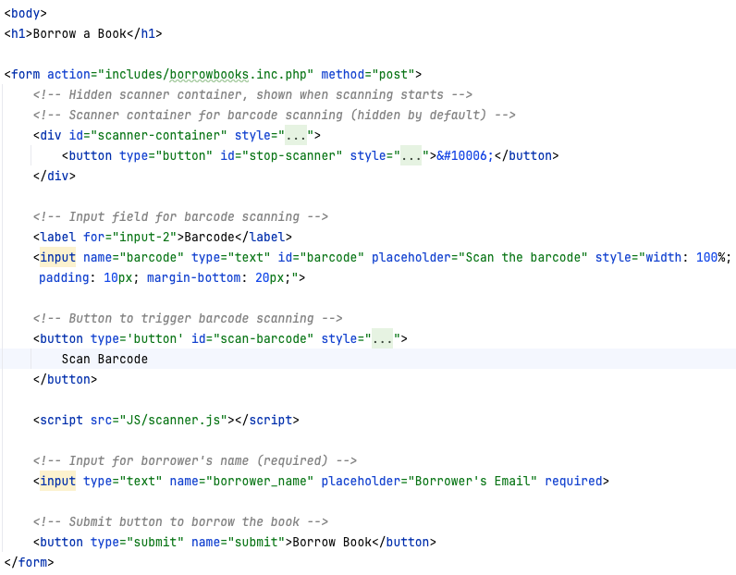
* The form is then submitted using POST method onto borrowbooks.inc.php, where a new borrow object is initialized: 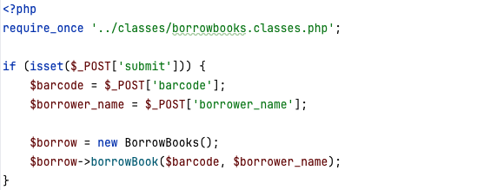

### Backend

BorrowBooks Class handles the borrowing logic, interacting with the database.

* The associated ISBN is retrieved from the "barcodes" table.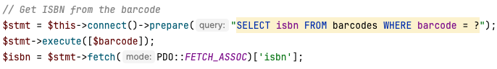
* Books availability is checked by selecting available copies from the "books" table of the book with the retrieved ISBN. 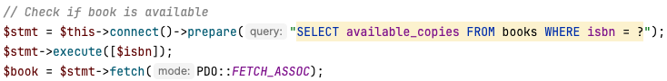
* If the book is available, the available copies count is decreased by 1. 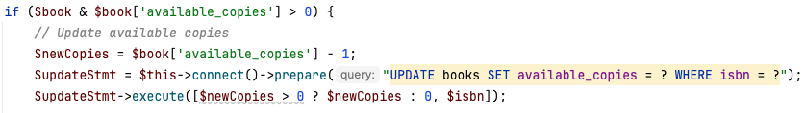
* If the borrower's email is not in the "users" table (meaning that the borrowing is not registered), a new user with the given email is added as an unreggistered user to the table. This is done to assotiate a borrow record with an existing user email, which is a foreign key. 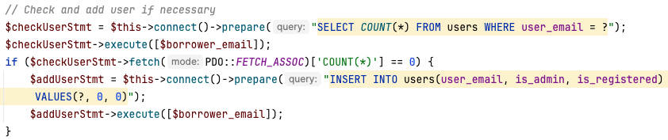
* The borrowing transaction is recorded by inserting a new record into the "borrow_records" table. 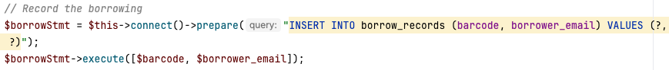
* A success/failure message is diplayed depending on the result of the request: 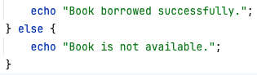

## Returning books (ref 1.7.8)

The returning books feature allows admins to mark a book as returned using either the barcode or ISBN. This process ensures that the borrow record is completed and book’s availability is updated in the system.

### Screen Output

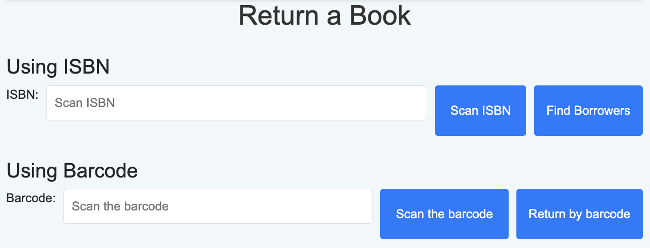

### Frontend

The page provides two options of returning a books

### Returning by barcode

* Once the barcode is manually inputted or scanned, the form is submitted using POST method.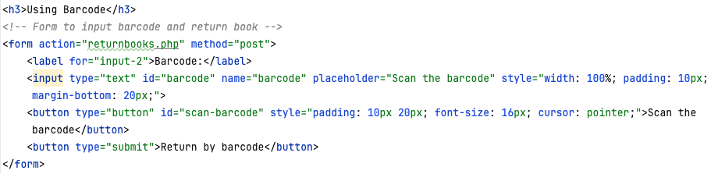
* "borrow_records" and "books" tables are updated using returnBookByBarcode method in the ReturnBooks class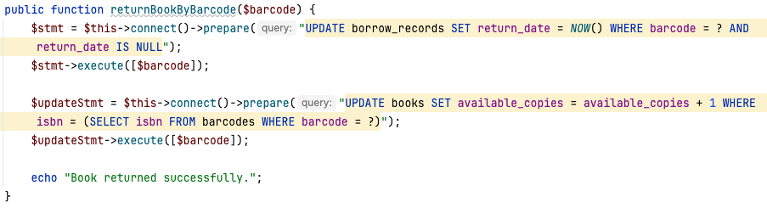

### Returning by ISBN

This option allows returning books for which the barcode is lost, which is normally a sticker attached to a book, unlike permanently printed ISBNs. Therefore, an option to return books by ISBN makes the system more robust.

* Once the ISBN is manually inputted or scanned, the ISBN is posted onto ReturnBooks class:

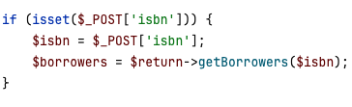­­­­­­

* A list of borrowers who borrowed the book with a given ISBN is generated using getBorrower() method: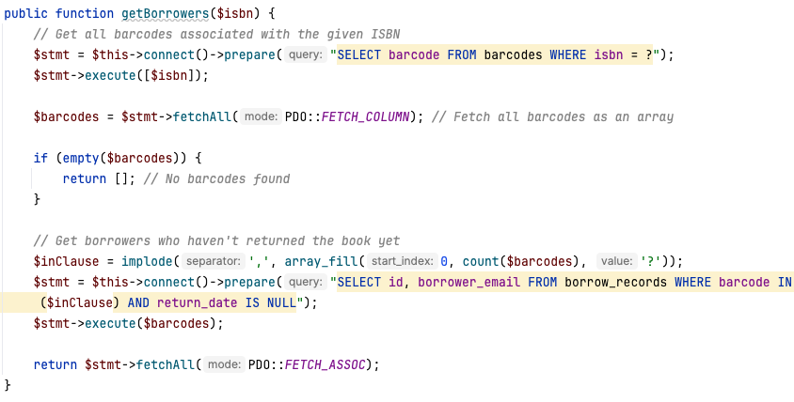
* The returned list and a submit button is displayed on the screen using the following code: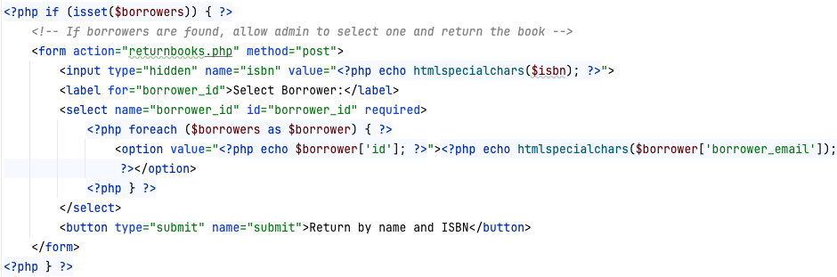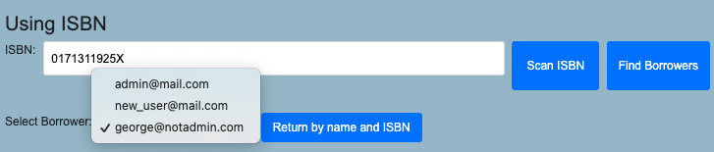
* The form is submitted using a POST method 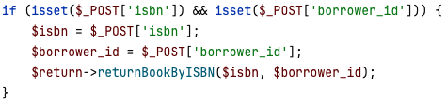
* returnBookByISBN updates borrow_records and books tables, returning relevant success/failure messages 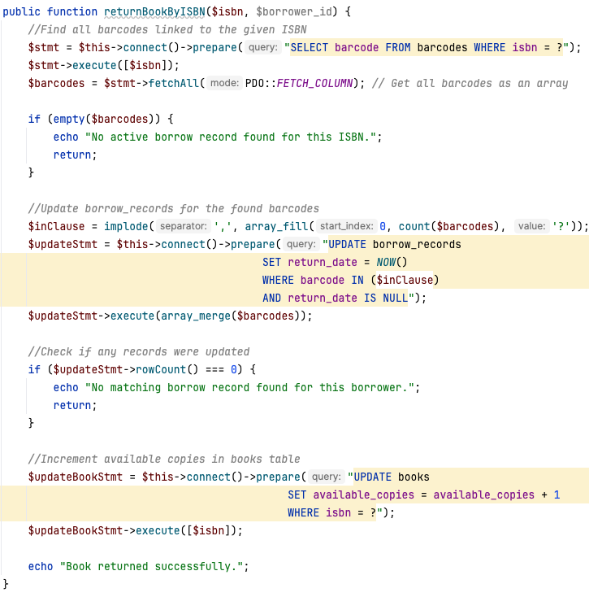

### Returning via Borrow history

#### Screen output

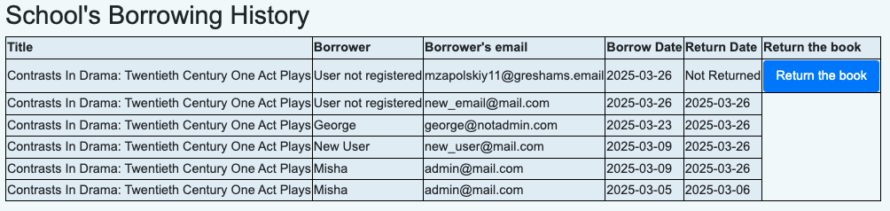

### Frontend

A new object of class BorrowingHistory is created and history is fetched with all records from the database. 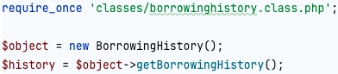

A method getBorrowingHistory from BorrowingHistory class: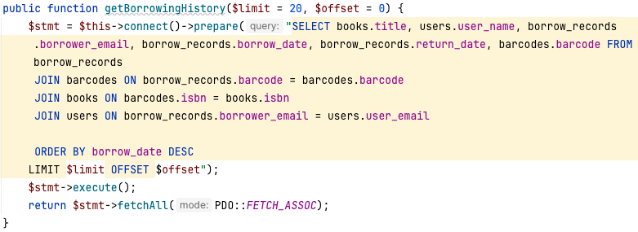

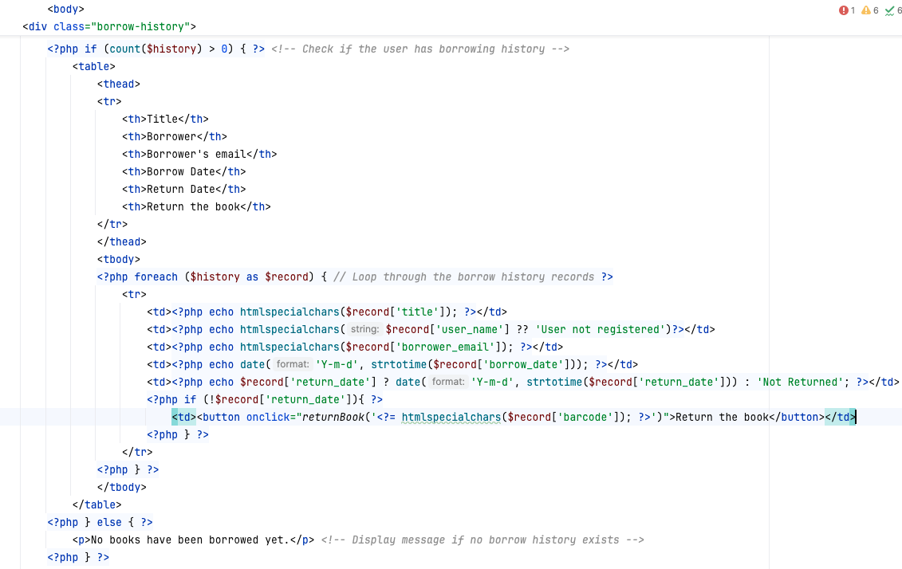

### Backend

When the "Return the book" button is pressed, JavaScript function is activated, which sends all the data to the returnbooks.inc.php: 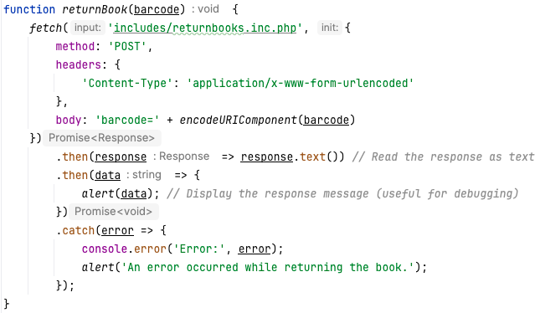

There, a new obect return of class returnBooks is created, and a method returnBookByBarcode is called, which works as described in 3.11.3

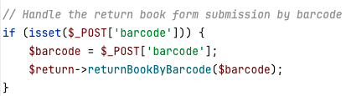

The method updates borrow_records adding the return data and books incrementing the value of available_books by 1.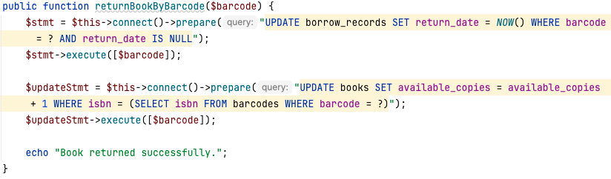

## Personal Borrow history (ref 1.7.9)

The borrow history feature allows users to view a record of the books they have borrowed from the library, along with details such as the book title, author, borrow date, and return date.

### Frontend:

#### Checks if the user has a borrowing history

* The script first checks whether the $history array contains any records (count($history) > 0).
* If there are no records, it displays a message: “You haven’t borrowed any books yet.”

#### Displays the borrow history in a table

* If there are records, it generates an HTML table with headers: Title, Author, Borrow Date, and Return Date.
* The script then loops through each borrowing record (foreach ($history as $record)) and fills the table rows with the corresponding book details.

#### Ensures data security and proper formatting

* htmlspecialchars($record['title']) and htmlspecialchars($record['author'])
* Prevents XSS (Cross-Site Scripting) attacks by escaping special characters.
* Formats the borrow and return dates using date('Y-m-d', strtotime($record['borrow_date']))
* Ensures dates are displayed in YYYY-MM-DD format.

#### Handles books that haven’t been returned yet

* If return_date is NULL or empty, it displays “Not Returned”.

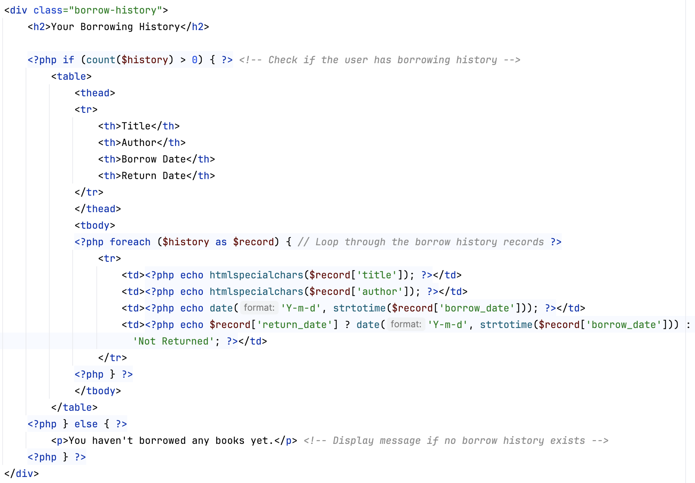

### Backend:

getBorrowhistory method is a part of the Profile class. It retrieves borrow history based on users email address, which is used as a foreigh key in the table.

The method prepares and executes an SQL query.

The SQL query retrieves the following columns:

* books.title – The title of the borrowed book.
* books.author – The author of the borrowed book.
* borrow_records.borrow_date – The date the book was borrowed.
* borrow_records.return_date – The date the book was returned (or NULL if not returned).

The query joins multiple tables:

* borrow_records – Stores borrowing transactions.
* barcodes – Links a book’s barcode to its ISBN.
* books – Stores book details.

The WHERE borrow_records.borrower_email = ? condition ensures that only borrowing records associated with the provided user email ($useremail) are retrieved.

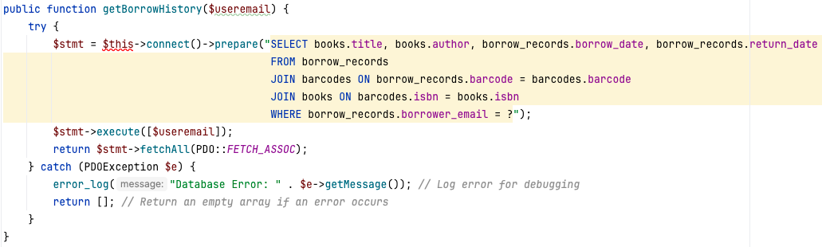

### Screen Output:

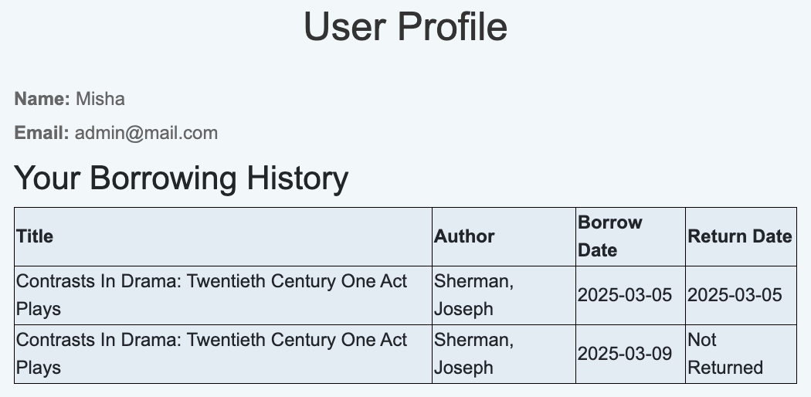

# Testing

|  |  |  |  |
| --- | --- | --- | --- |
| Test No | Objective | Outcome | Video Timestamp |
| 1 | Using the header to switch between pages as a guest | User accesses home, catalogue, login, and signup pages | 0:00 |
| 2 | Using the header to switch between pages as a logged in user | User accesses home, catalogue, and profile pages | 0:08 |
| 3 | Using the header to switch between pages as an admin | User accesses home, catalogue, add books, borrow books, return books, and profile pages | 0:17 |
| 4 | Attempting to access non-permitted pages with restricted access (ie Add books) | Access is restricted and an appropriate message is returned on the screen | 0:33 |
| 5 | Accessing profile page when the user is not logged in | A message indicating that the user needs to login is returned | 0:44 |
| 6.1 | Signing up sending empty strings | The user is not added and asked to fill in the empty fields | 0:50 |
| 6.2 | Signing up entering incorrectly formatted email | Formatting criteria are shown | 0:54 |
| 6.3 | Signing up using existing email | A message saying that the user already exists is returned | 1:07 |
| 6.4 | Signing up repeating password incorrectly | A message saying that the passwords do not match is returned | 1:17 |
| 7 | Successful sign in (SQL) | A new record is inserted in the users table, containing username, email, hashed password, registration date, is_admin equal to 0 and is_registered equal to 1  If the user email is already in the table and marked as not registered, a record in the users table is updated setting a new password and updating is_registered value from 0 to 1 | 1:25 |
| 8.1 | Logging in using a non-registered email | "User not found" is returned | 1:36 |
| 8.2 | Logging in using a wrong password | "Wrong password" is returned | 1:46 |
| 8.3 | Logging in sending an empty input | "Empty input" is returned | 1:51 |
| 8.4 | Successful login | A session is started allowing the user to access personalised features | 1:59 |
| 9 | Searching and sorting in the book catalogue | Search and filtering methods work as intended | 2:07 |
| 10 | Switching between catalogue pages | "Show previous/more books" buttons allow user to extend the list of the shown sorted and filtered books .  The "Show previous books" button is hidden on the first page.  The "Show more books" button disappears when there are no more books to be shown | 2:28 |
| 11.1 | Opening book modal | A pop-up window appears on the screen containing all the book's details | 2:39 |
| 11.2 | Expanding and minimising summary | Works by pressing "show more"/"show less" buttons | 2:41 |
| 12.1 | Rating a book (SQL) | When a logged in user selects a rating for a book in the book modal and presses "Submit rating", the rating is saved by inserting a new record in the ratings table, containing the user id, isbn, rating date and the rating itself. | 2:50 |
| 12.2 | Updating books rating | A rating in a record with a given user id and isbn in the ratings table is updated. | 3:02 |
| 13 | Editing a book (SQL) | Users with administrative status can edit book details in the modal by pressing writing new data in the updated fields and saving the changes, causing an update in the books table. | 3:15 |
| 14 | Book recommendations based on ratings of a harry potter fan. | A user who has highly rated multiple Harry Potter books is recommended to read more related books in his profile, proving the efficiency of the recommender algorithm. | 3:34 |
| 15.1 | Opening a barcode scanner | A window with a scanner is opened by pressing on the "scan the ISBN/barcode" button. | 4:06 |
| 15.2 | Manually closing the scanner | If the window was opened accidentally can be closed by pressing |  |
| 15.3 | Successful scan of an ISBN/barcode | The input field is filled in and the scanner window is automatically closed |  |
| 16 | Automatic fetching book details | When pressing "Fetch Book info" button all book details are filled into the input fields on the page. | 4:22 |
| 17 | Adding a new book using invalid credentials | A message explaining the problem appears on the screen. | 4:26 |
| 18 | Adding a new book (SQL) | A new record is inserted into the books table and a message appears on the screen confirming it. | 4:32 |
| 19.1 | Borrowing a book with invalid credentials | The email must be correctly formatted before sending the form.  If the barcode is empty "Please input the barcode is returned". | 5:07 |
| 19.2 | Borrowing a book with a non-existing barcode | "Please check if the barcode is valid" is returned on the screen. | 5:19 |
| 19.3 | Borrowing a not available book | If a book is not available (0 available copies), "The book is not available" is rreturned on the screen. | 5:31 |
| 20 | Borrowing a book for a non-existing user (SQL) | A new user is added to the users table with a given email and is_registered value equal to 0.  A new record in the borrow_records is created with user's email, the barcode, and the time of borrowing. | 5:44 |
| 21 | Borrowing a book for existing user | A new record in the borrow_records is created with user's email, the barcode and the time of borrowing. | 6:05 |
| 22 | Returning a book using ISBN (SQL) | Once the ISBN is entered, all the borrowers who borrowed a book with a given ISBN are fetched onto the page. The admin can then select the needed borrower and return the book by pressing "Return by name and ISBN" button.  Then, borrow_records table is updated by adding a return_date value in the needed record, and incrementing available copies for the book in the books table by 1. | 6:15 |
| 23 | Returning a book using a barcode (SQL) | Once the barcode is entered and submitted, borrow_records table is updated by adding a return_date value in the needed record, and incrementing available copies for the book in the books table by 1. | 6:35 |
| 24 | Returning a book from a borrowing history (SQL) | By pressing "Return the book" button in the School's Borrow History table causes identical result as in test 23 | 6:48 |
| 25 | Logging Out | The session is over and the user is sent to the home page as a guest. | 7:01 |

# Evaluation

## Met Objection

The Library Website an efficient and user-friendly experience for both students and librarians. The conducted testing confirms that all the key objectives were met.

User navigation is based on the website header, linking all the pages around the website with each other (tests 1,2,3) and restricting access based on user's administrative status (tests 4,5).

The authentication system provides secure sign-up and login pages, effectively dealing with empty fields, incorrect email formats, duplicate accounts, and mismatched passwords (tests 6,7,8). It correctly verifies users' credentials and restricts access based on their roles. The session-based system ensures that the users securely access personalised and managing features.

The library catalogue provides search, filter, and sort functions, with which users can easily find the needed books (test 9). Pagination of the library dataset optimises the load on the webpage and allows users to switch between the pages, preventing accessing non-existent pages (test 10). The book modal compactly displays all the book information in a pop-up window, also allowing rating if a user is logged in (test 12), editing if a user is an admin (test 13), and expanding the summary (test 11).

The recommender system effectively suggests books based on user ratings, ensuring that enjoyers of certain genres or authors receive appropriate recommendations (test 14).

The barcode ad ISBN scanner successfully scans the codes on "Add books", "Borrow books", and "Return books" pages, auto filling the input fields (test 15).

On the "Add books" page, the book details can be fetched using Google Books API, significantly automating the process (test 16).

Books can be borrowed by inputting or scanning the barcode and entering user's email (tests 19, 20, 21), providing an appropriate of input verification and error handling.

The books can be returned in multiple methods, all being useful under different circumstances. Returning using ISBN and user 's email does not require the book's barcode (test 22). The book can also be returned simply using a barcode (test 23), or in case of being borrowed recently, by clicking "return the book" button in the school's borrowing history table (test 24).

Logout button works as intended by ending the session when a user is finished or wants to switch an account.

## Areas for improvement

* Google API does not contain all books; thus, some books are not fetched automatically. It can be improved by choosing one of the APIs requiring a paid subscription but providing a wider range of books
* Email reminders to users if they have kept a book for too long and the book is needed for another student. Even though it happens rarely in my school, it would simplify the process for the librarians, who will need to manually find the student on teams and text them.
* The home page features can be potentially enhanced. Whilst now the home page does not contain any information, a function to create events or post latest news can potentially be added for librarians.
* Automatic synchronisation with students' school Microsoft accounts would streamline user authentication. This could allow for single sign-on (SSO) and better integration with school systems.

## Interview

**Interviewer:** Now that the new library management system has been developed, how does it compare to the existing system in terms of functionality and usability?

**Mrs Corder:** The new system provides a much more intuitive and streamlined experience, particularly for students. Unlike our previous LMS, which was underutilized, this system encourages more engagement through features like book ratings and recommendations. The user interface is also much simpler, requiring no training compared to the more complex interface of Accessit. Additionally, it is great to have control over our records, rather than requiring a response form Accessit whenever we need to get data from their servers.

**Interviewer:** Were the key issues with the previous system effectively addressed?

**Mrs Corder:** Yes, most of the issues we discussed in the initial interview have been tackled. Automating book cataloguing was a major improvement—the barcode and ISBN scanning features greatly reduce the time required for manual data entry. The recommendation engine, as already mentioned, is another strong addition, encouraging students to rate books and making book discovery more exciting. However, sometimes automating cataloguing lacks information on certain books, therefore requiring manual input, so this is probably the main area for a future improvement.

**Interviewer:** How do you find the new borrowing and returning process compared to the previous system?

**Mrs Corder:** It is much more efficient. I was worried that switching from a laser scanner to camera will take much longer, yet it appeared to be even more convenient as it can be done using any device with a camera. Also, I found tracking borrowing history to be quite useful to track general activity across the school and return any borrowed books just in one click... And it is great that students can see their personal history, I think it is very useful. However, I know I haven't mentioned it in the first interview, but implementing automated overdue notifications in the future would further enhance the system.

**Interviewer:** Do you think the book recommendation system is useful for students?

**Mrs Corder:** Absolutely. The system has proven to provide recommendations based on user ratings, which is a great way to introduce students to books they might not have considered. They are not always accurate, but I believe it is unavoidable for a relatively small range of books in the school catalogue. Anyways, since students often struggle to decide what to read next, this feature adds significant value.

**Interviewer:** Apart from overdue notifications and an API with a wider range of books, are there any additional features you would like to see in future updates?

**Mrs Corder:** Integrating Microsoft accounts for authentication would streamline access for students and staff. If possible, adding a section for library news and events could further engage students and promote reading initiatives.

**Interviewer:** Overall, how satisfied are you with the system?

**Mrs Corder:** I am very satisfied with the outcome. The system successfully addresses the limitations of the previous LMS while adding new features. It is easy to use, efficient, and designed with both students and staff in mind. With some future refinements, this system could become a perfect fit for our library’s needs.

**Interviewer:** Thank you for your feedback!

**Mrs Corder:** You're welcome! This has been a great project, and I look forward to seeing how the system evolves.

## Conclusion

The development of this library management system has resulted in a fully functional and efficient platform for managing book borrowing, returning, and recommendations within a school library setting. The system integrates user authentication, book search, borrowing history tracking, and personalized recommendations based on user ratings, providing a seamless experience for both students and administrators.

A key strength of the system lies in its structured, class-based architecture, which follows the Model-View-Controller (MVC) paradigm. This ensures a clear separation of concerns, making the system more maintainable and scalable. The Dbh class plays a crucial role in managing database connections, which are inherited by other classes to facilitate seamless interactions with the MySQL database. The authentication process is efficiently handled by the SignupContr and LoginContr classes, ensuring secure user registration and login functionalities. Additionally, the BorrowingHistory class enhances user experience by providing a structured view of previously borrowed books.

The Book class is responsible for managing book entries, while the BorrowBooks and ReturnBooks classes ensure smooth book transactions by linking ISBNs with user records. The Catalogue class allows for dynamic search and sorting functionality, making it easier for users to find books of interest. Furthermore, the integration of a rating system enables the generation of personalized book recommendations, encouraging users to explore new reading materials based on their preferences.

The system enhances user experience by offering barcode scanning functionality, allowing for quick and error-free book checkouts and returns. Real-time updates to borrow and return records ensure that book availability remains accurate at all times. Future improvements could include an administrative panel for enhanced oversight of overdue books and user management, as well as synchronization with students' Microsoft accounts for automatic authentication.

The implementation of object-oriented programming principles significantly contributes to the system's efficiency. By encapsulating key functionalities within dedicated classes, the system is highly modular and reusable. Inheritance in authentication-related classes streamlines user management, while encapsulation ensures that database operations remain secure and well-structured. These principles not only improve maintainability but also provide a strong foundation for future enhancements.

A key feature of the system is the book recommendation engine, which uses Singular Value Decomposition (SVD) for matrix factorization. This technique is particularly suited to the library environment, where users have only rated a small subset of books. SVD efficiently processes large datasets while maintaining accuracy, ensuring users receive high-quality recommendations. By leveraging existing datasets of user ratings and ISBNs, the system generates meaningful suggestions that improve the user experience and encourage broader book engagement.

Despite its robust design, there are areas for improvement. The reliance on the Google Books API for fetching book details poses limitations, as not all books are available. Exploring alternative APIs with a broader database, even if subscription-based, could enhance data accuracy. Additionally, introducing email reminders for overdue books would help streamline library operations by notifying students when their borrowed books are urgently needed by others. Enhancing the homepage to display news and events related to the library would also increase user engagement.

Overall, this project successfully demonstrates the power of structured software design in creating an intuitive and effective library management system. By leveraging OOP principles and MVC architecture, the system is well-positioned for future expansions and refinements to further enhance user experience and administrative efficiency.

# Code

## Code structure

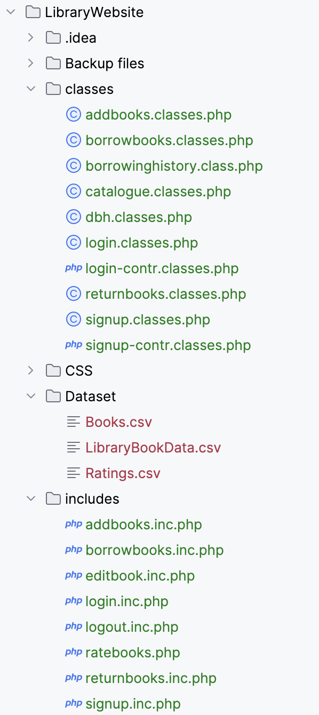 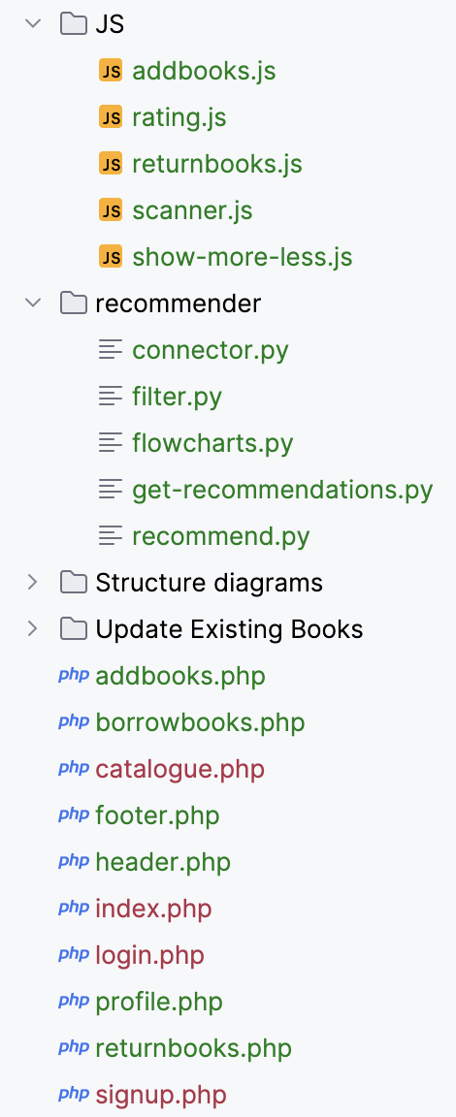

## Web pages

### addbooks.php

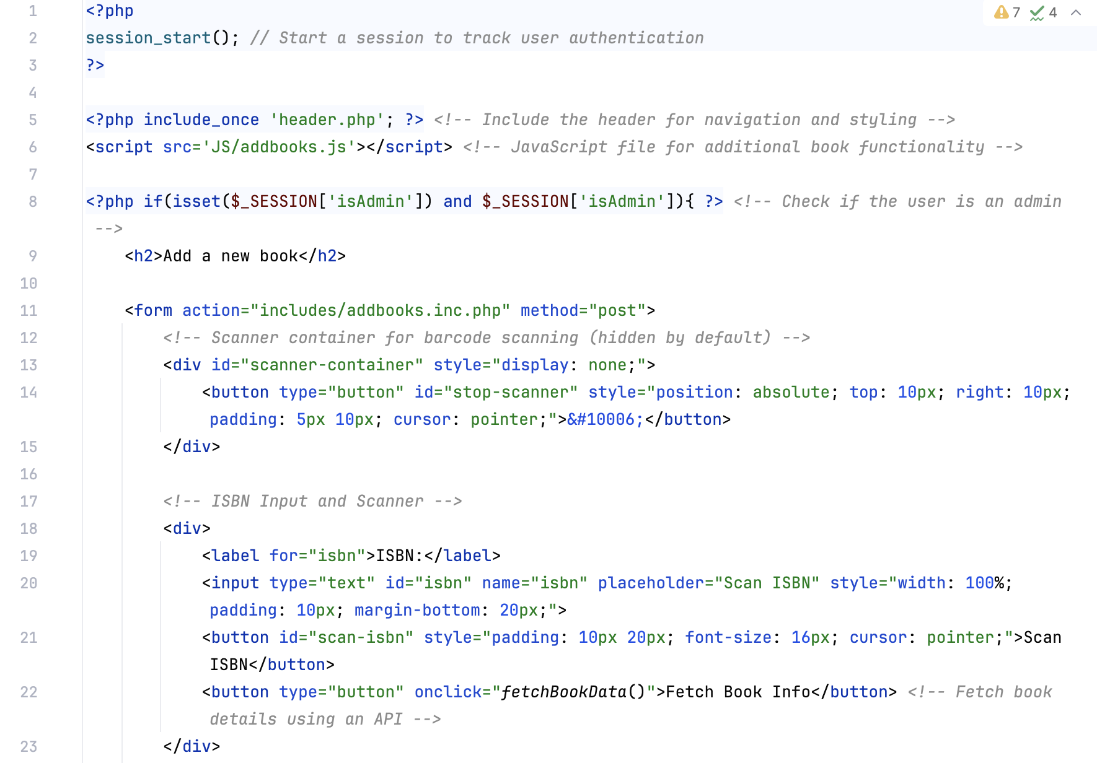

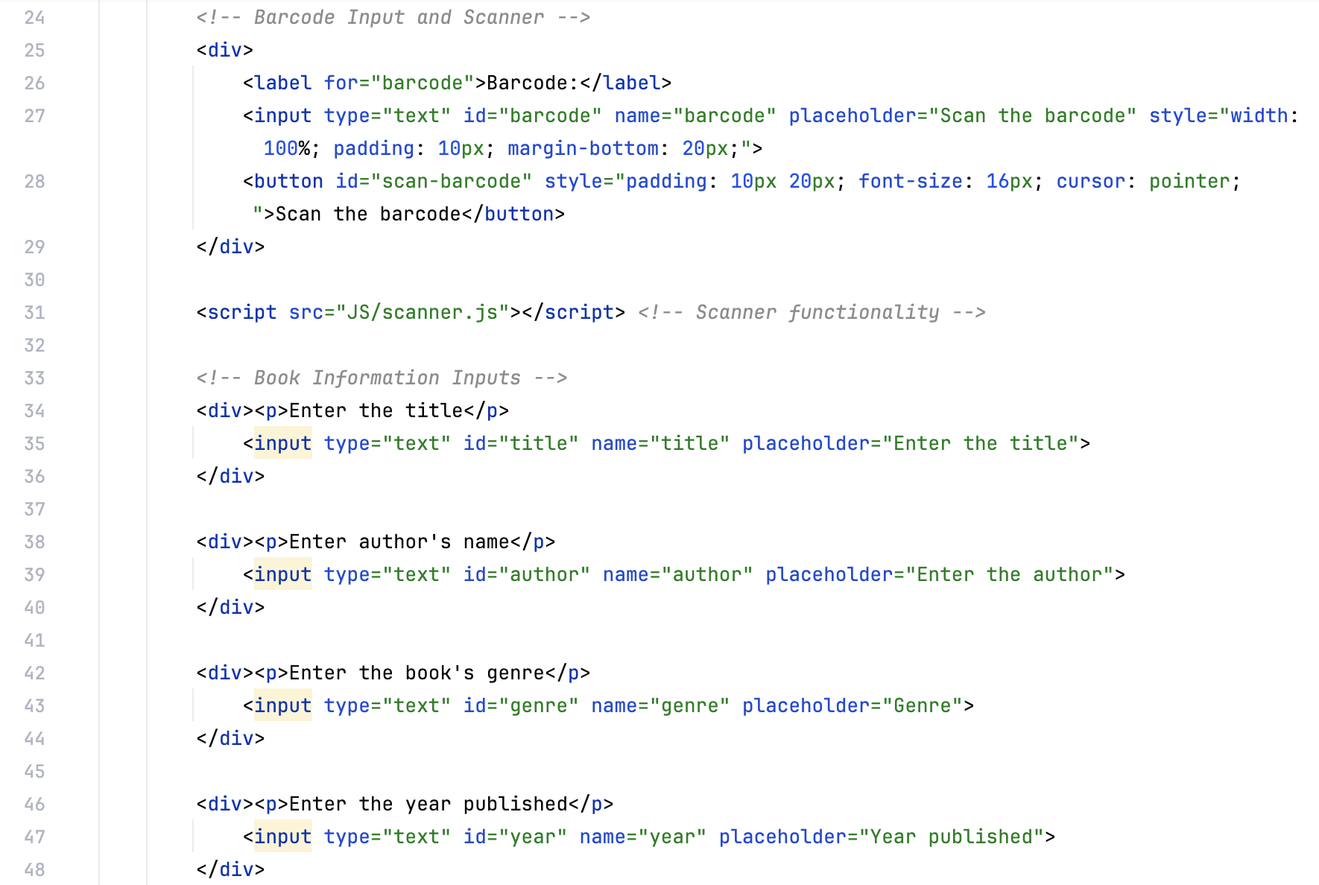

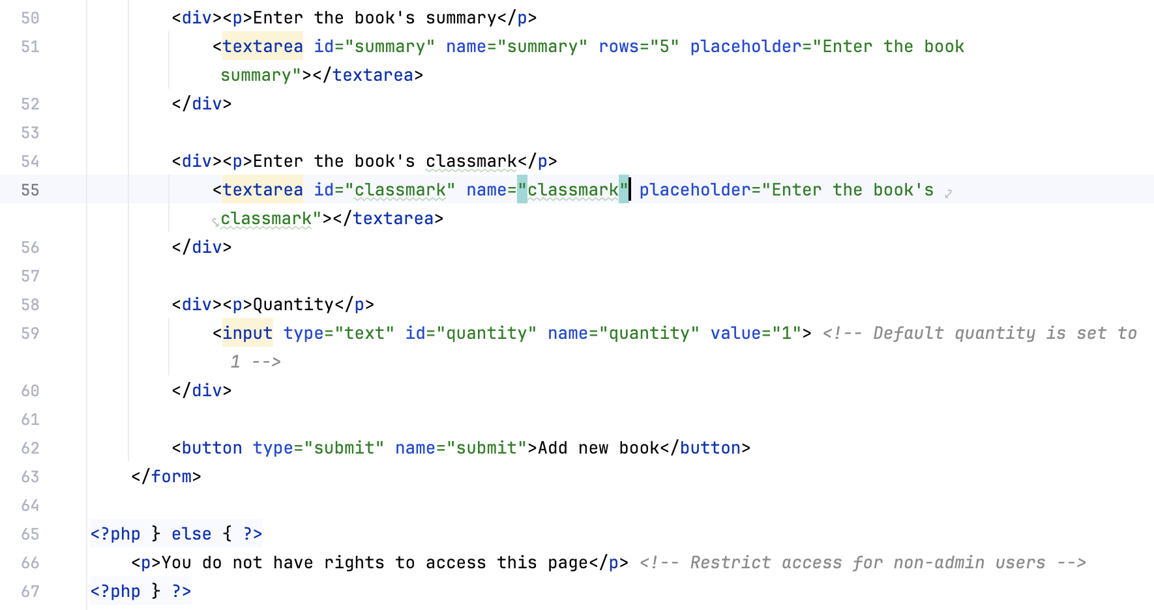

### borrowbooks.php

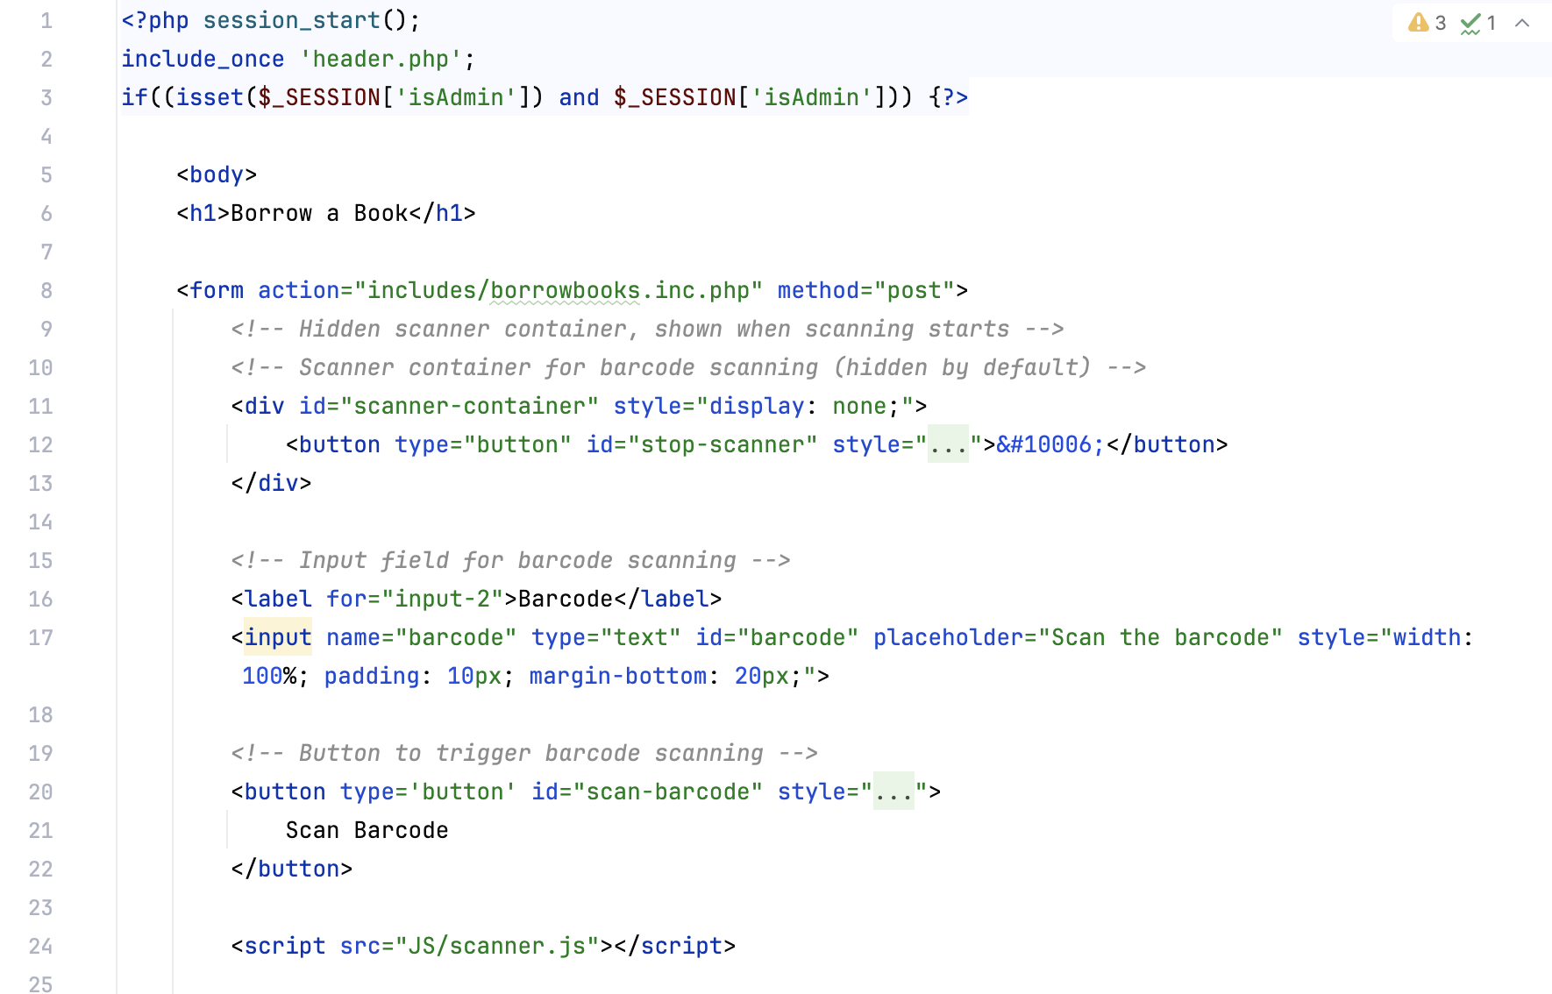

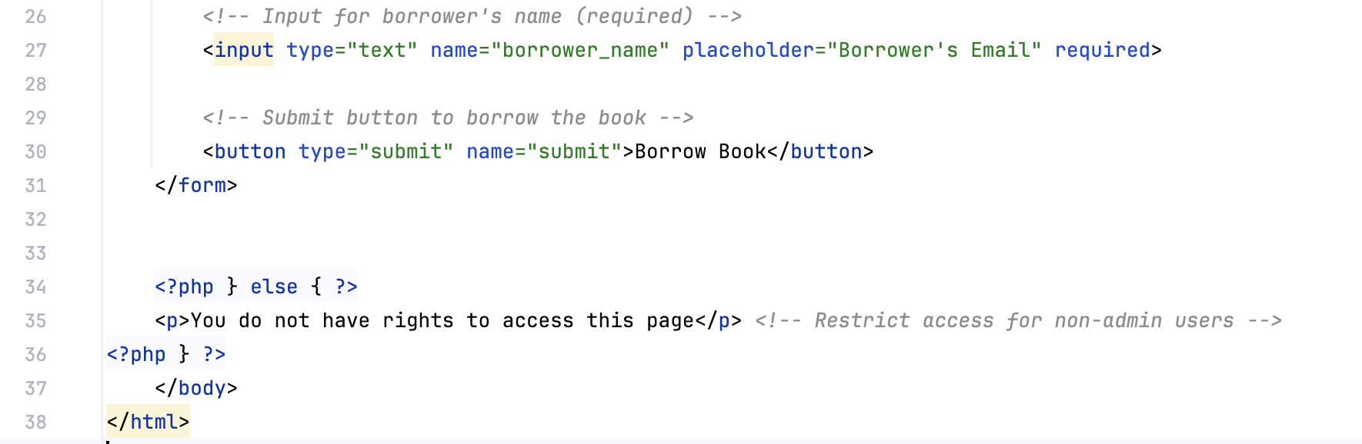

catalogue.php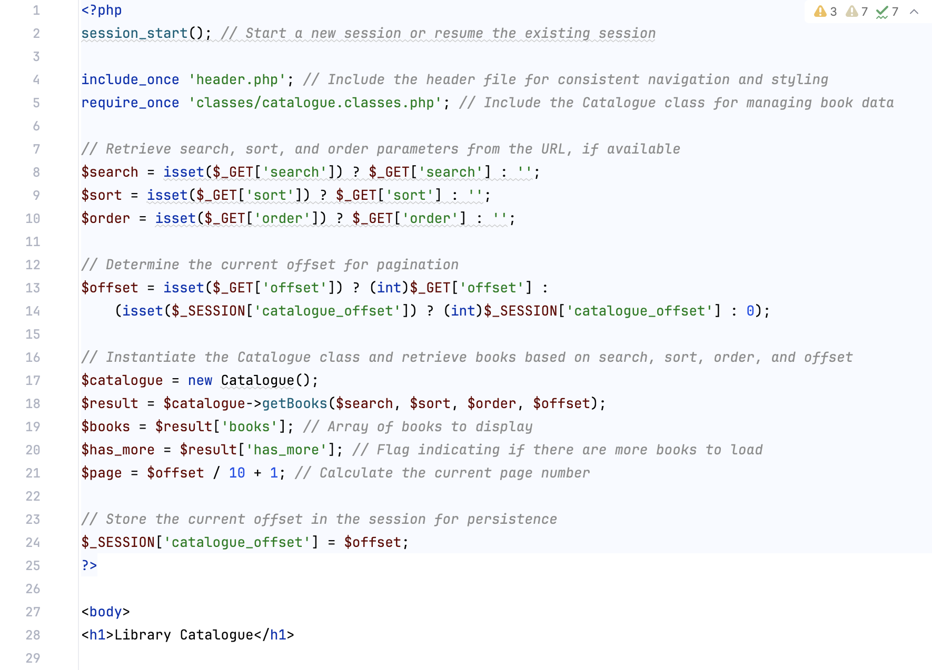 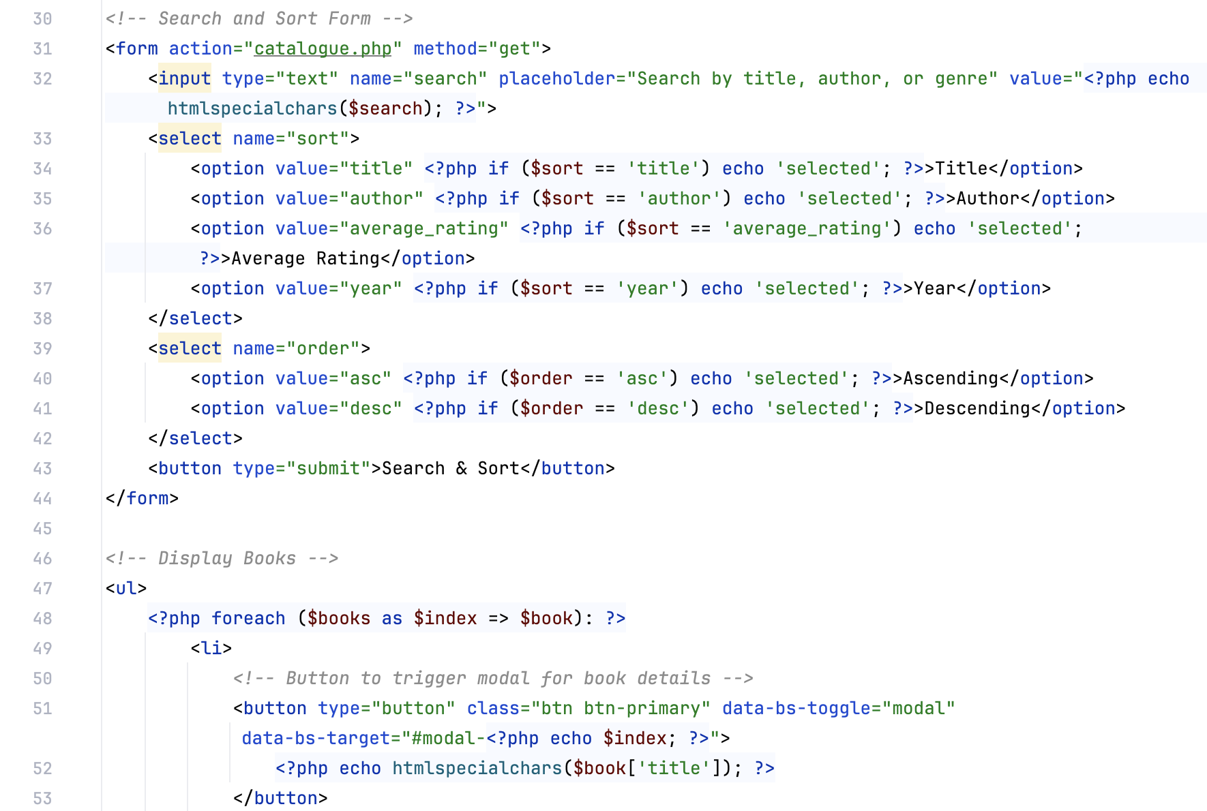 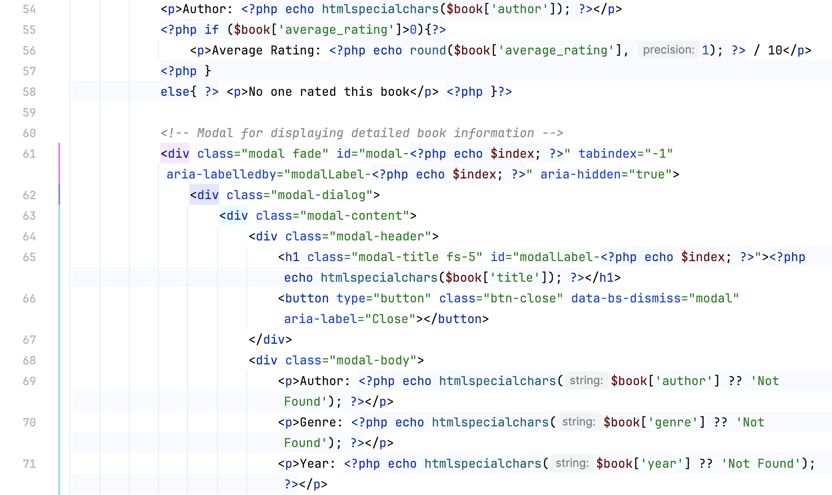 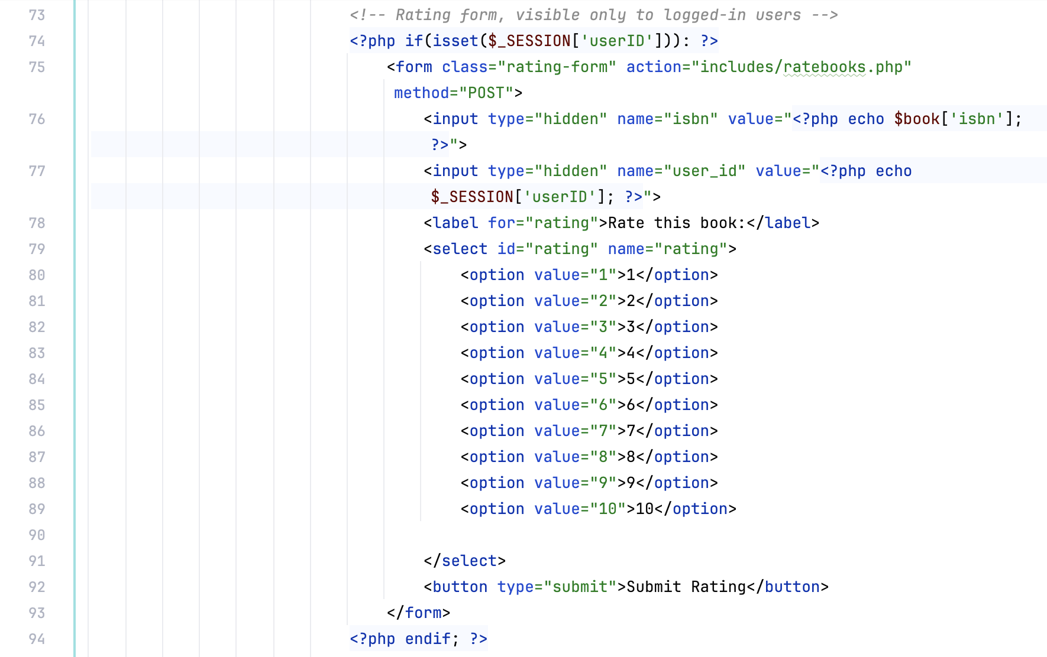 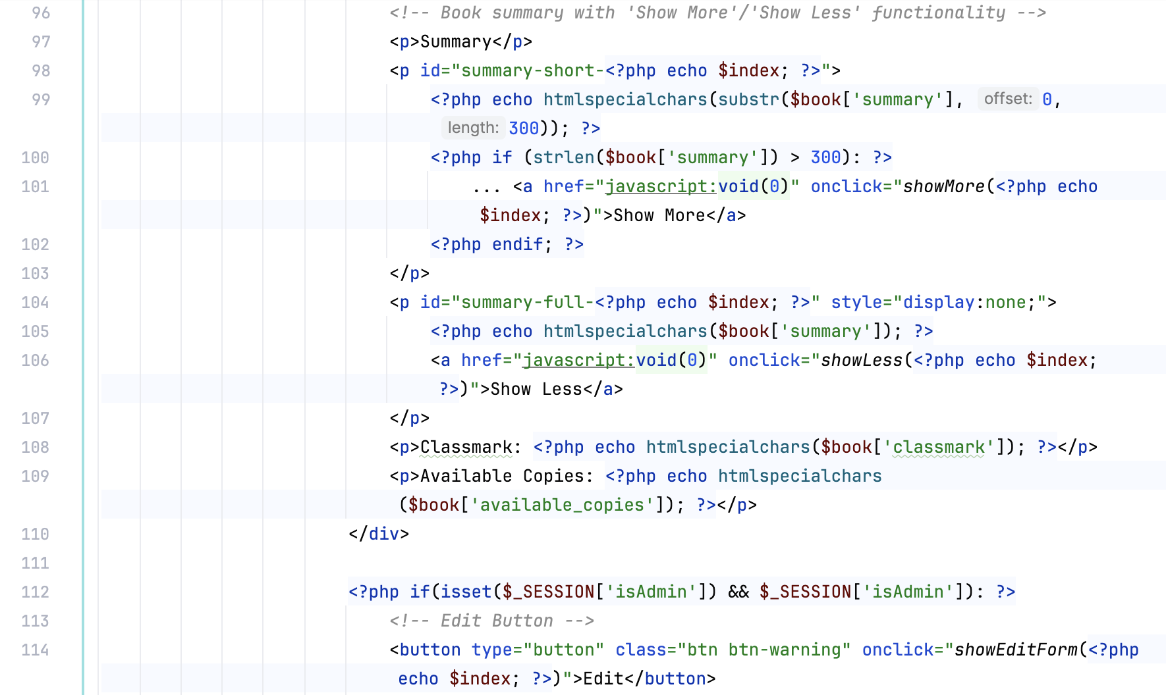 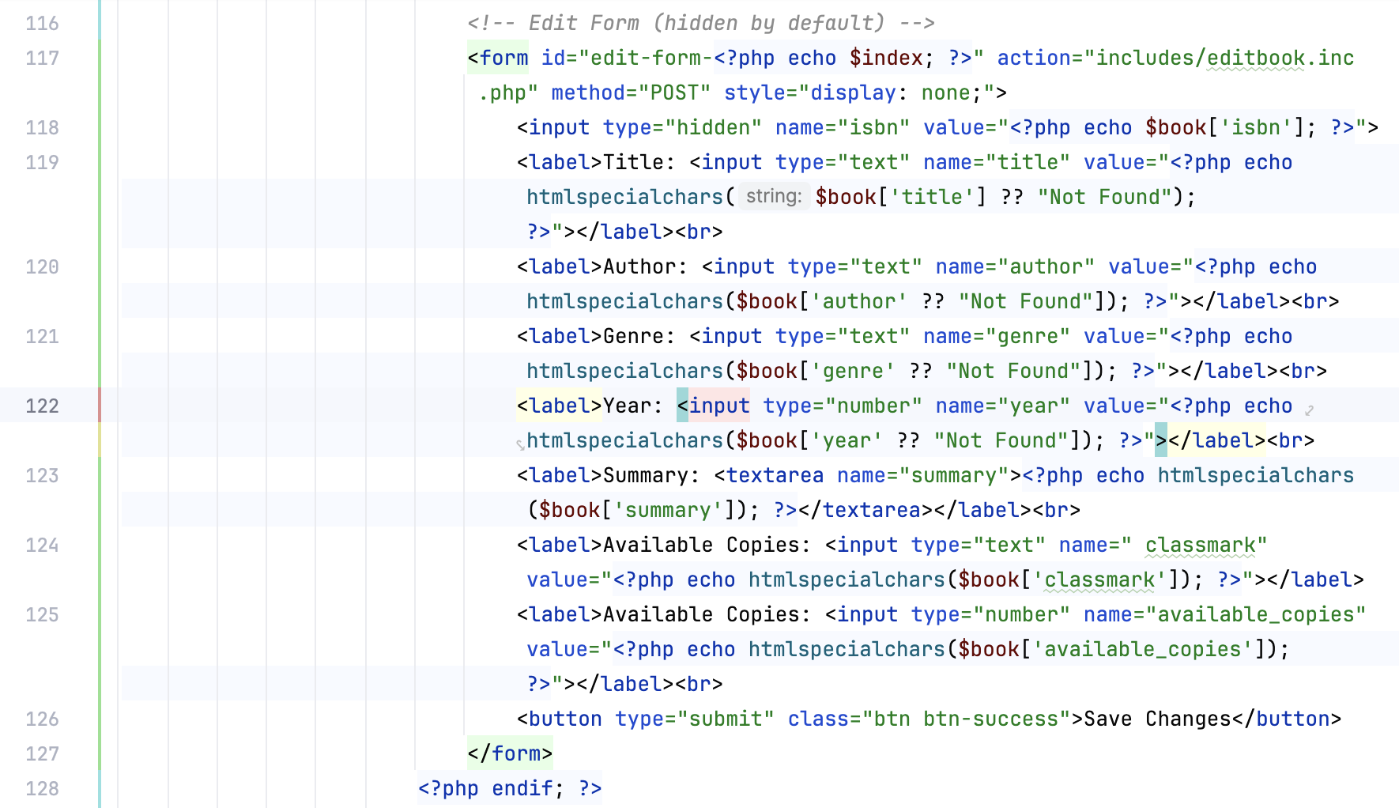 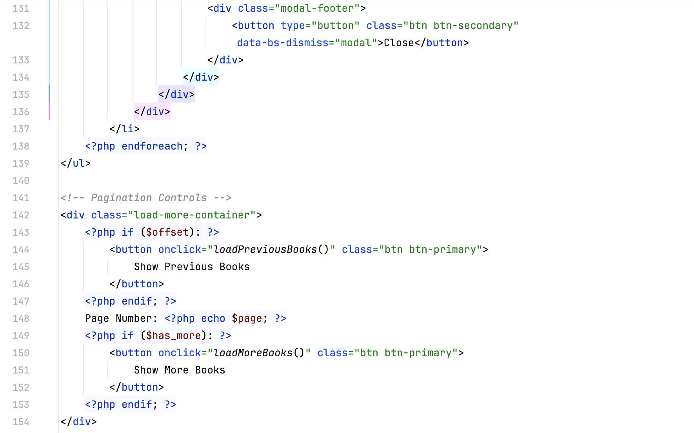 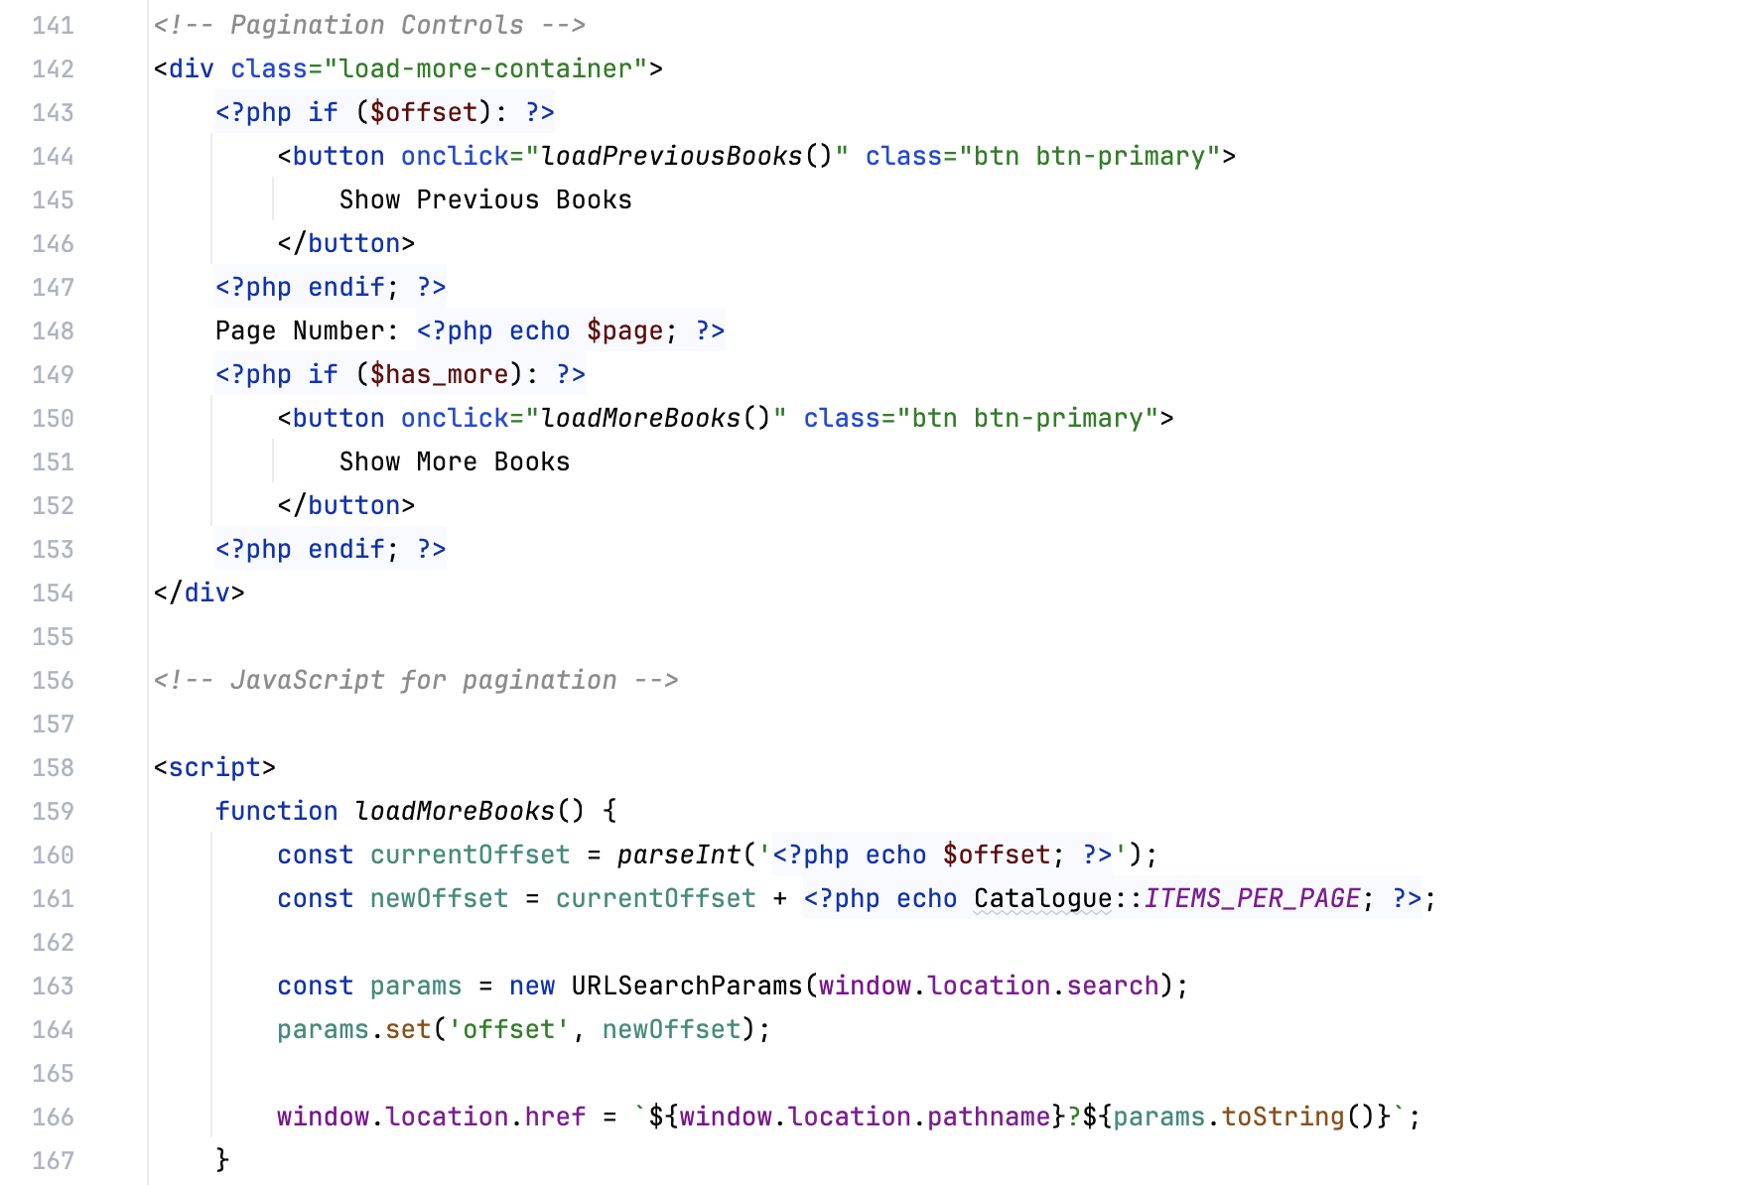 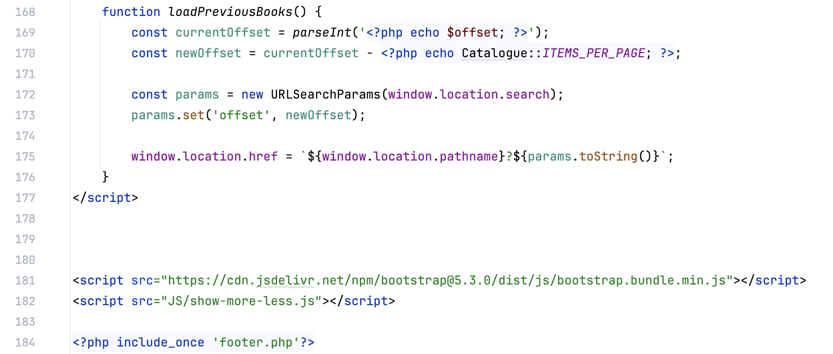

### footer.php



### header.php

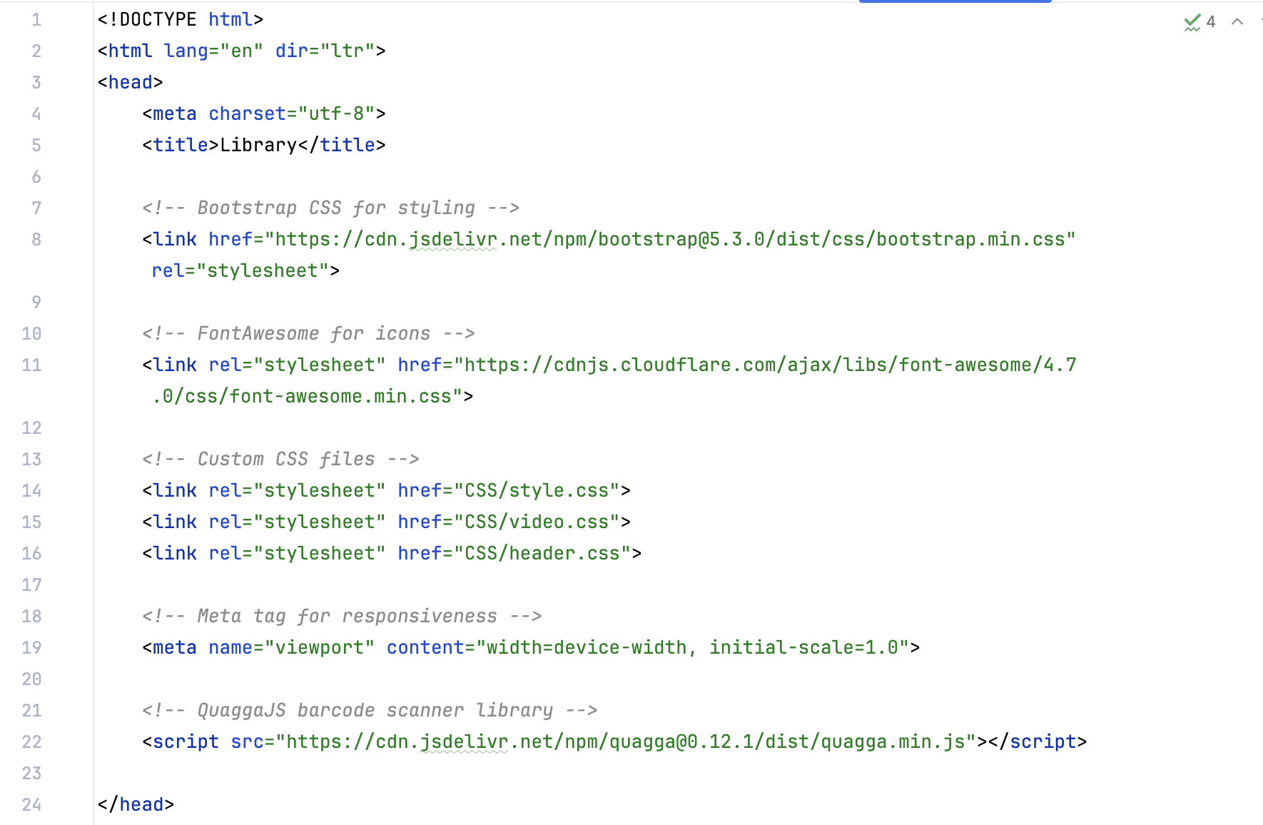 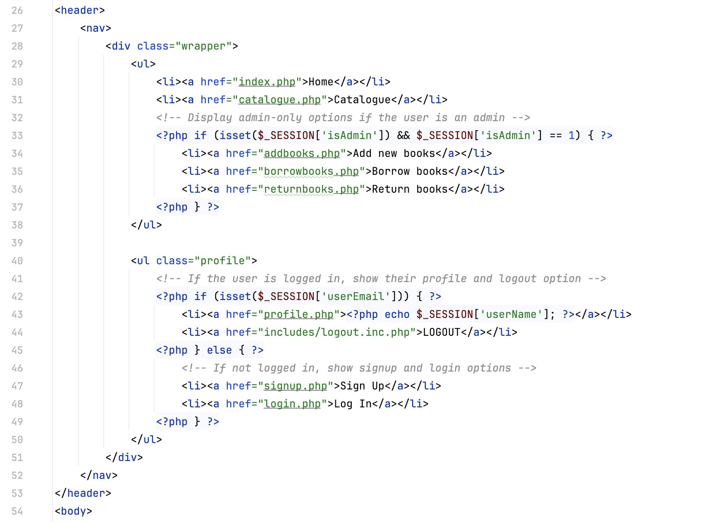

### index.php

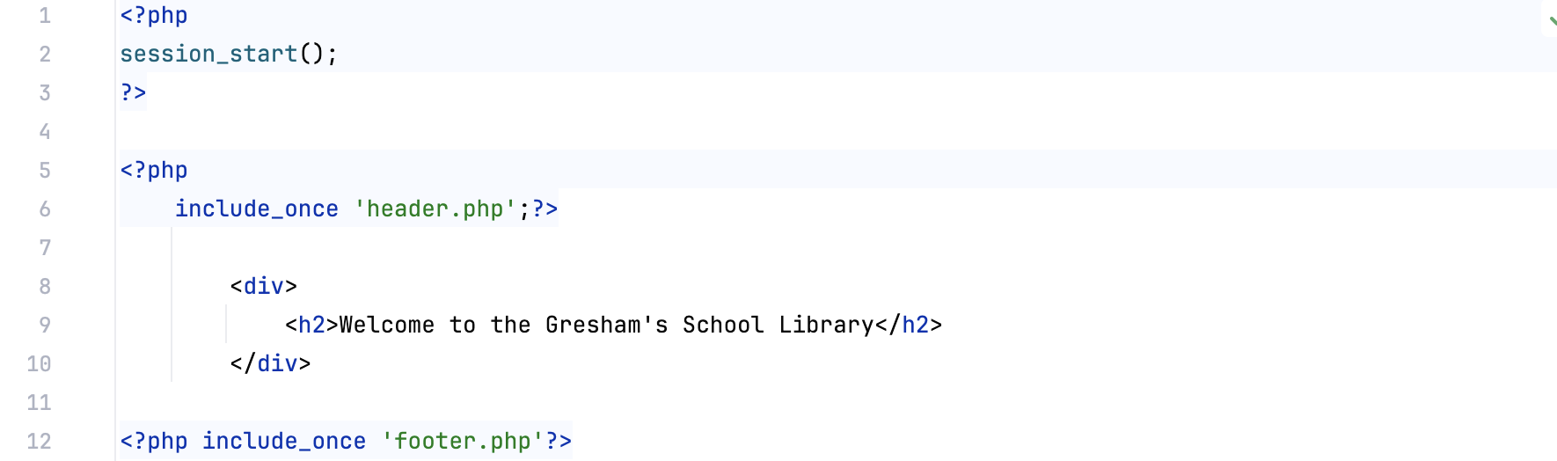

### login.php

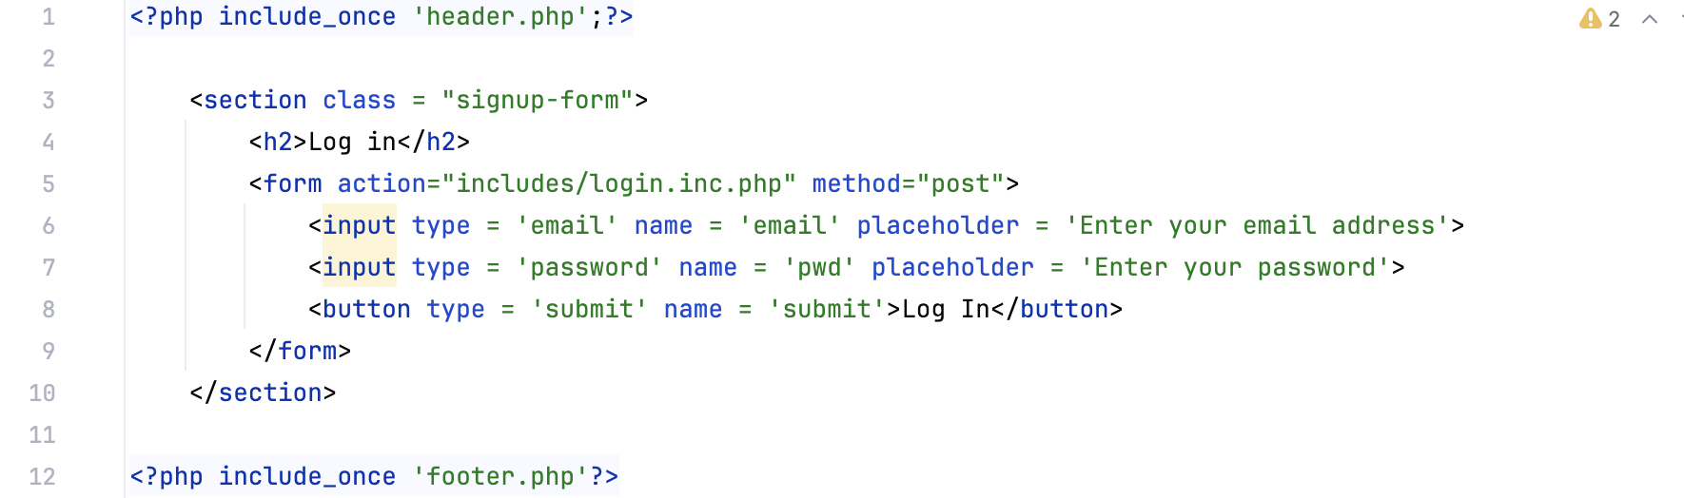

### profile.php

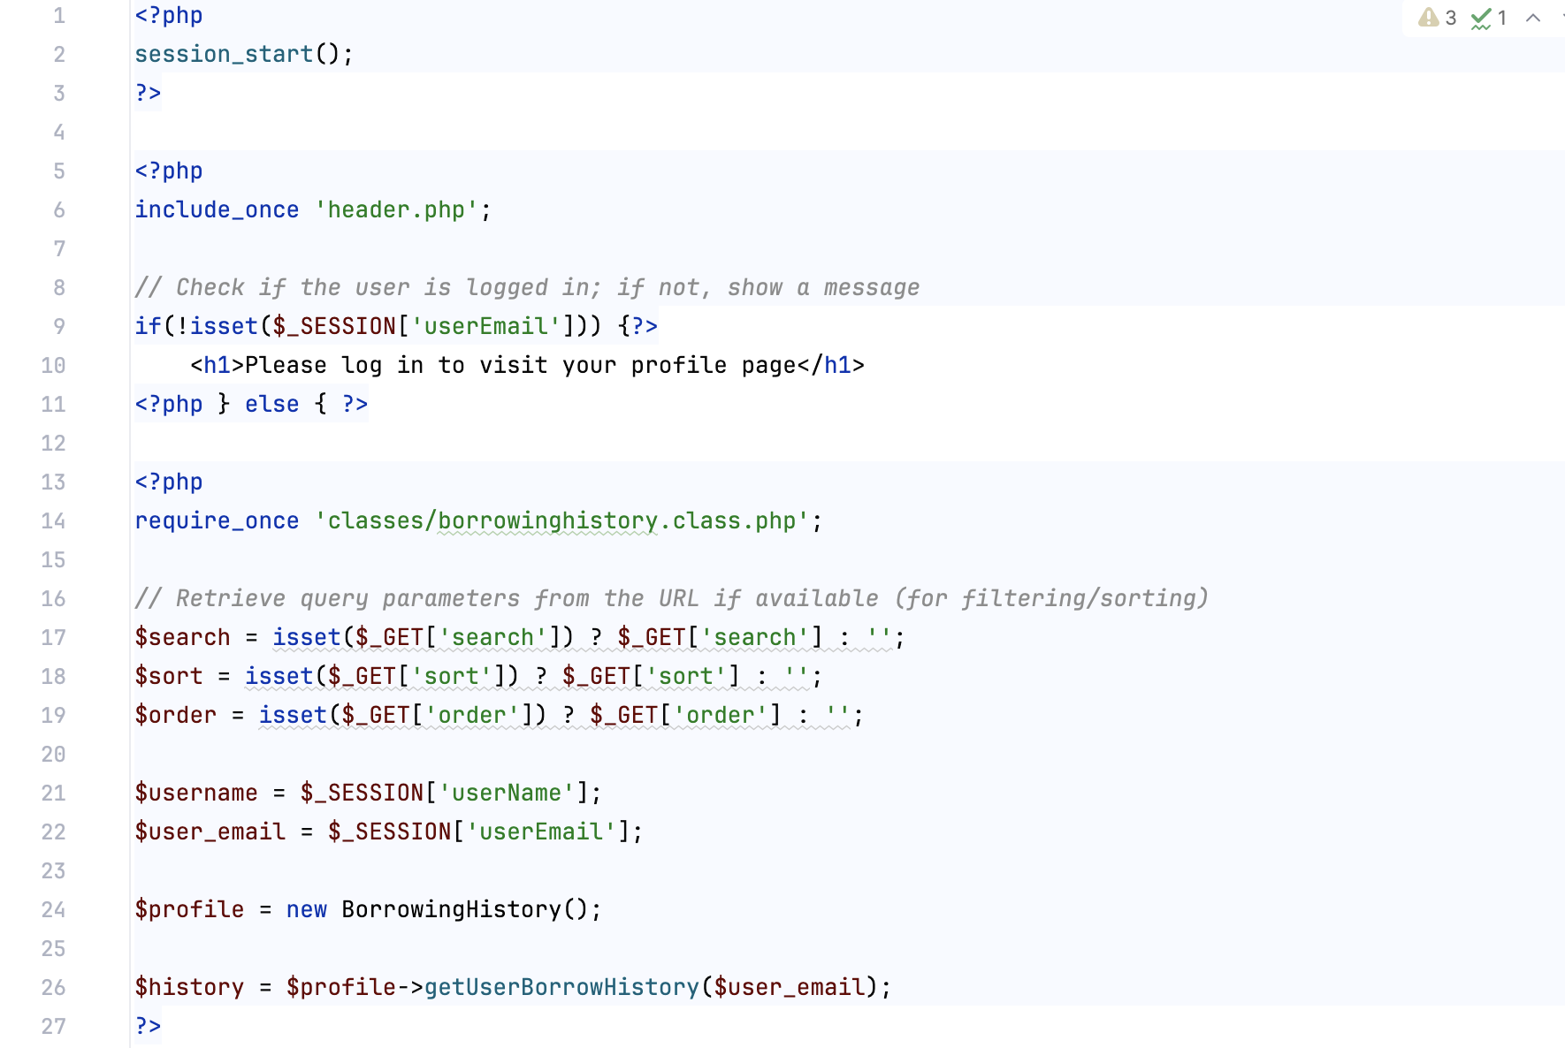 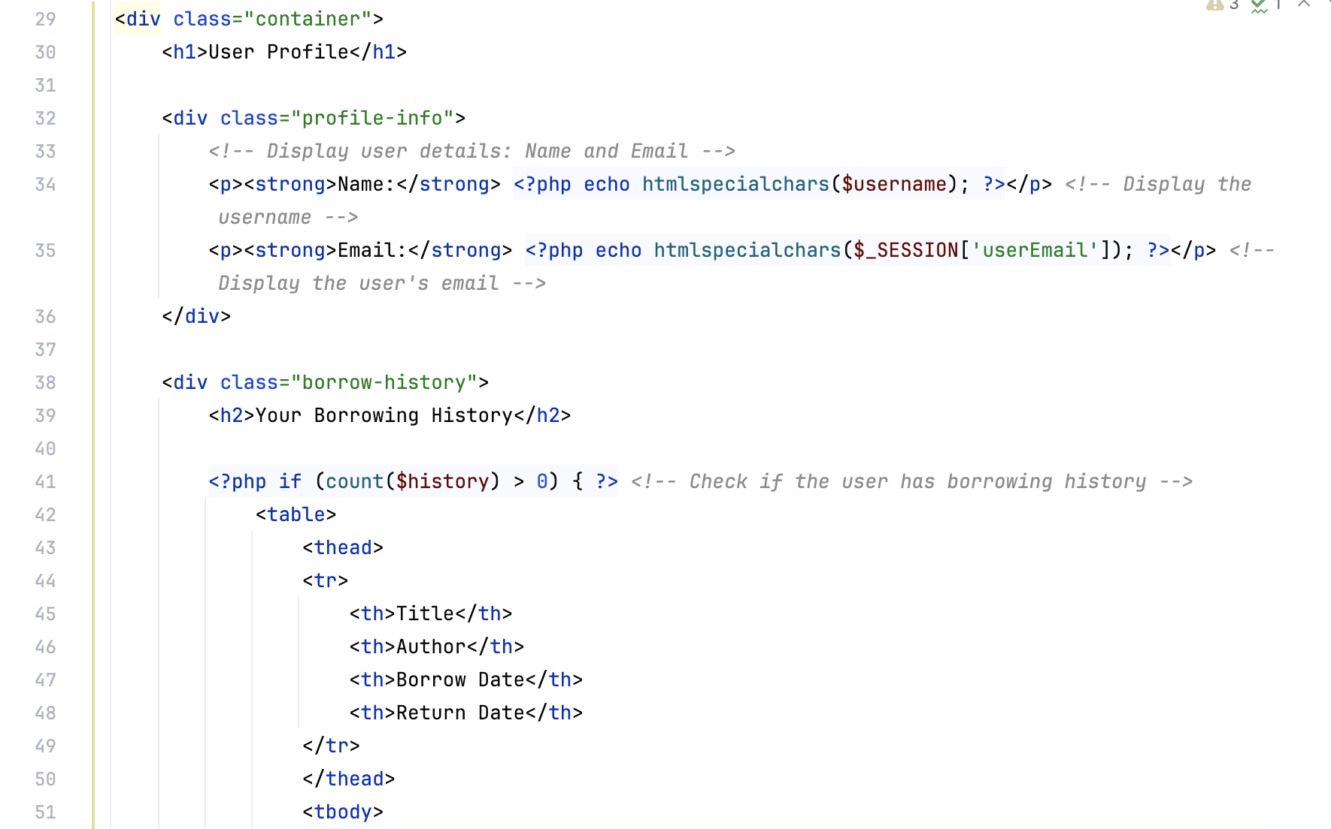 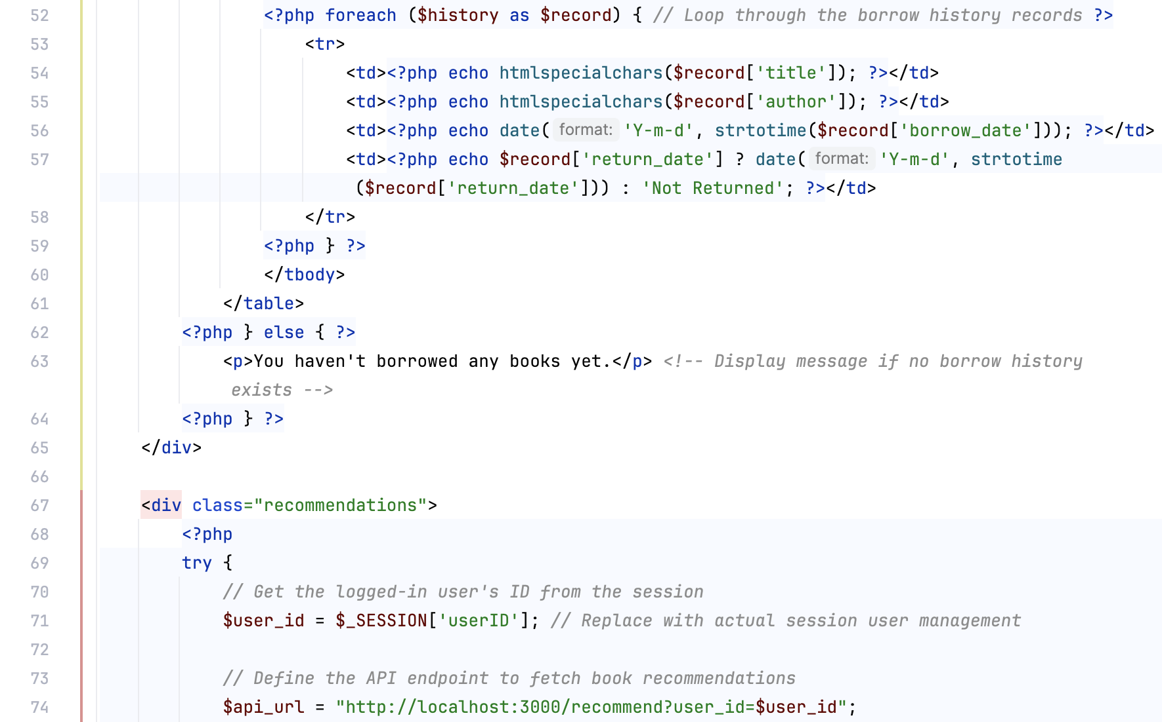 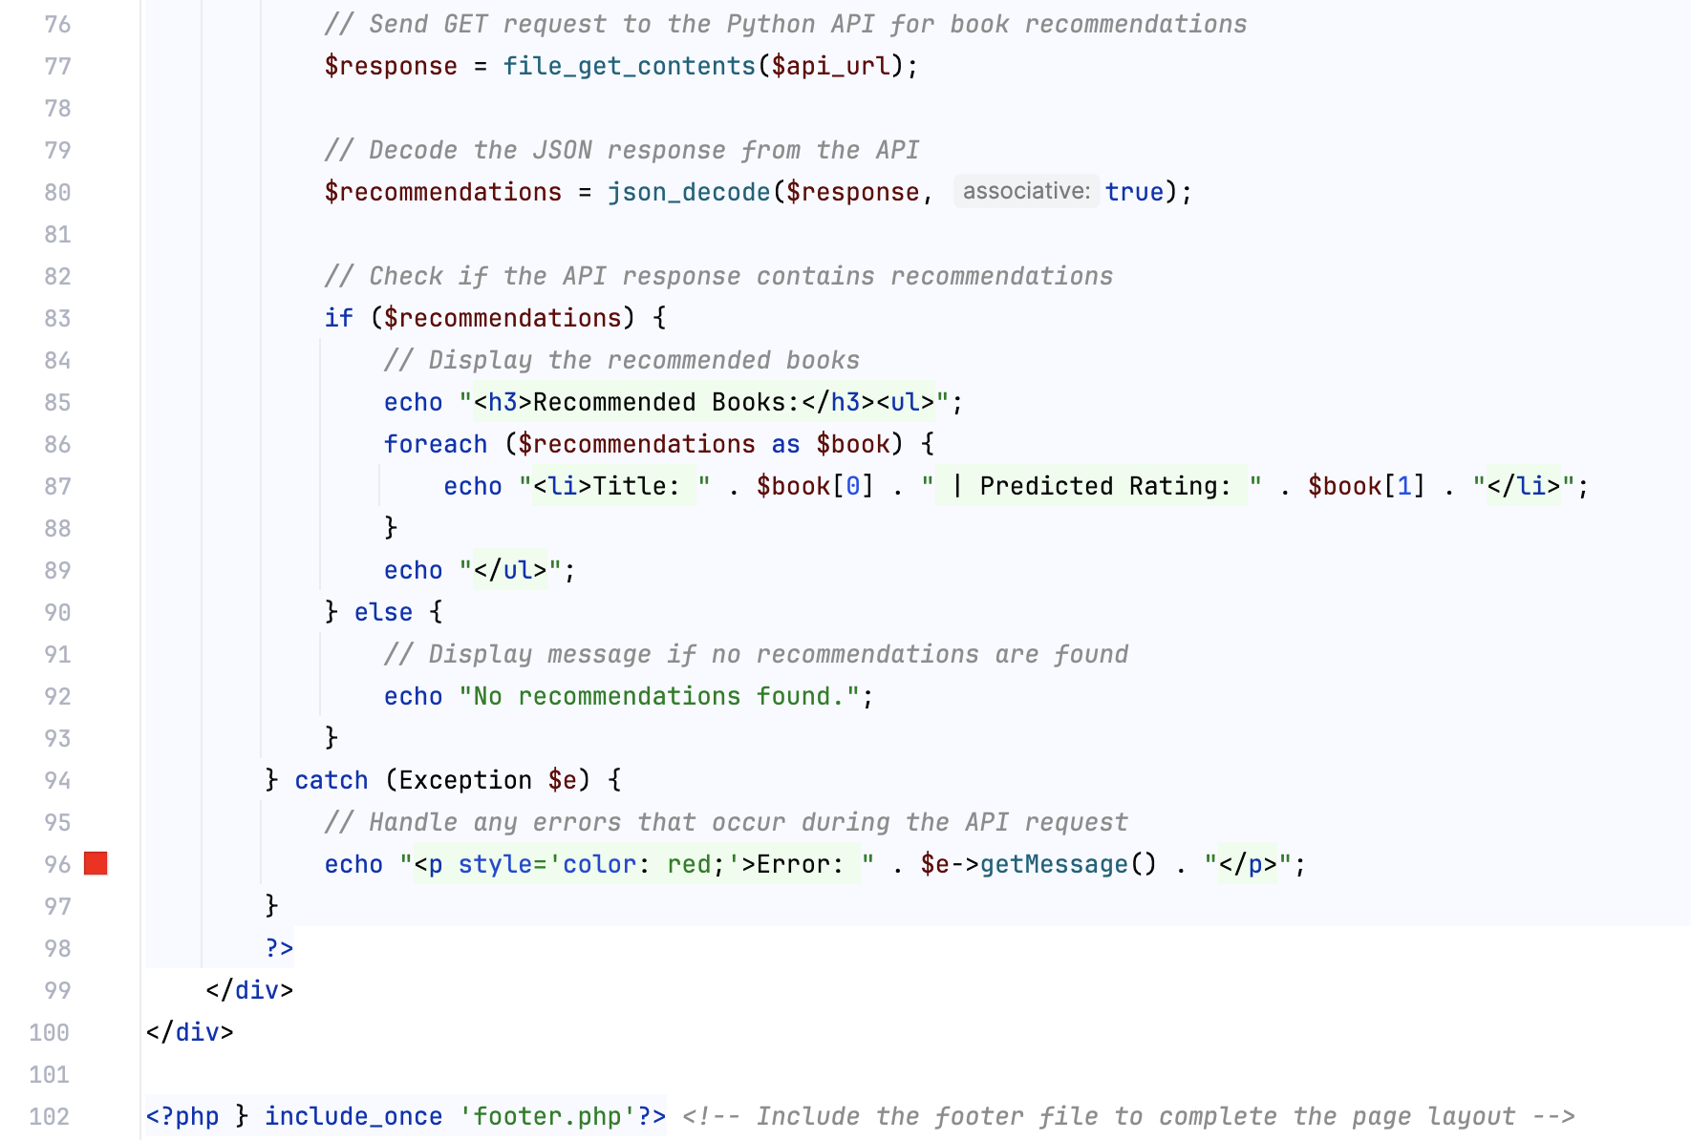

### returnbooks.php

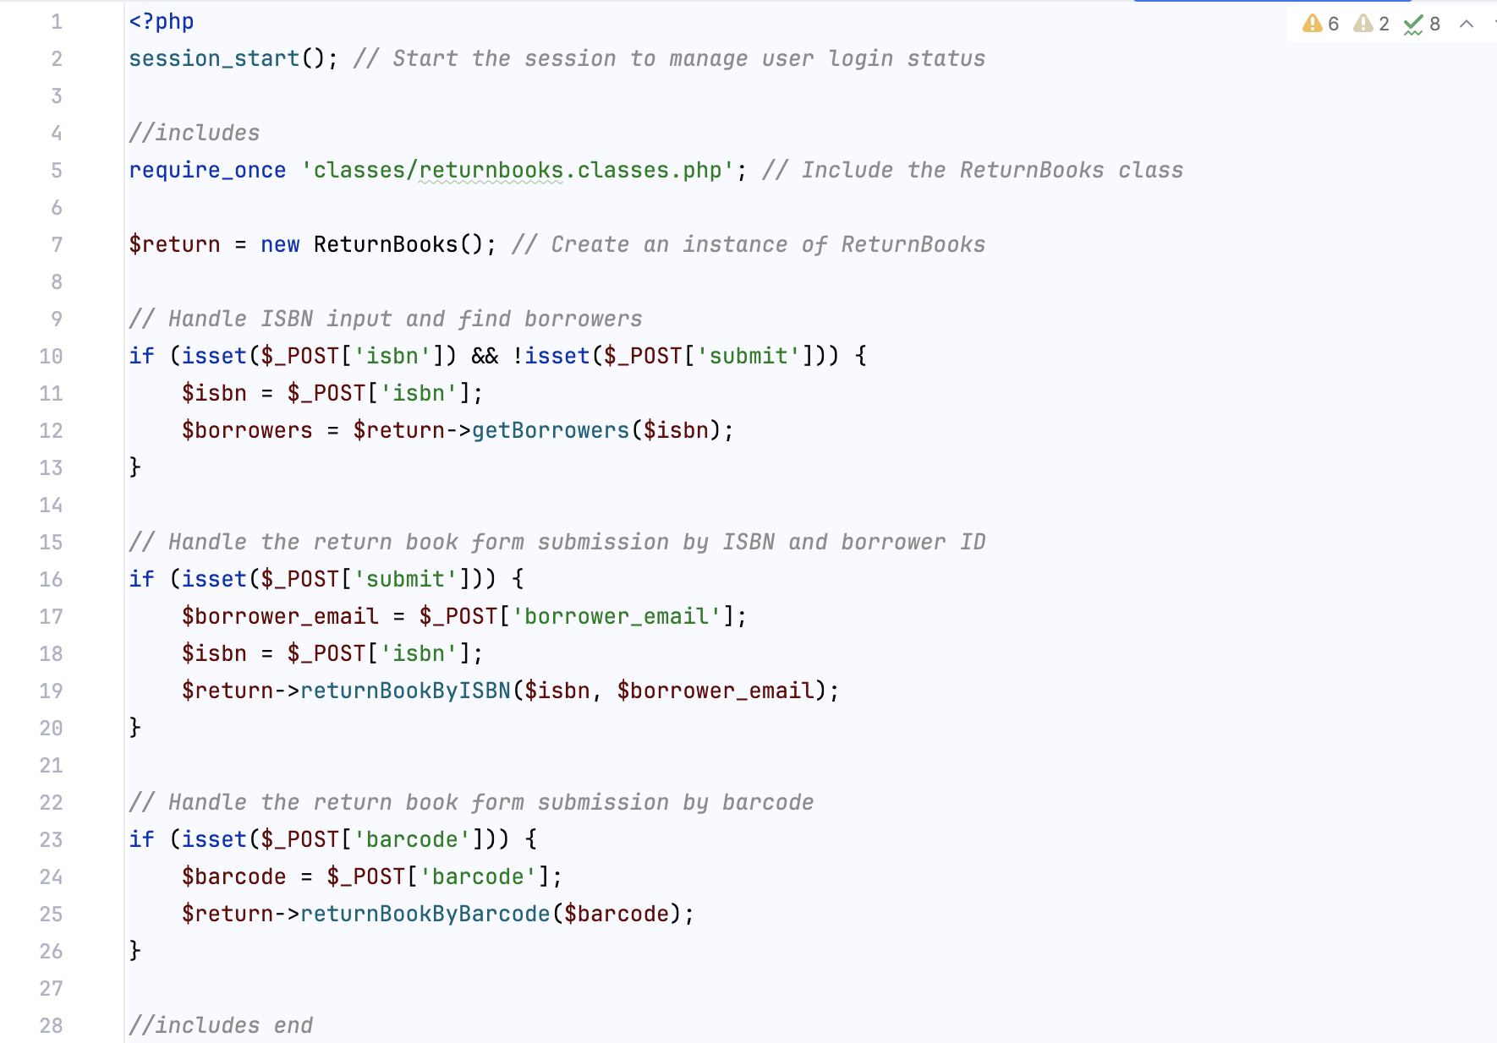 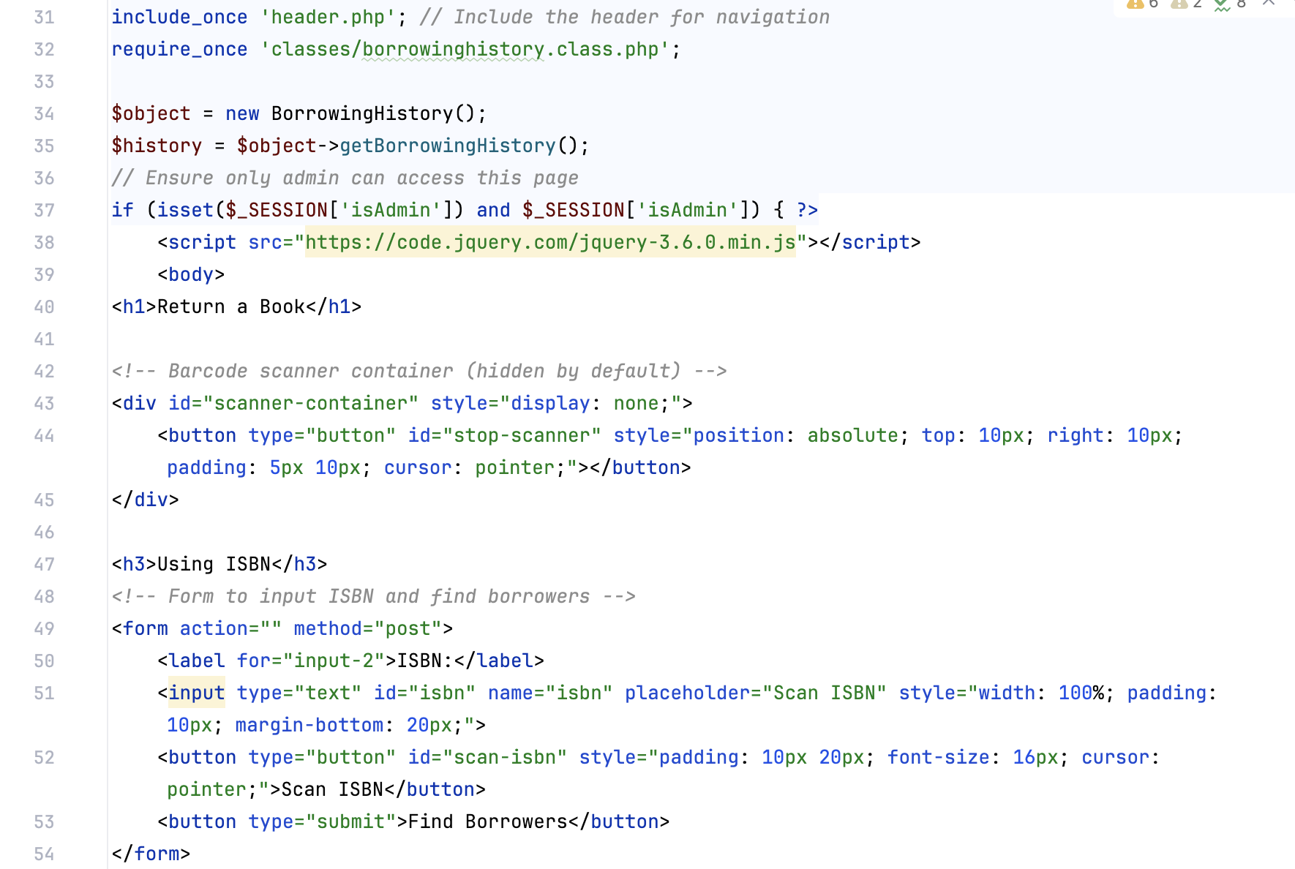 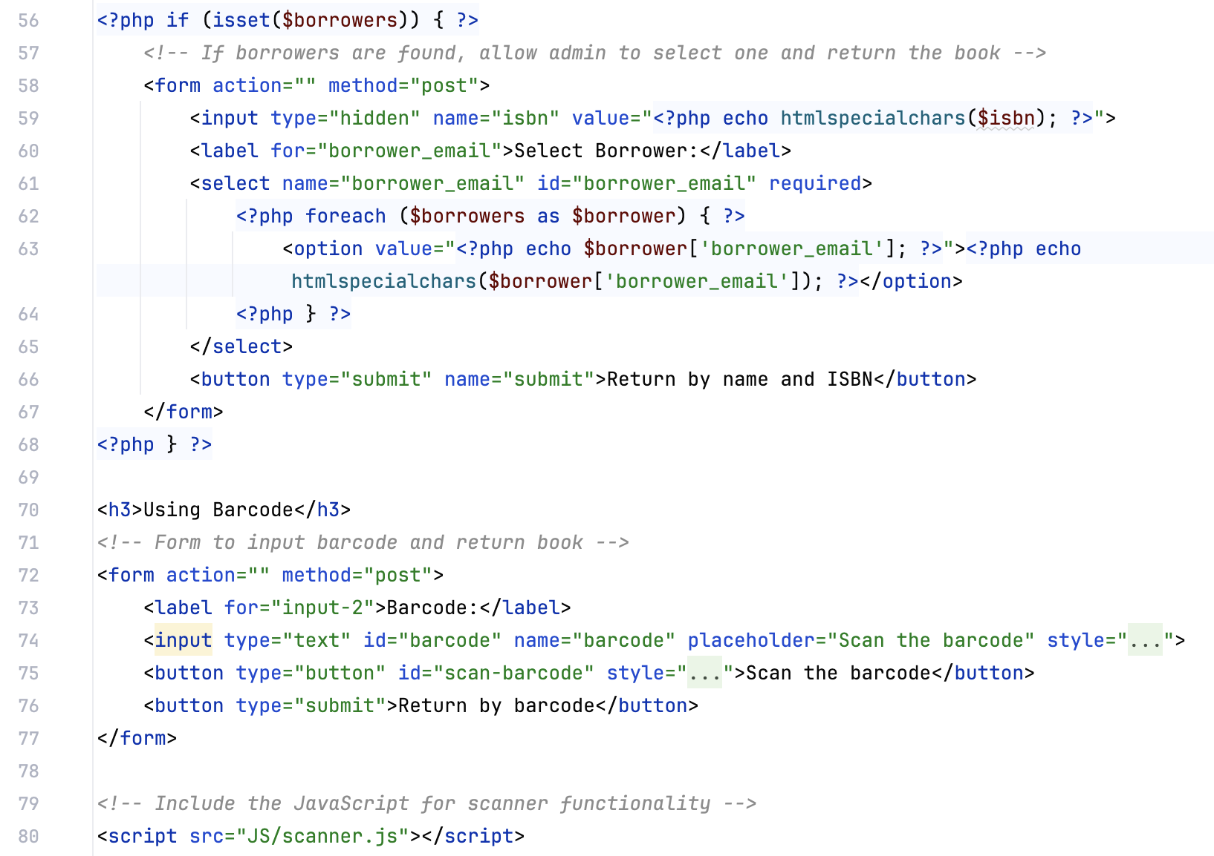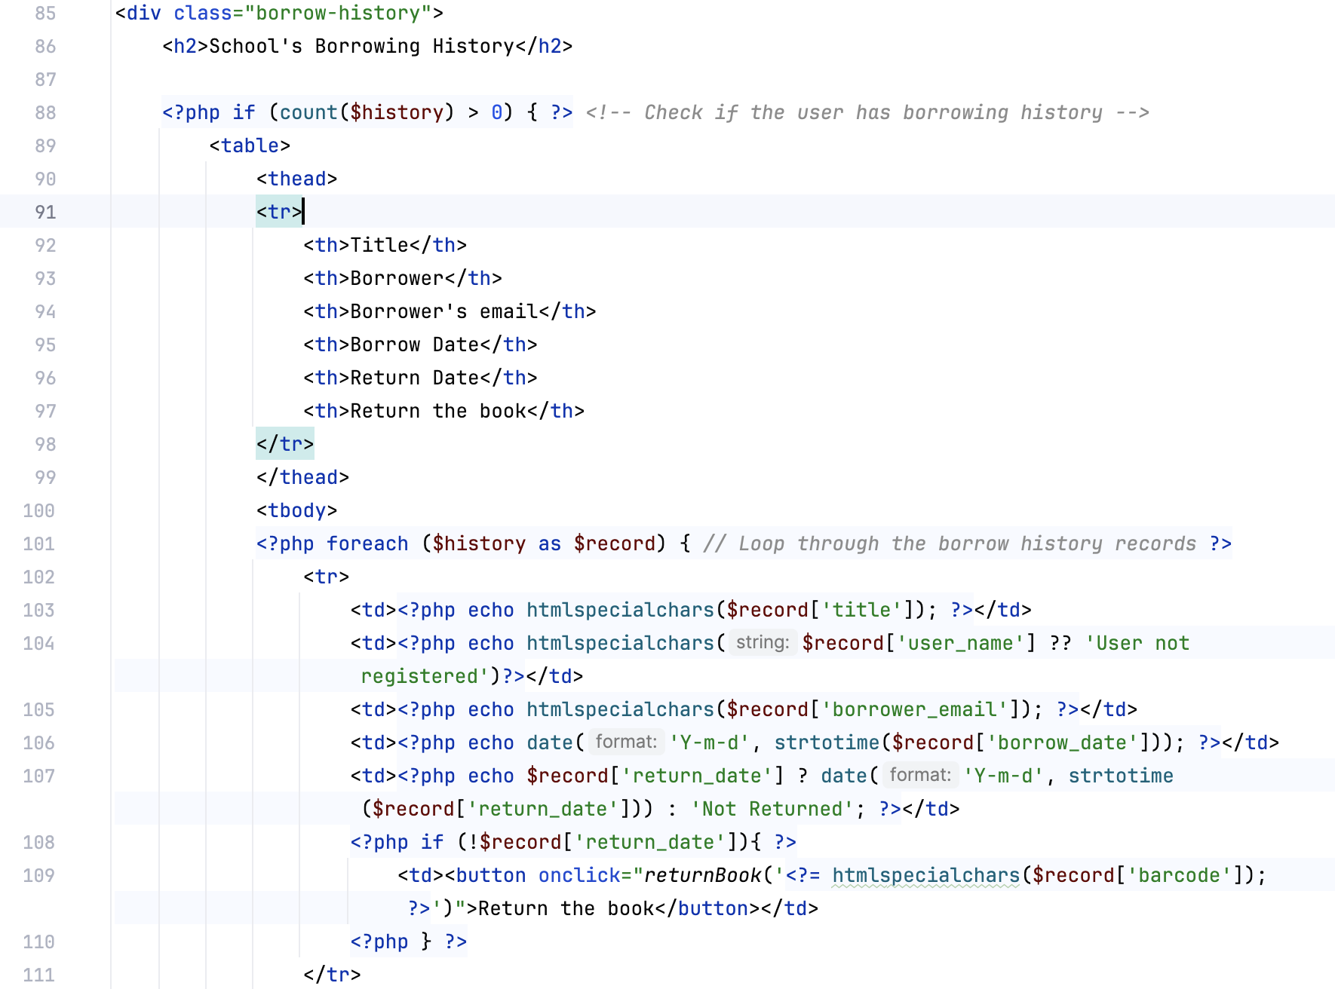 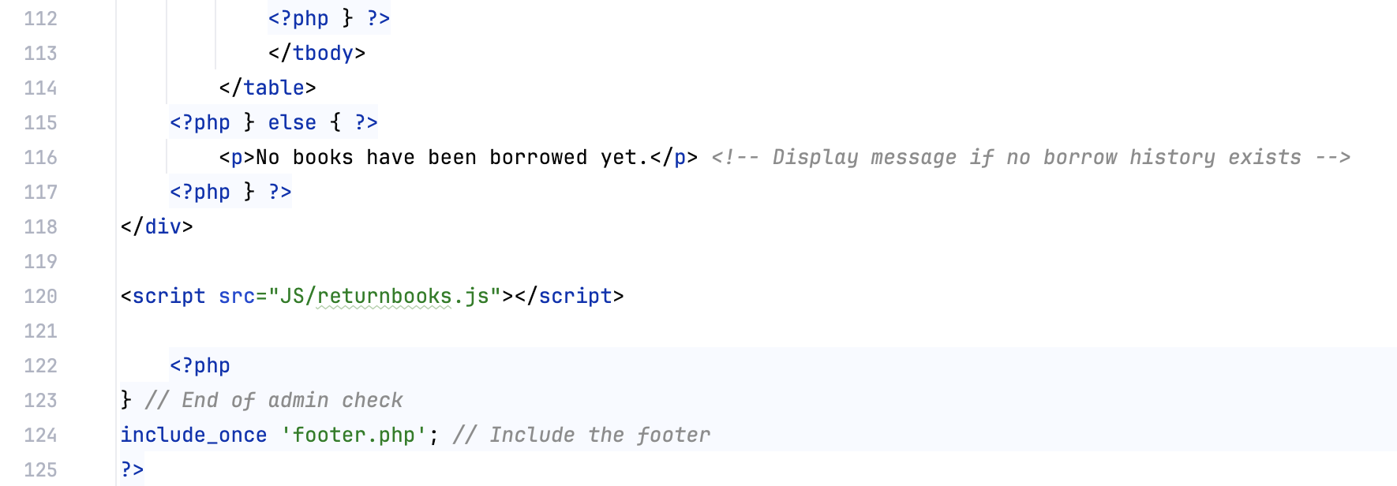

### signup.php

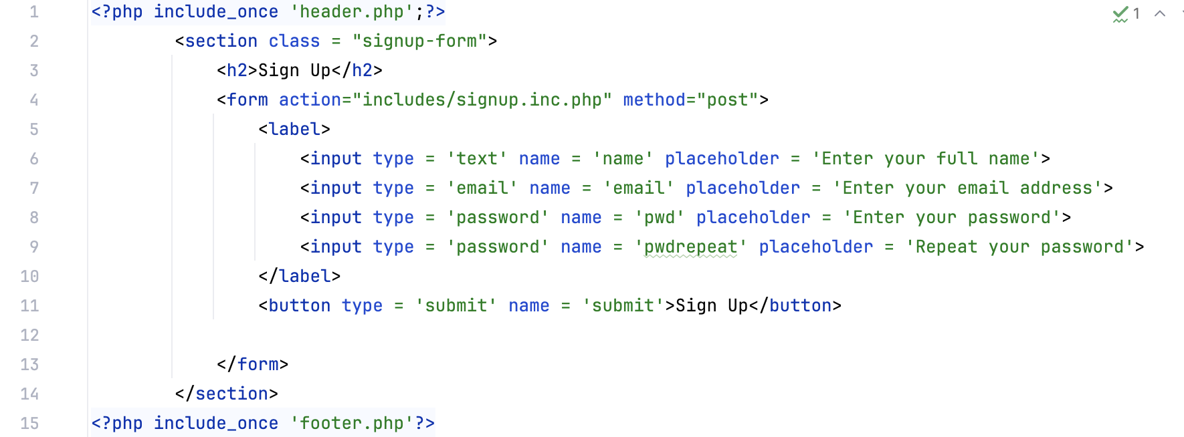

## Includes

### addbooks.inc.php

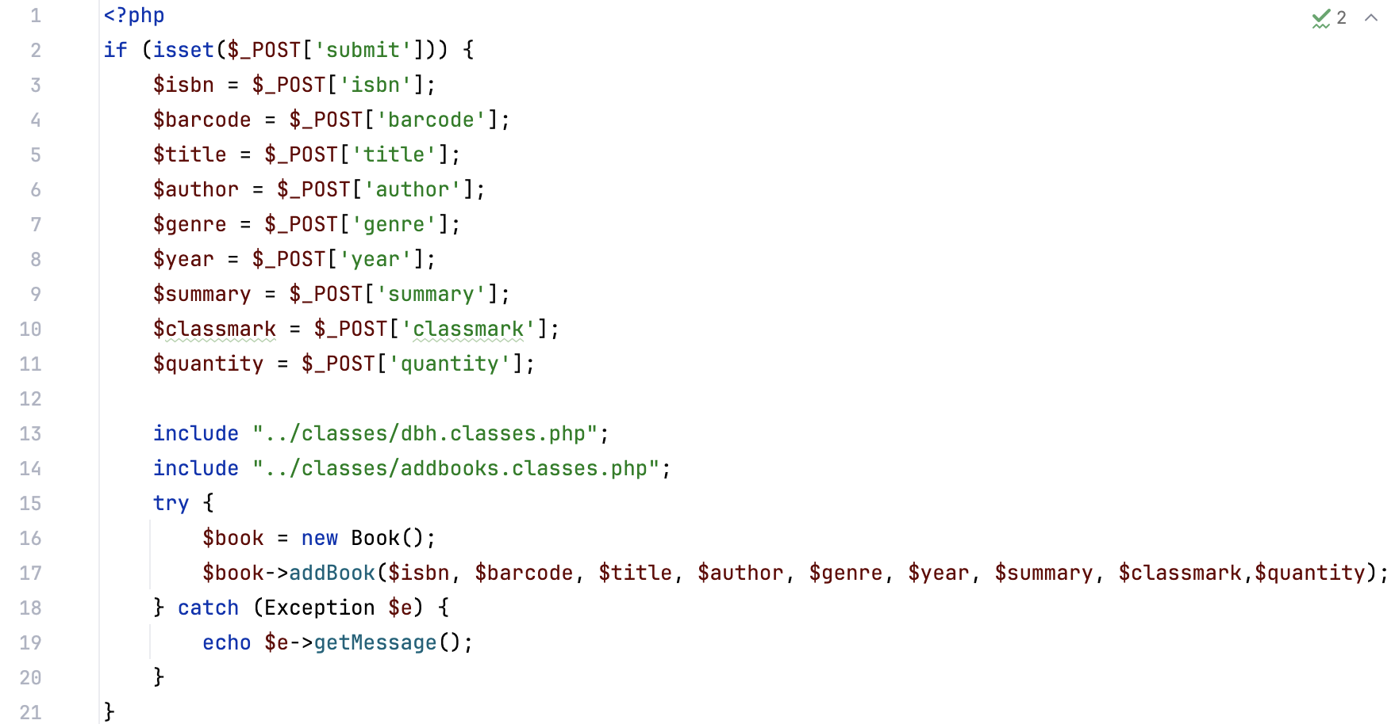

### borrowbooks.inc.php

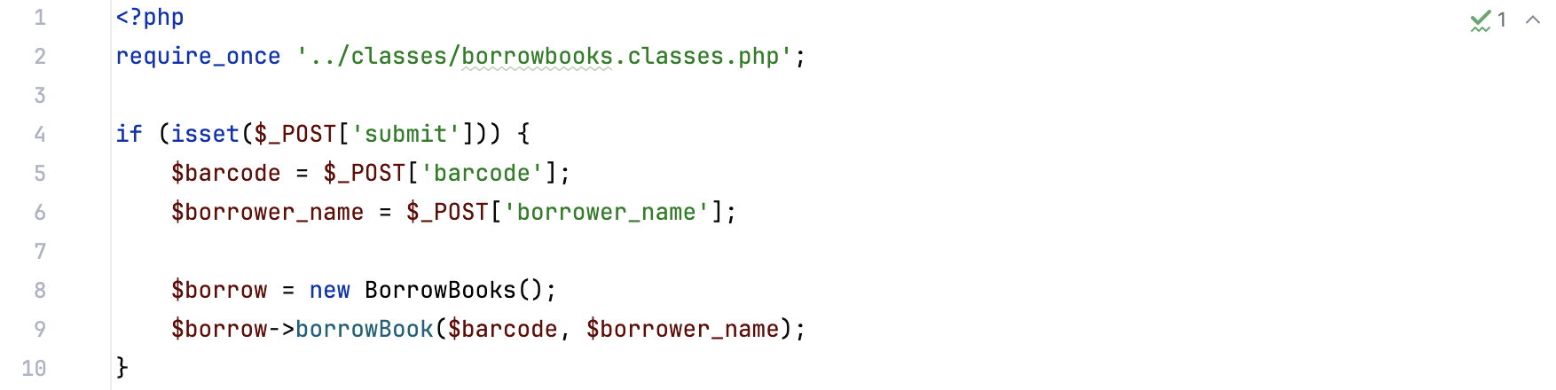 editbooks.inc.php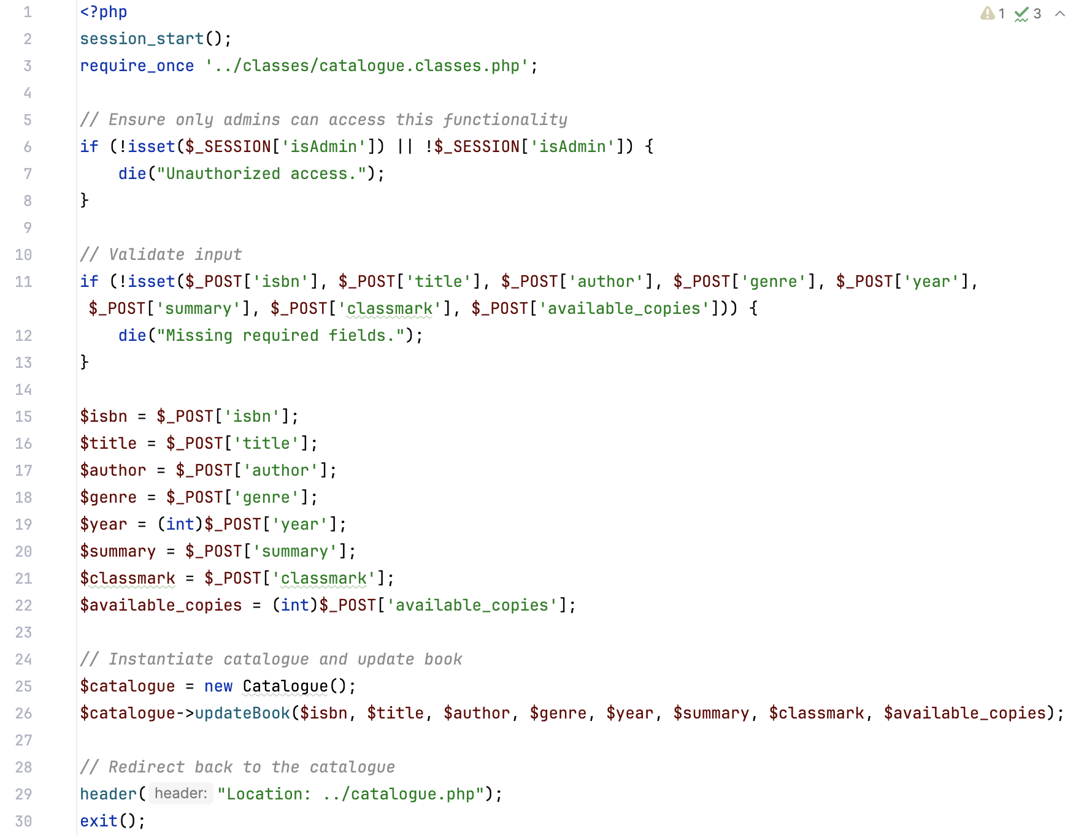

### login.inc.php

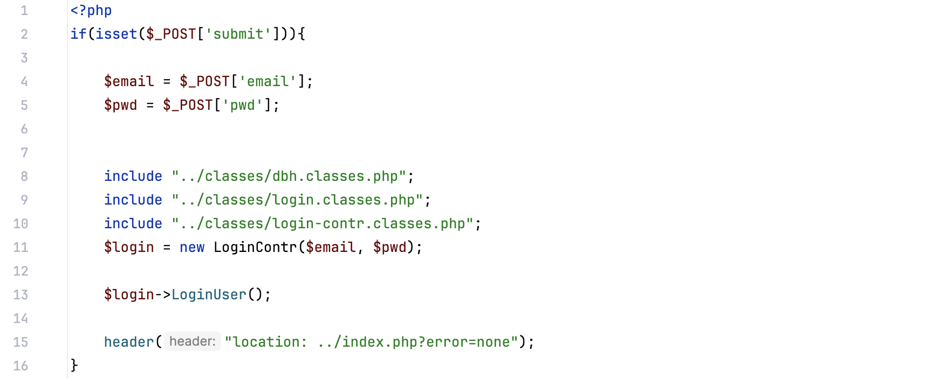

### logout.inc.php

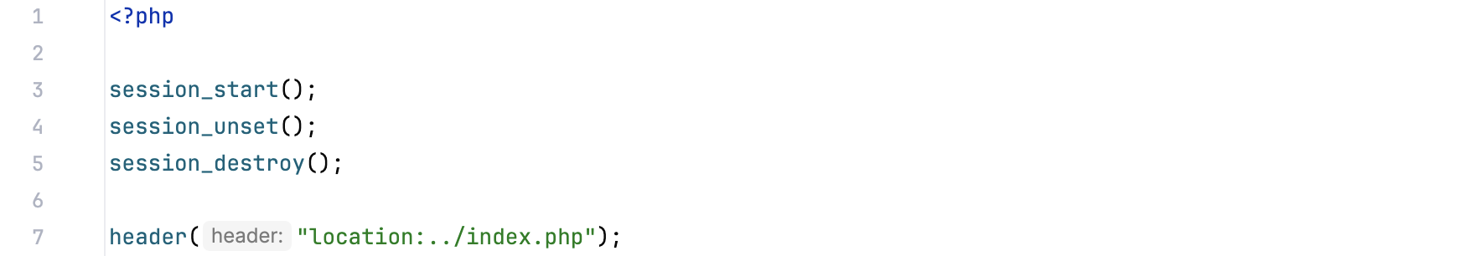

### ratebooks.inc.php

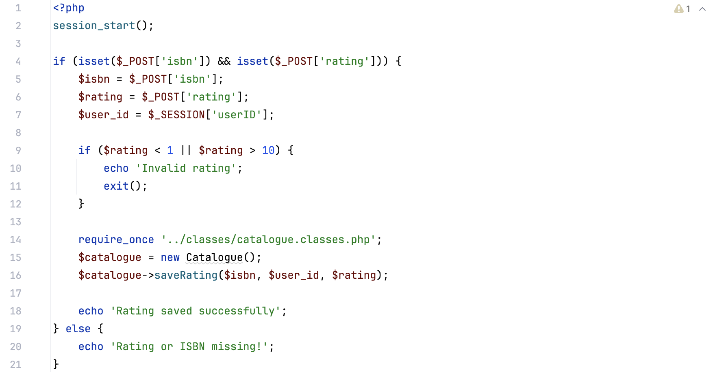

### signup.inc.php

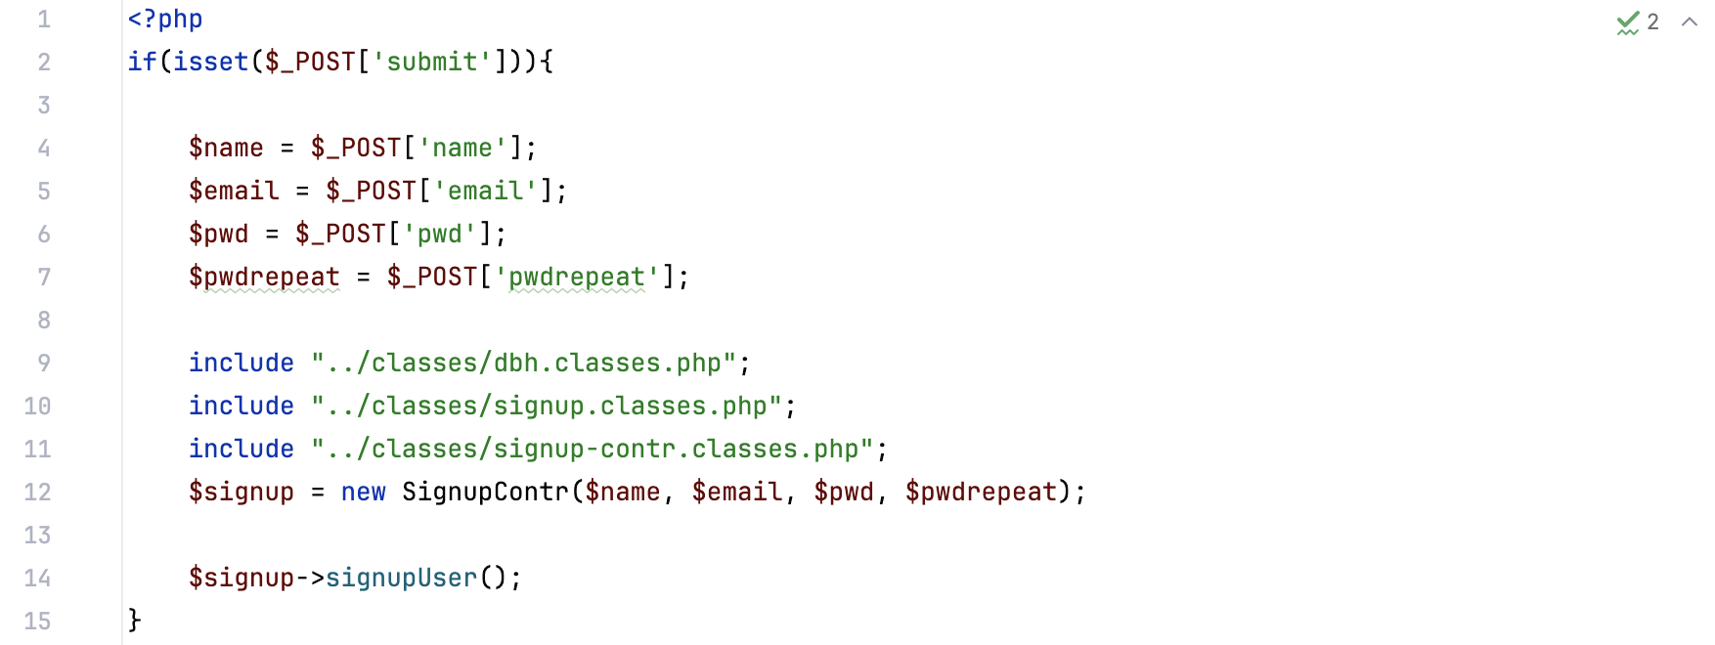

## Classes

### addbooks.classes.php

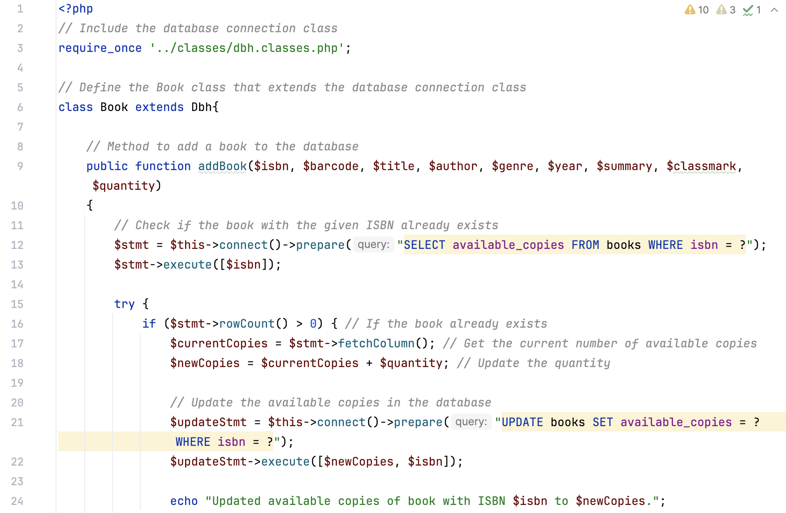

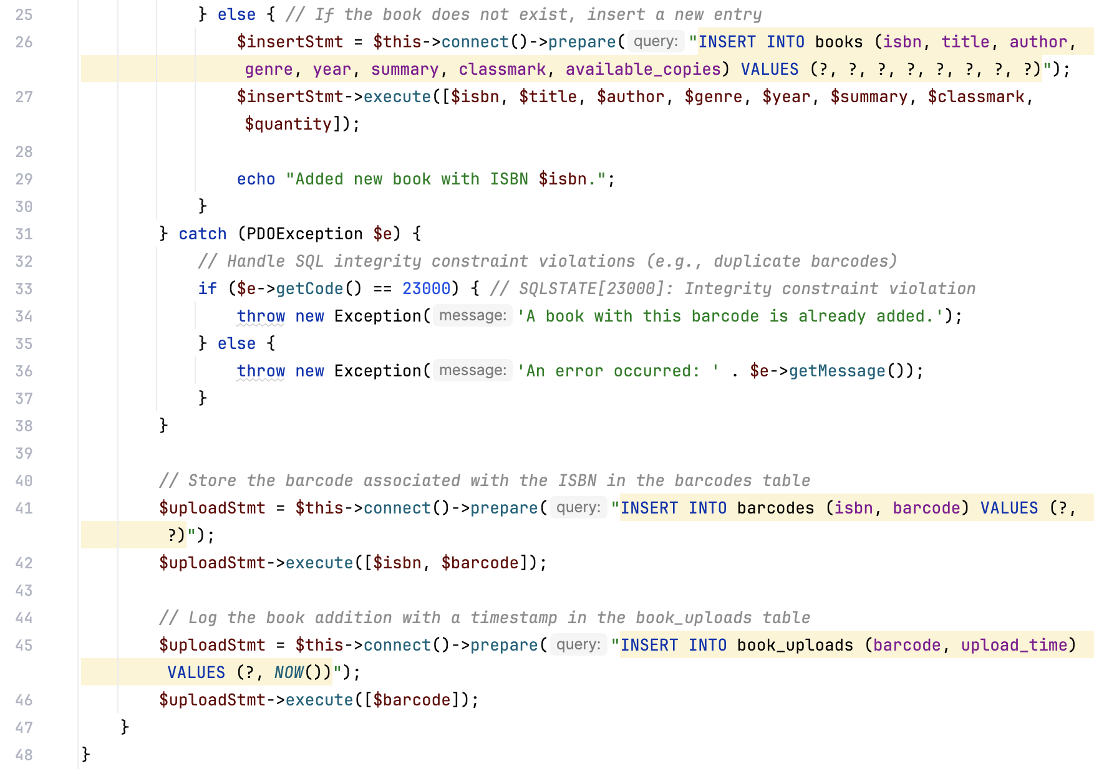

### borrowbooks.classes.php

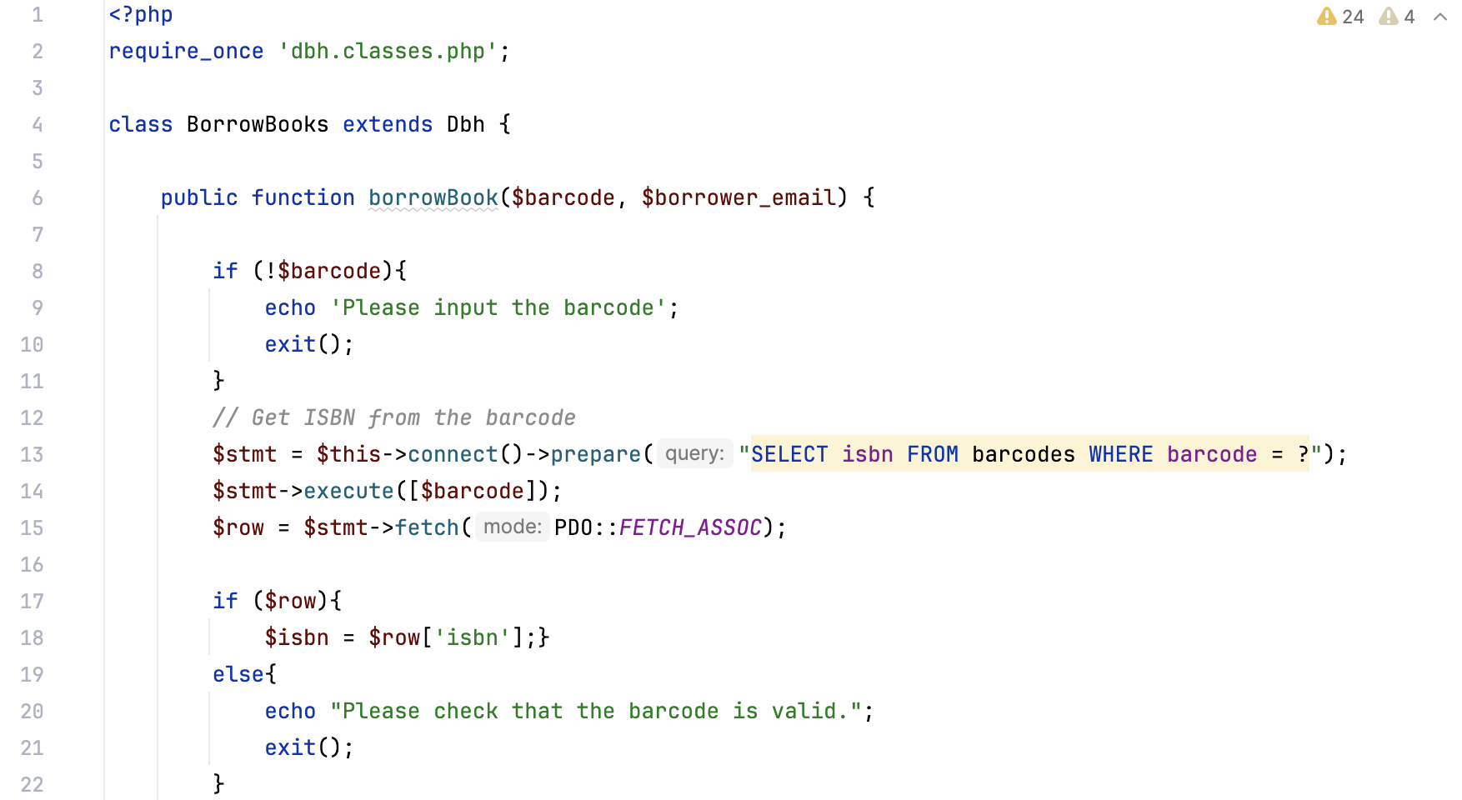 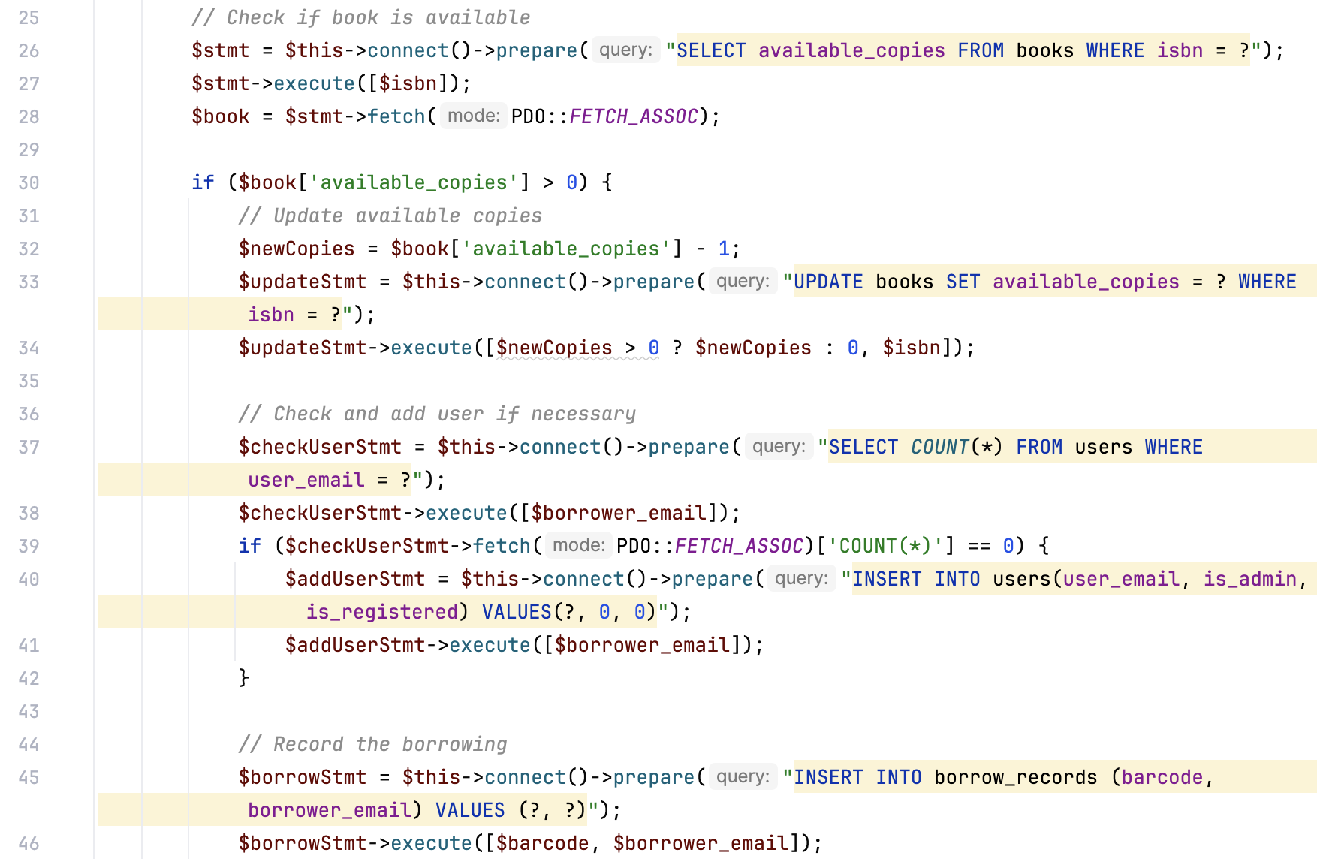 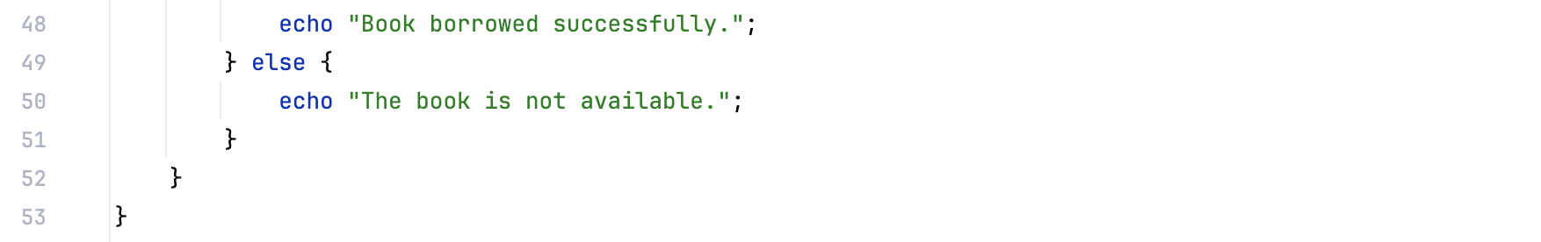

### borrowinghistory.classes.php

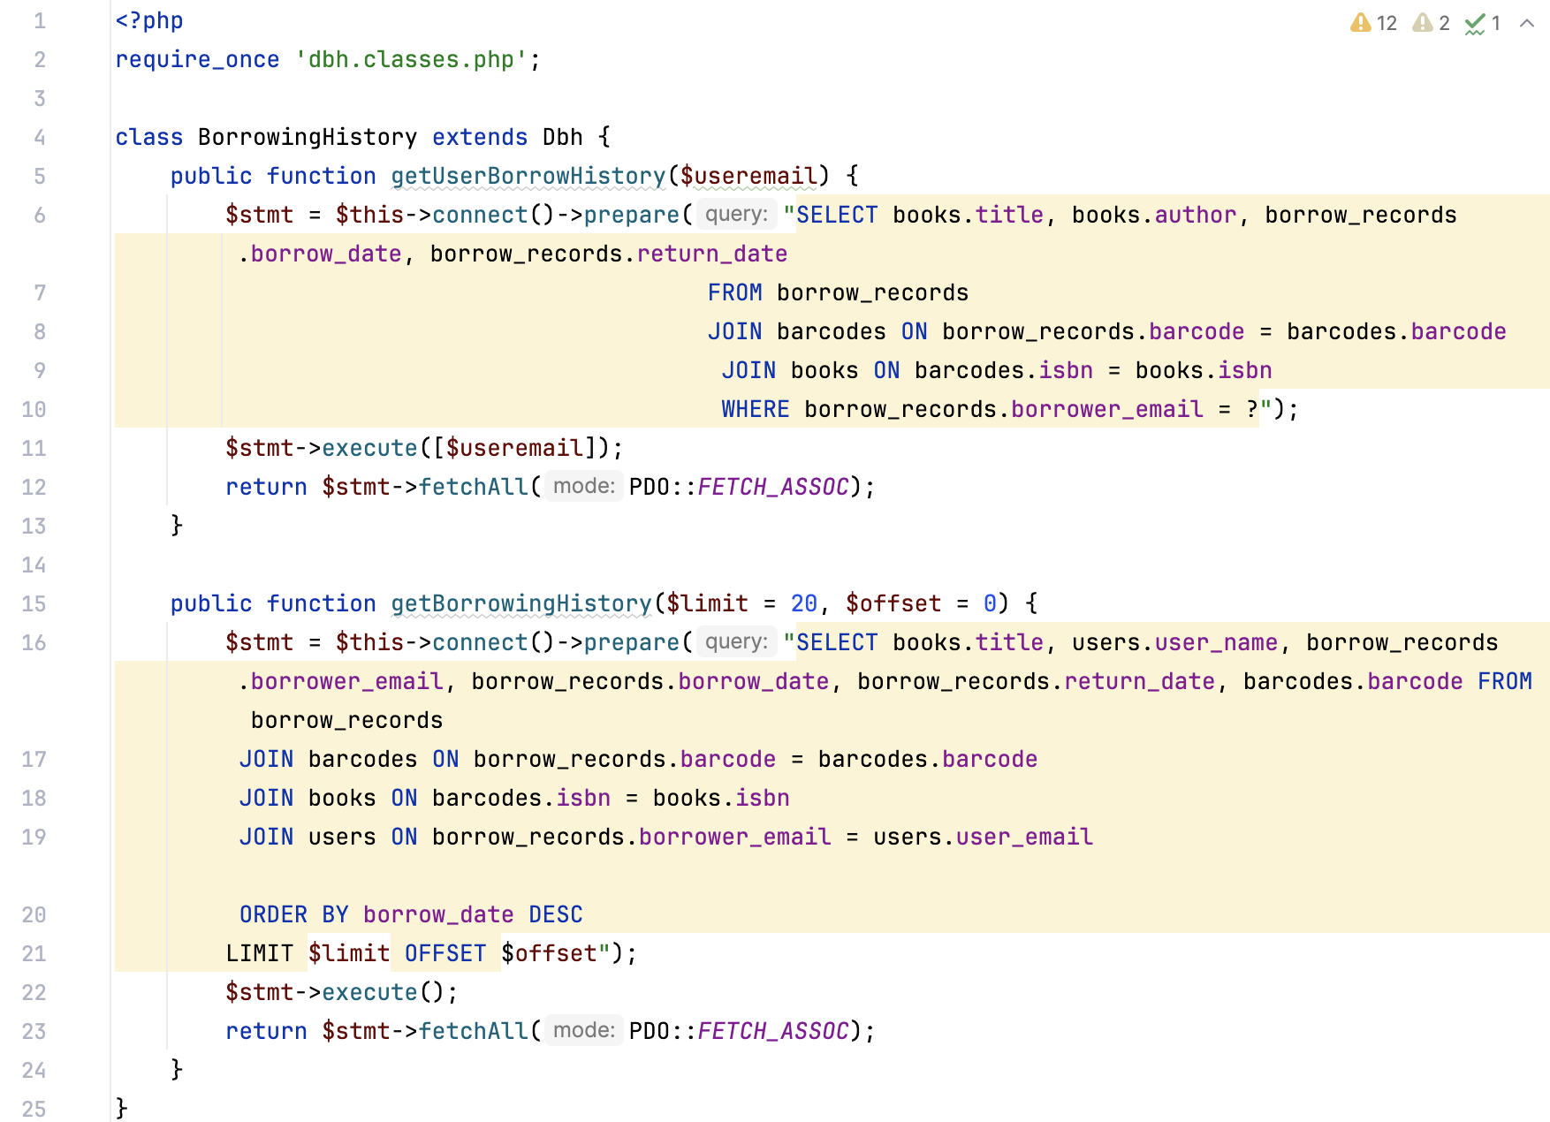

### catalogue.classes.php

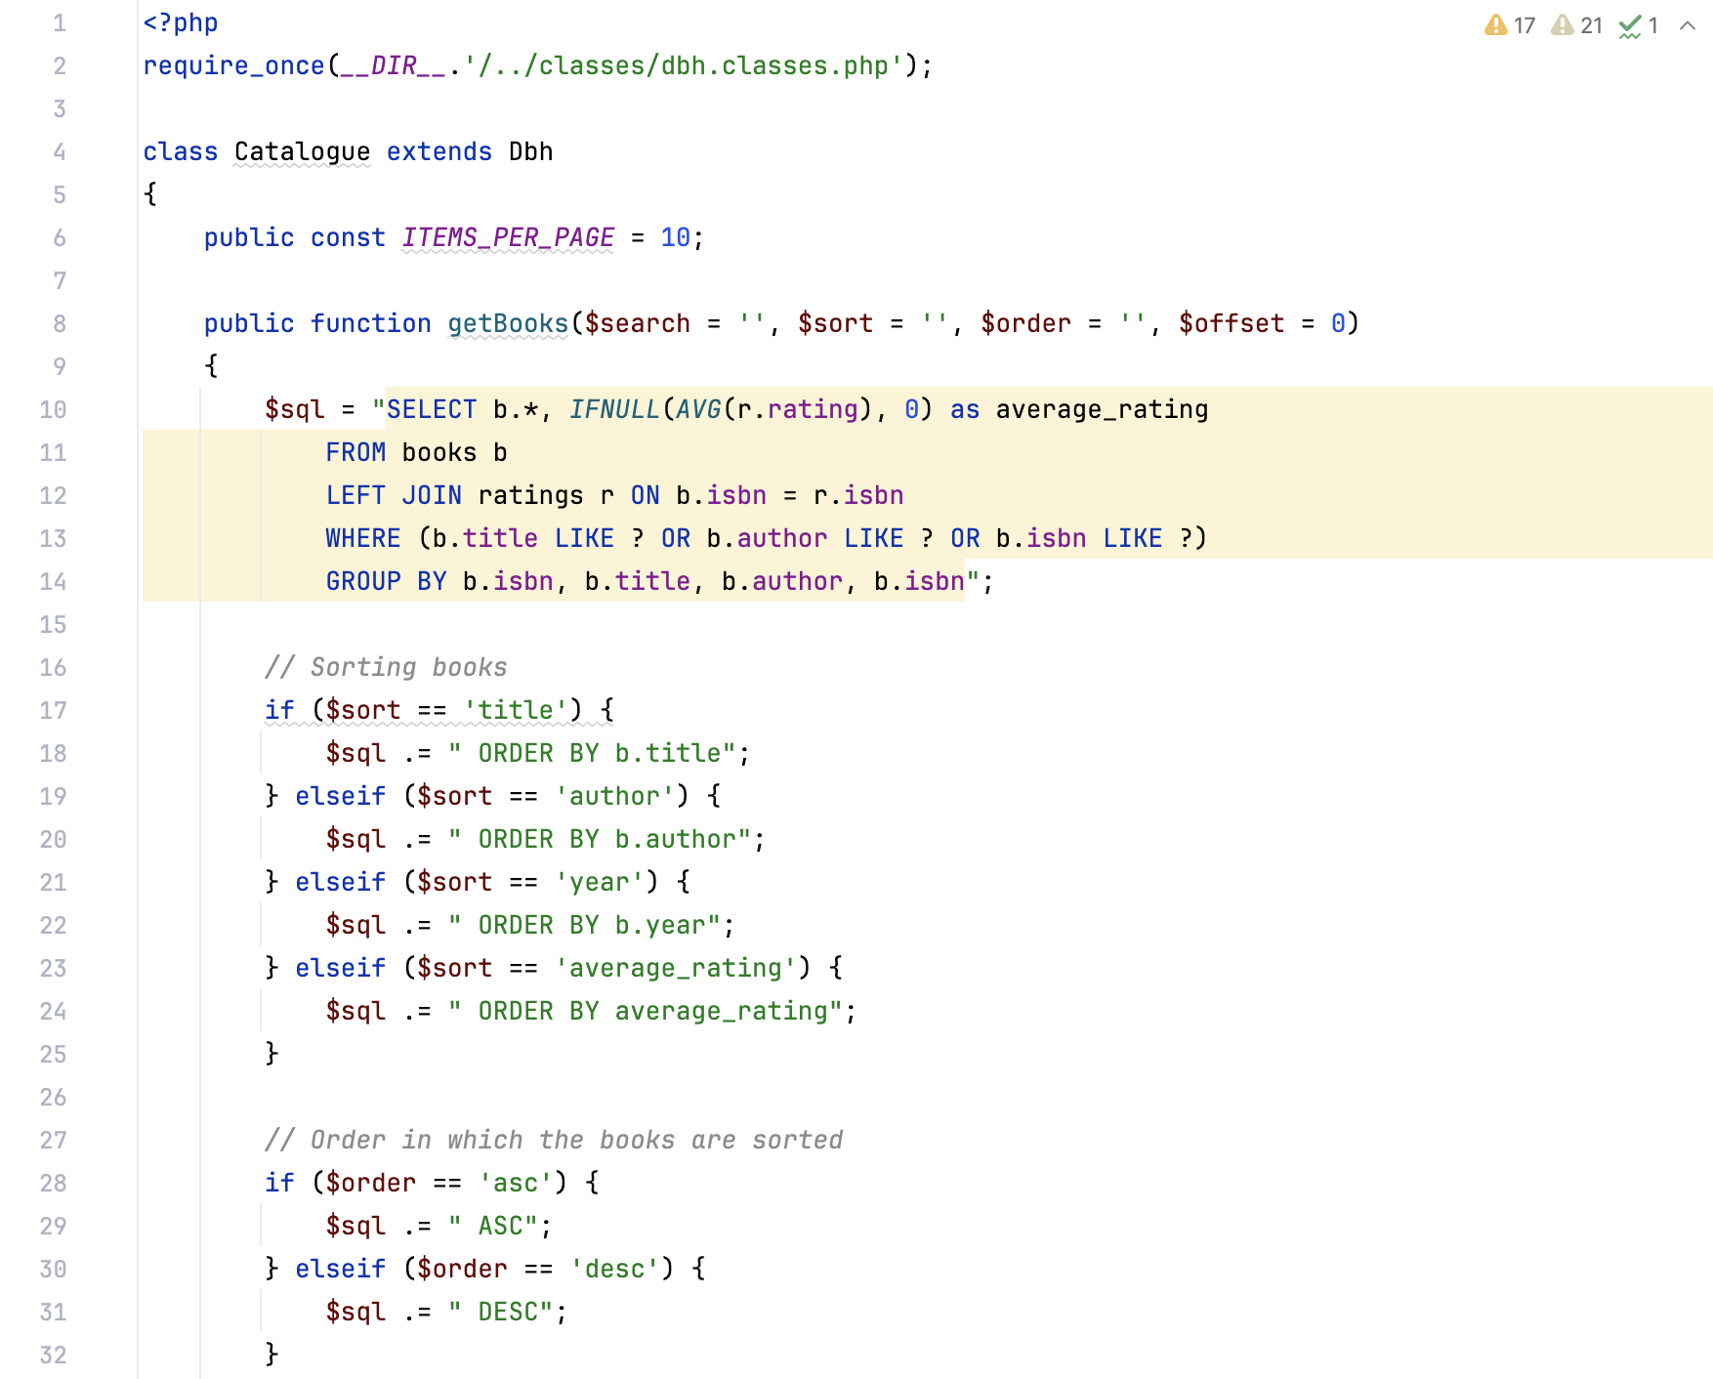 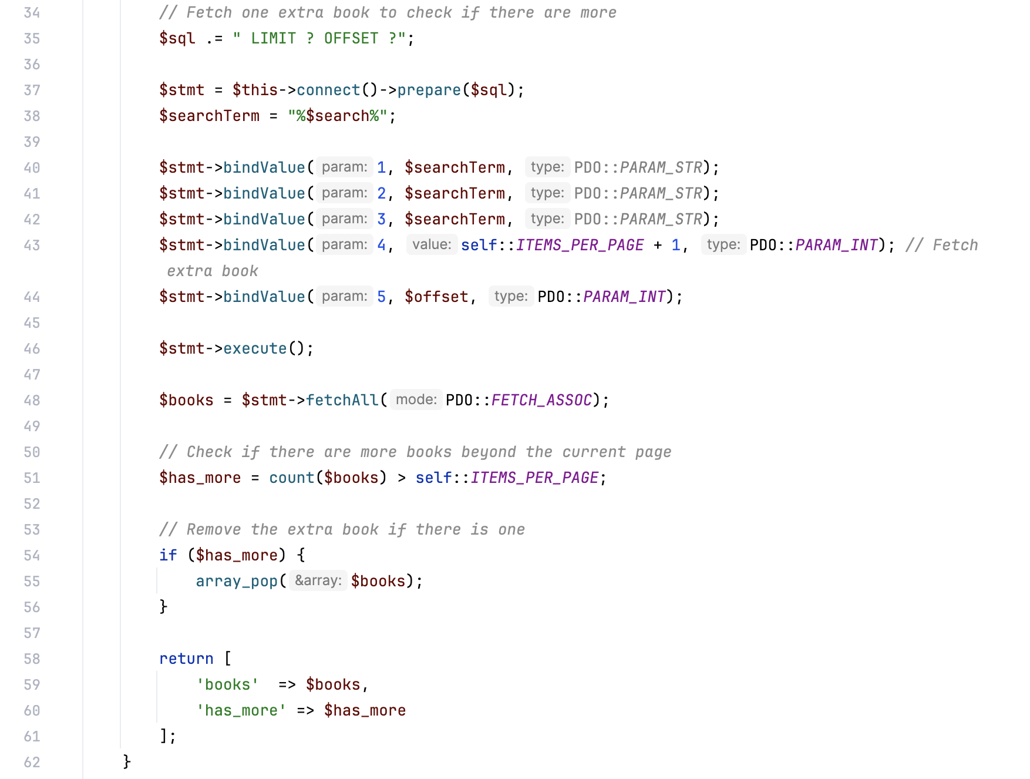 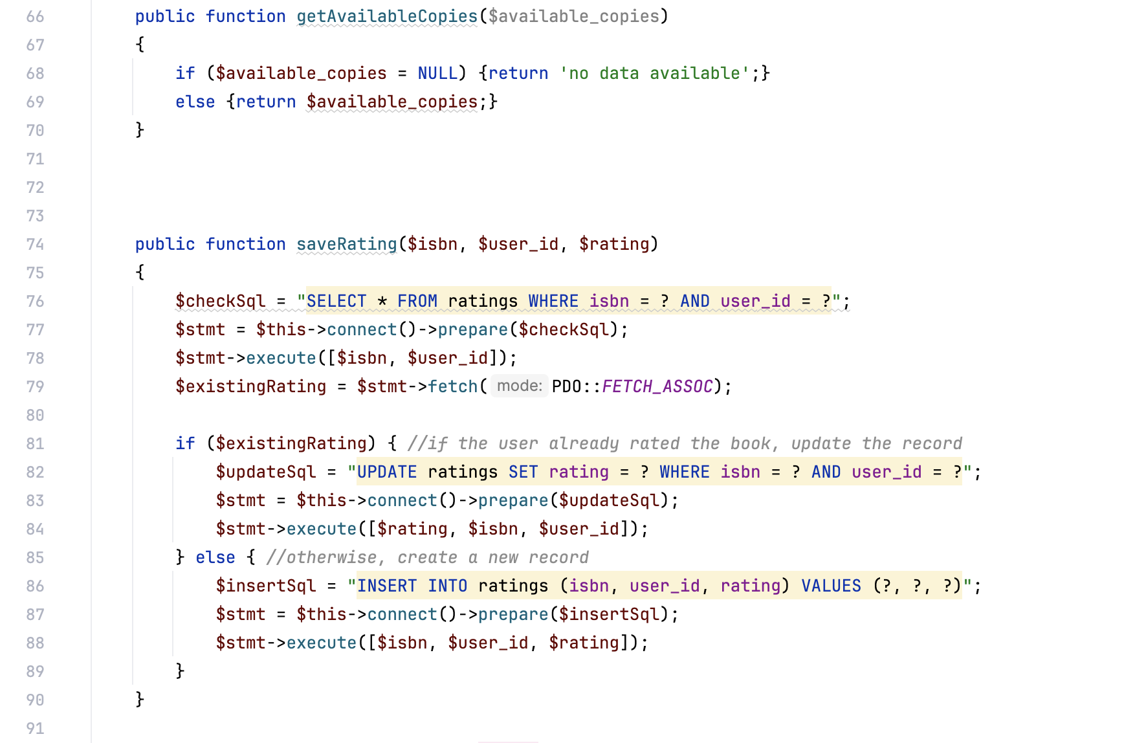 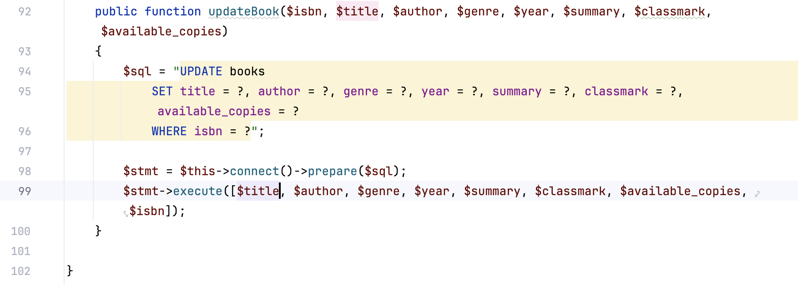

### dbh.classes.php

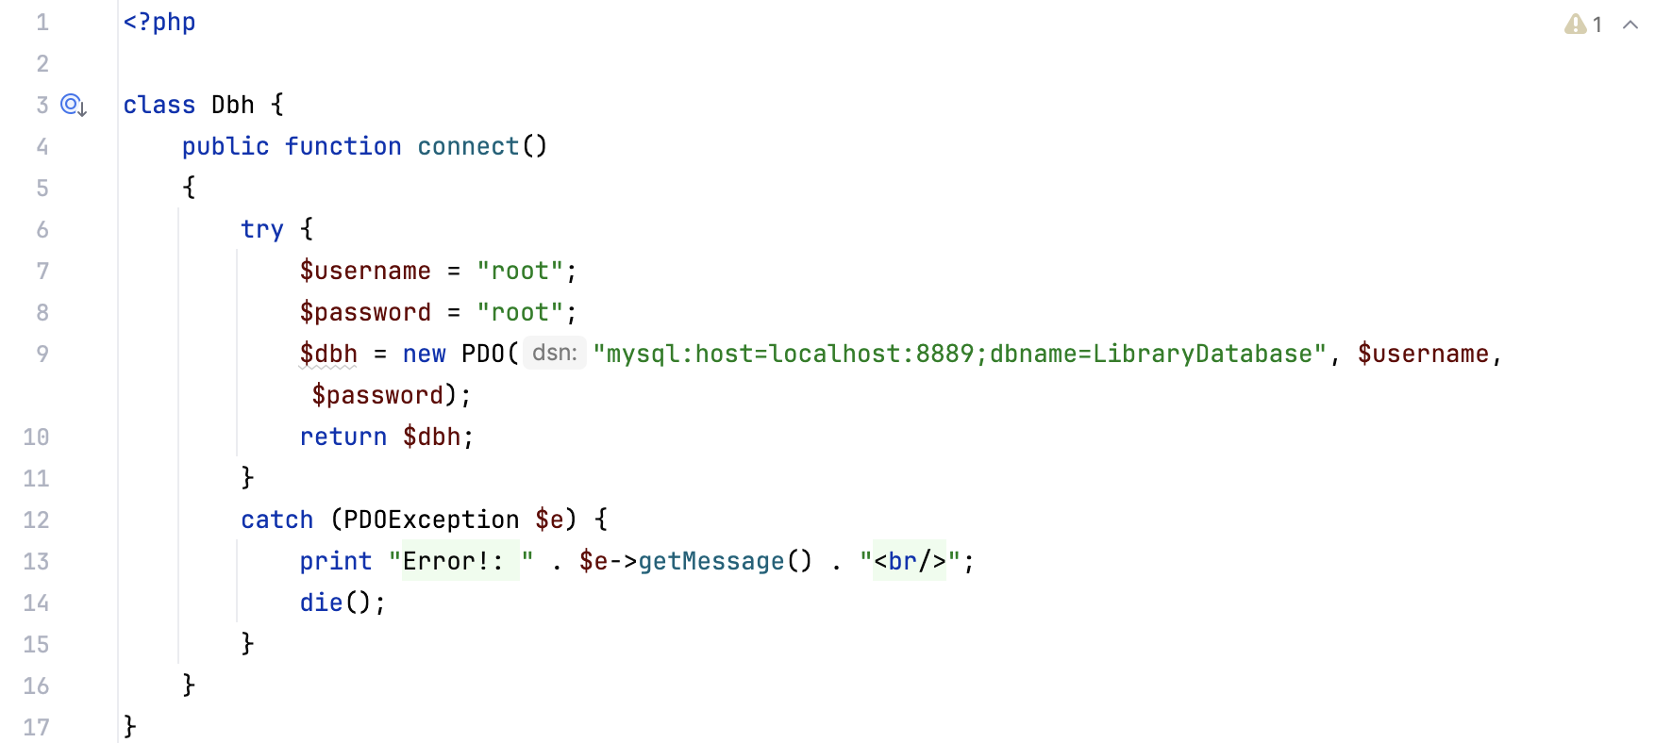

### login.classes.php

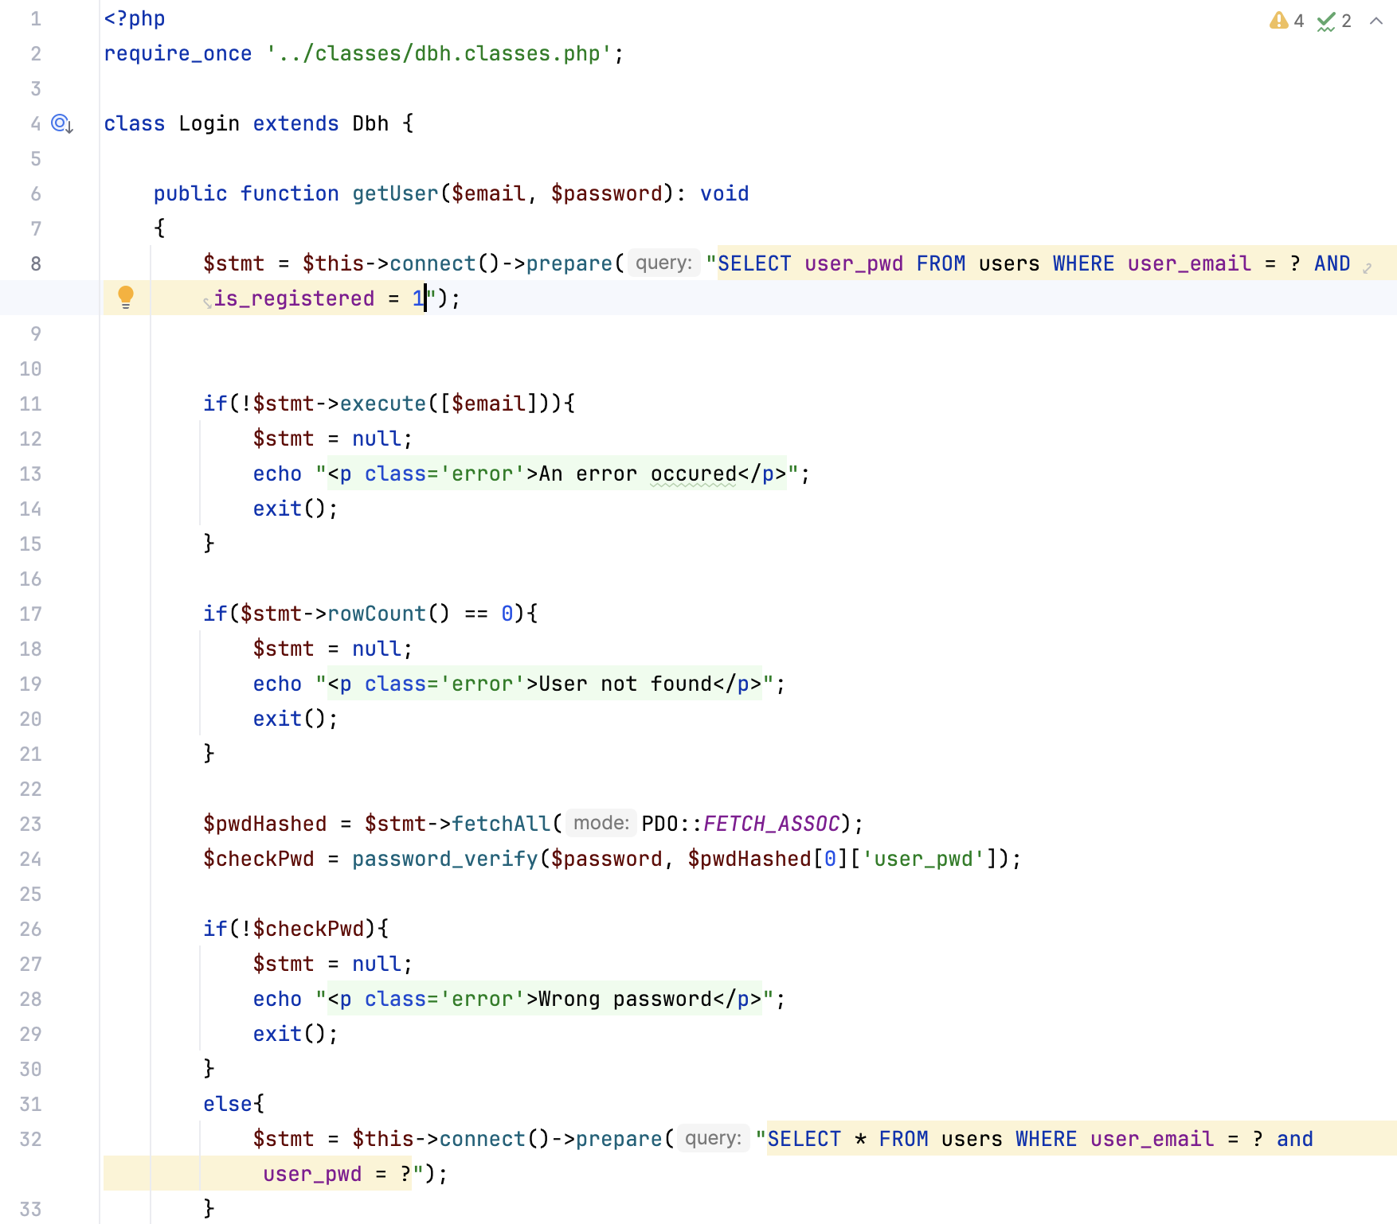 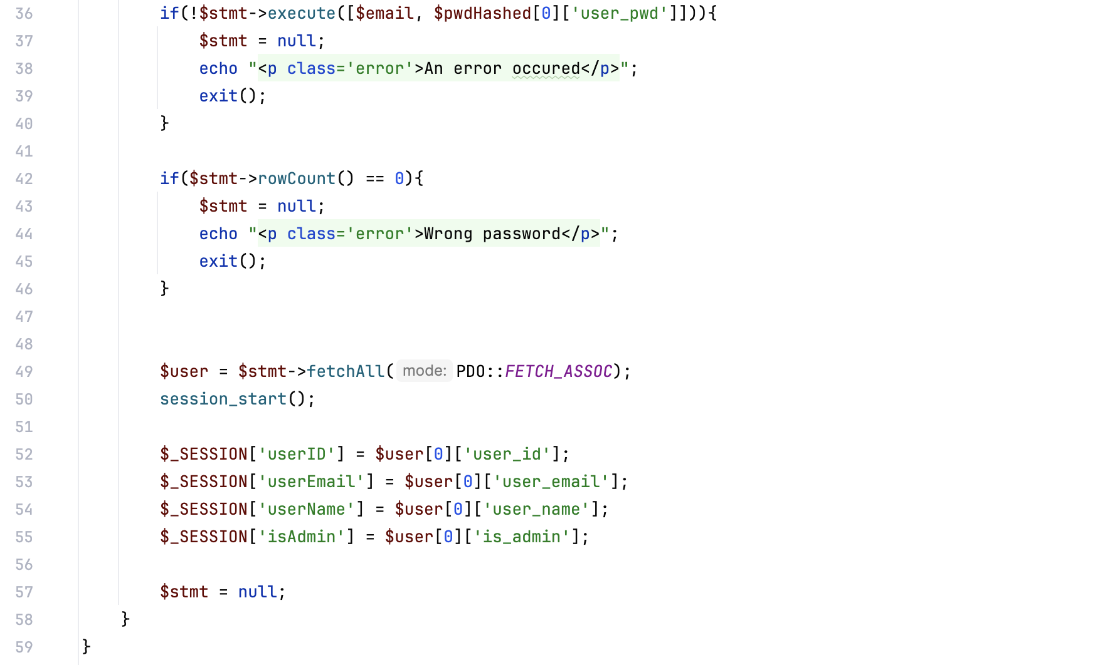

### login-contr.classes.php

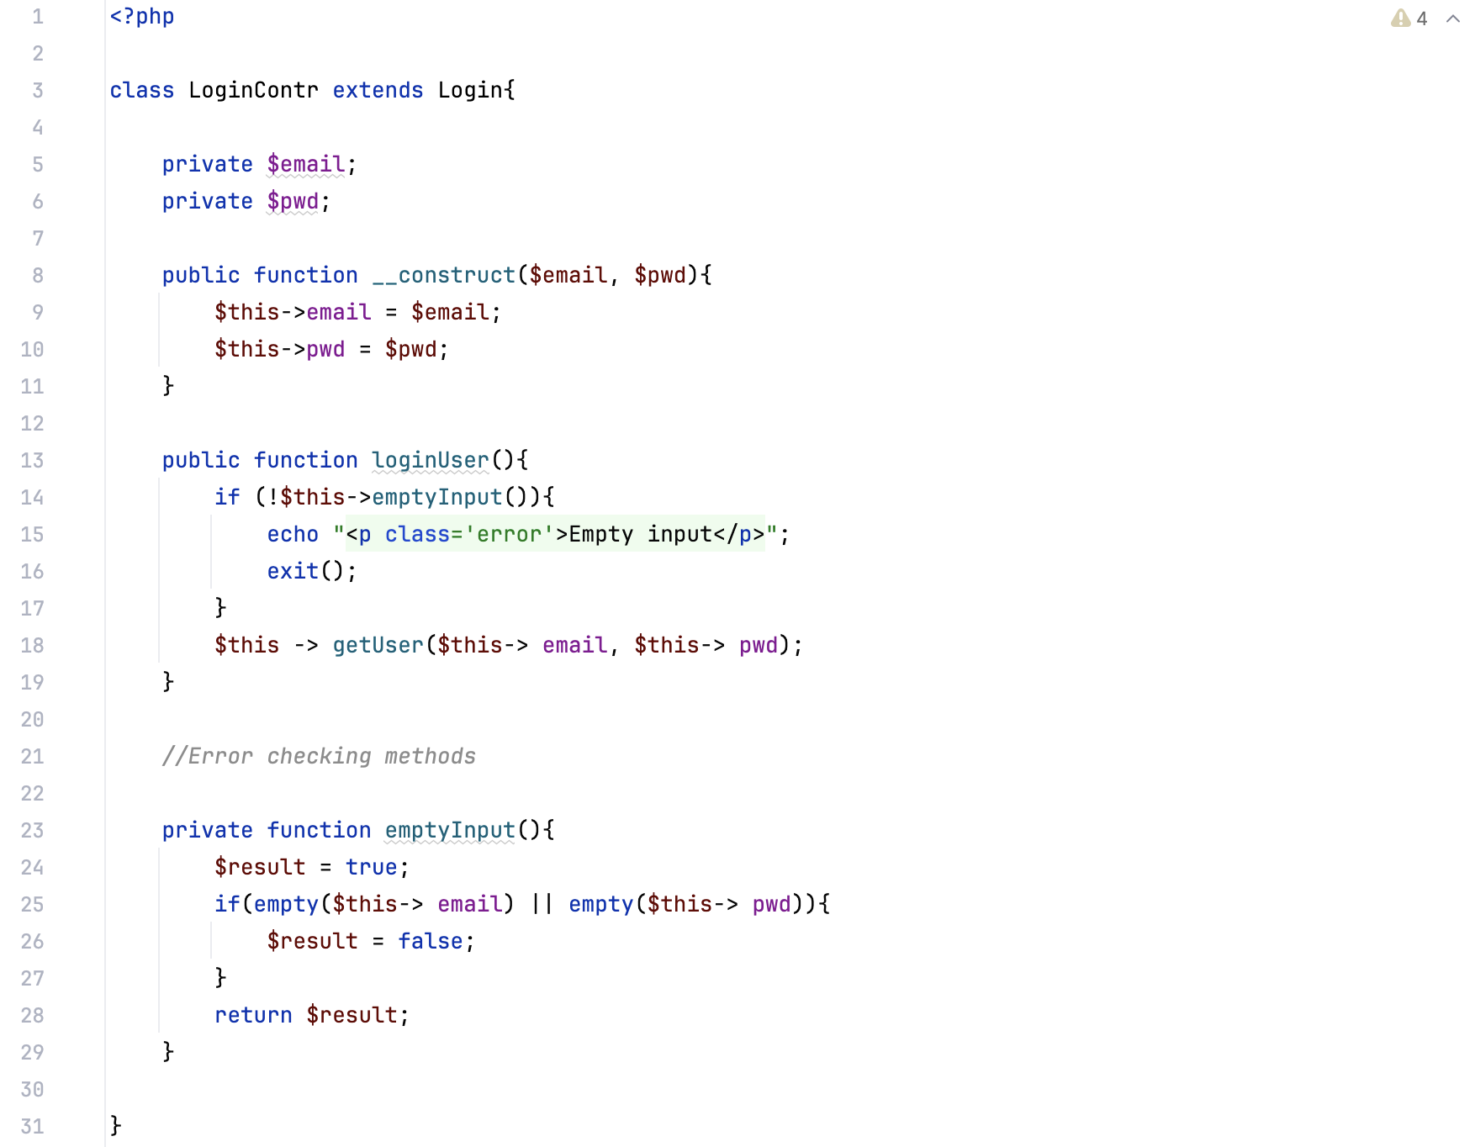

### returnbooks.classes.php

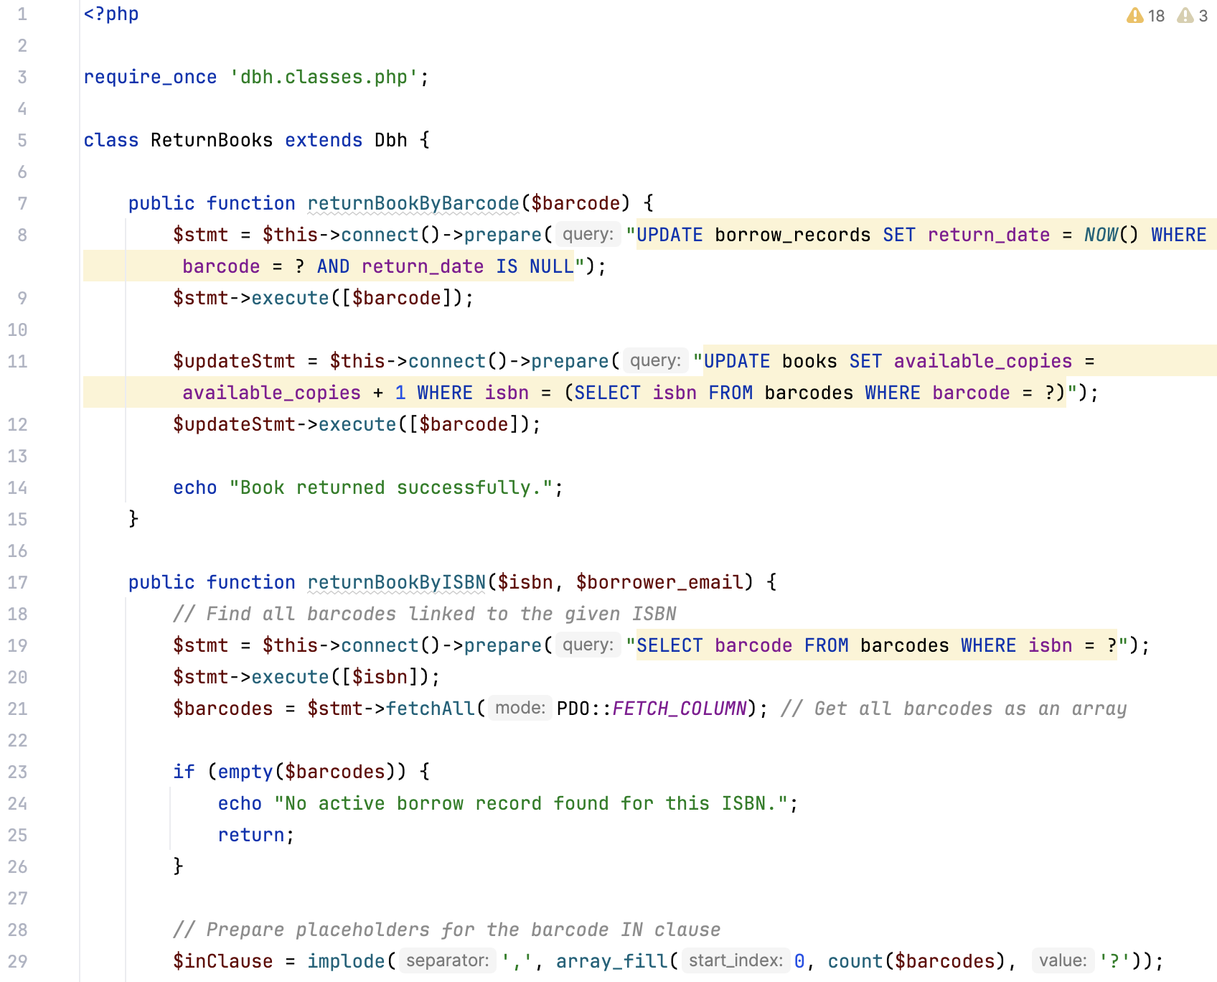 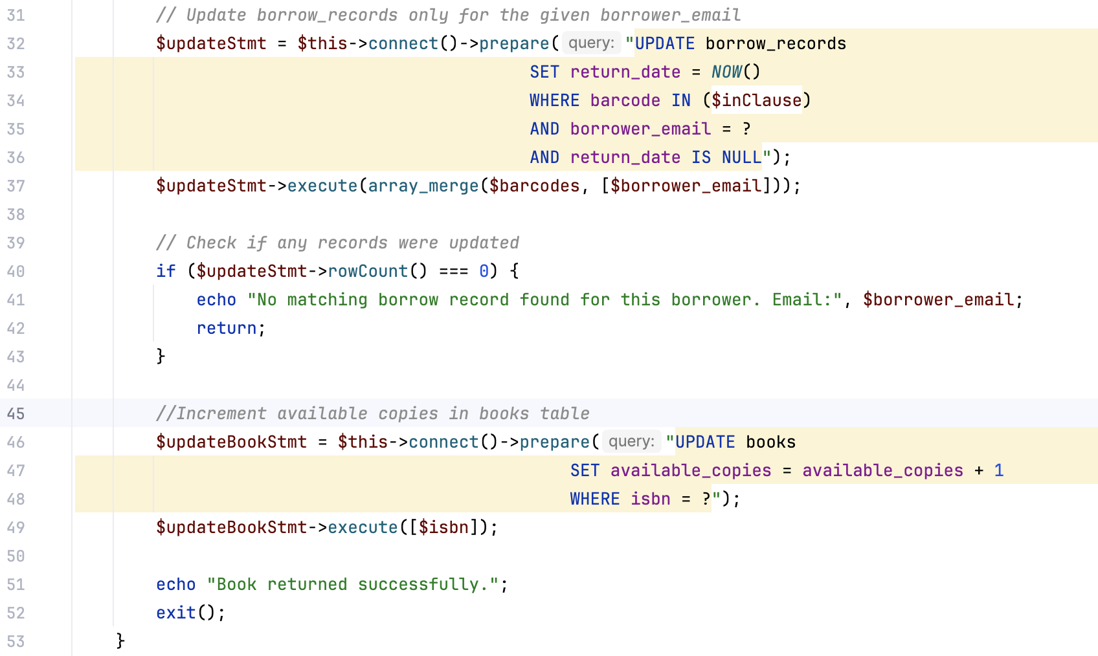 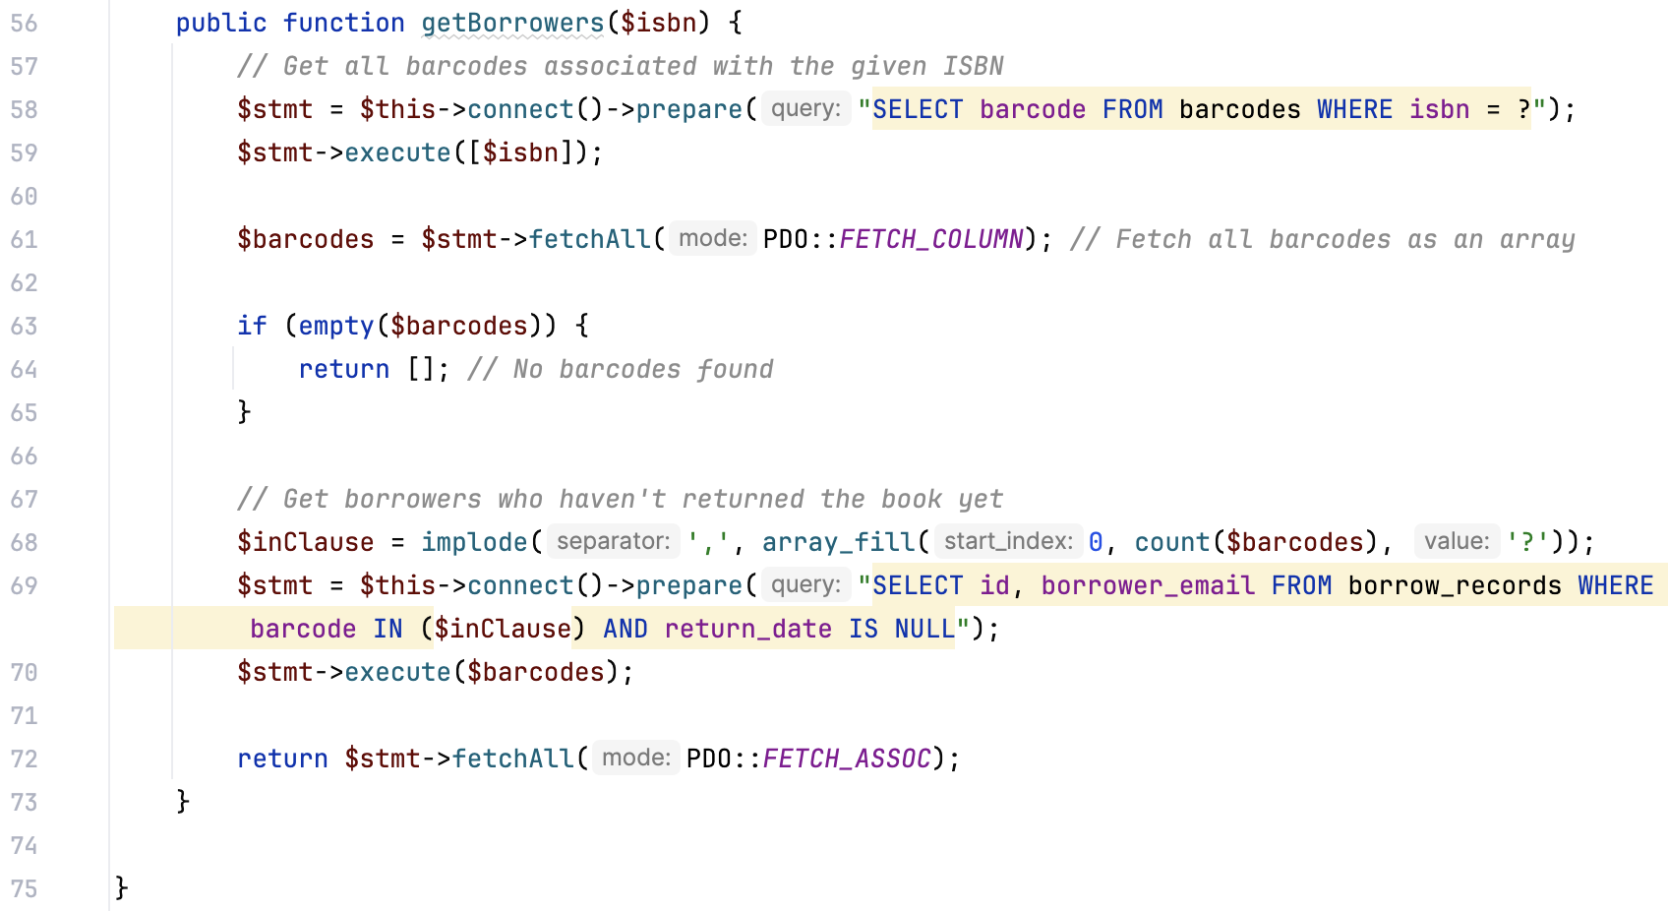

### signup.classes.php

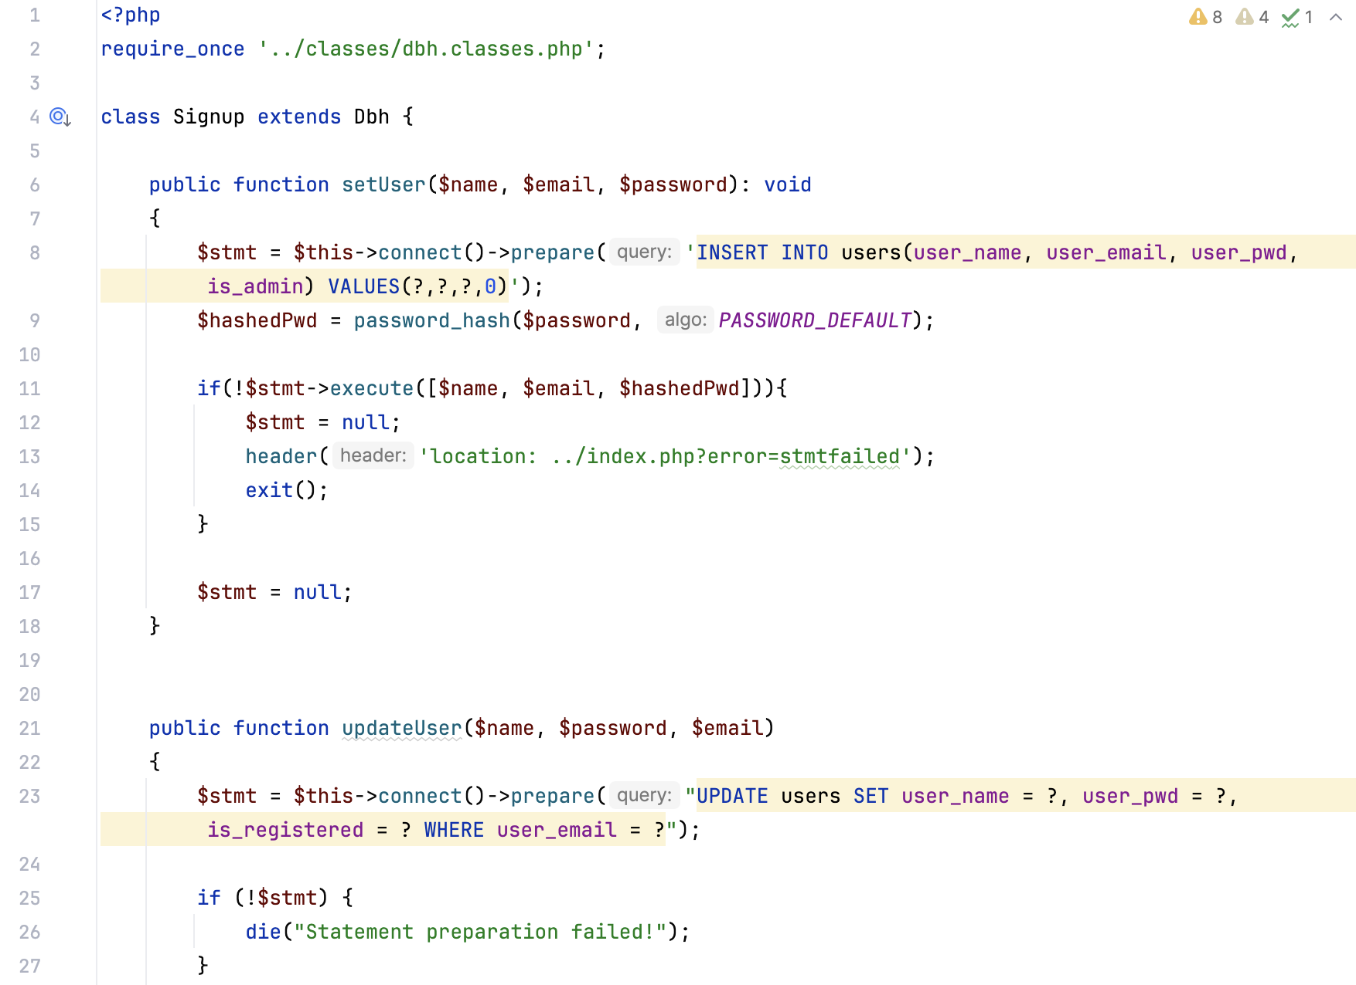 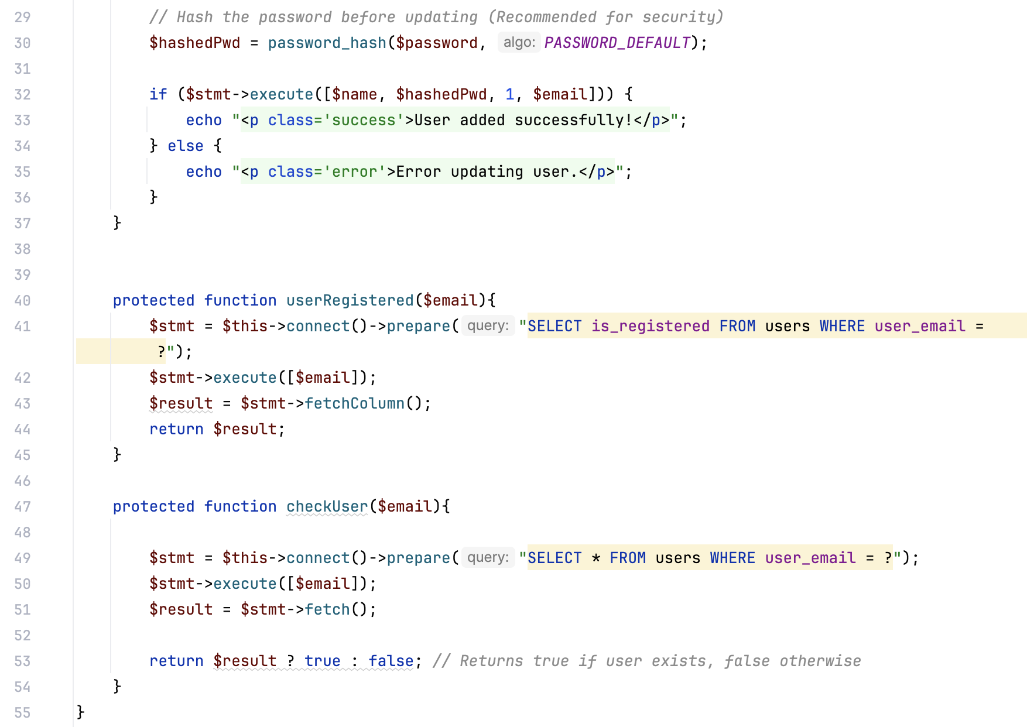

### sinup-contr.classes.php

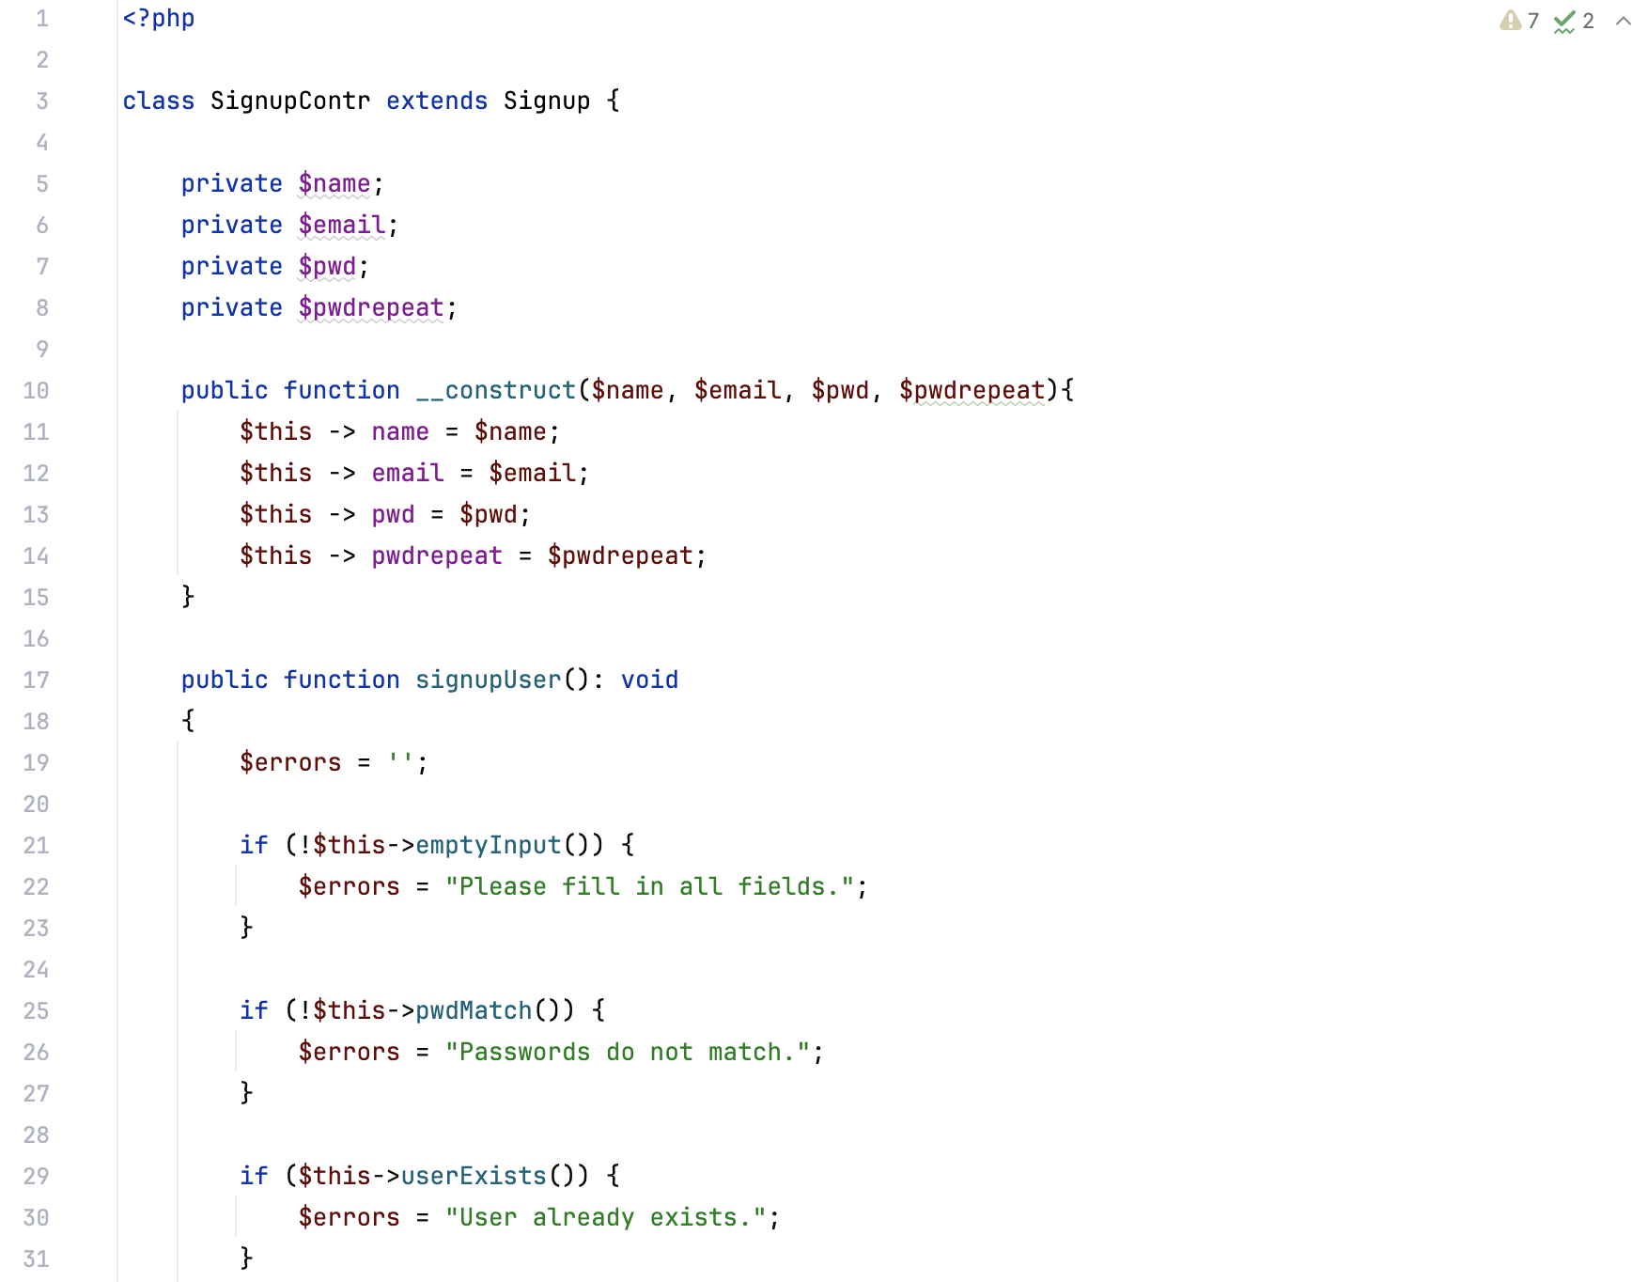

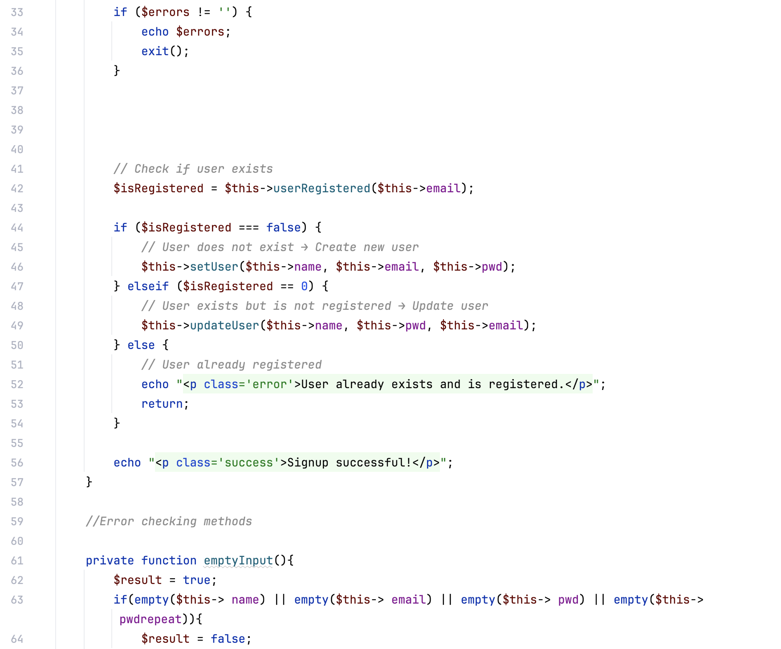

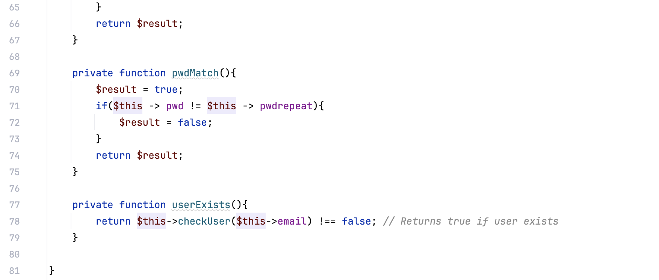

## JavaScript

### addbooks.js

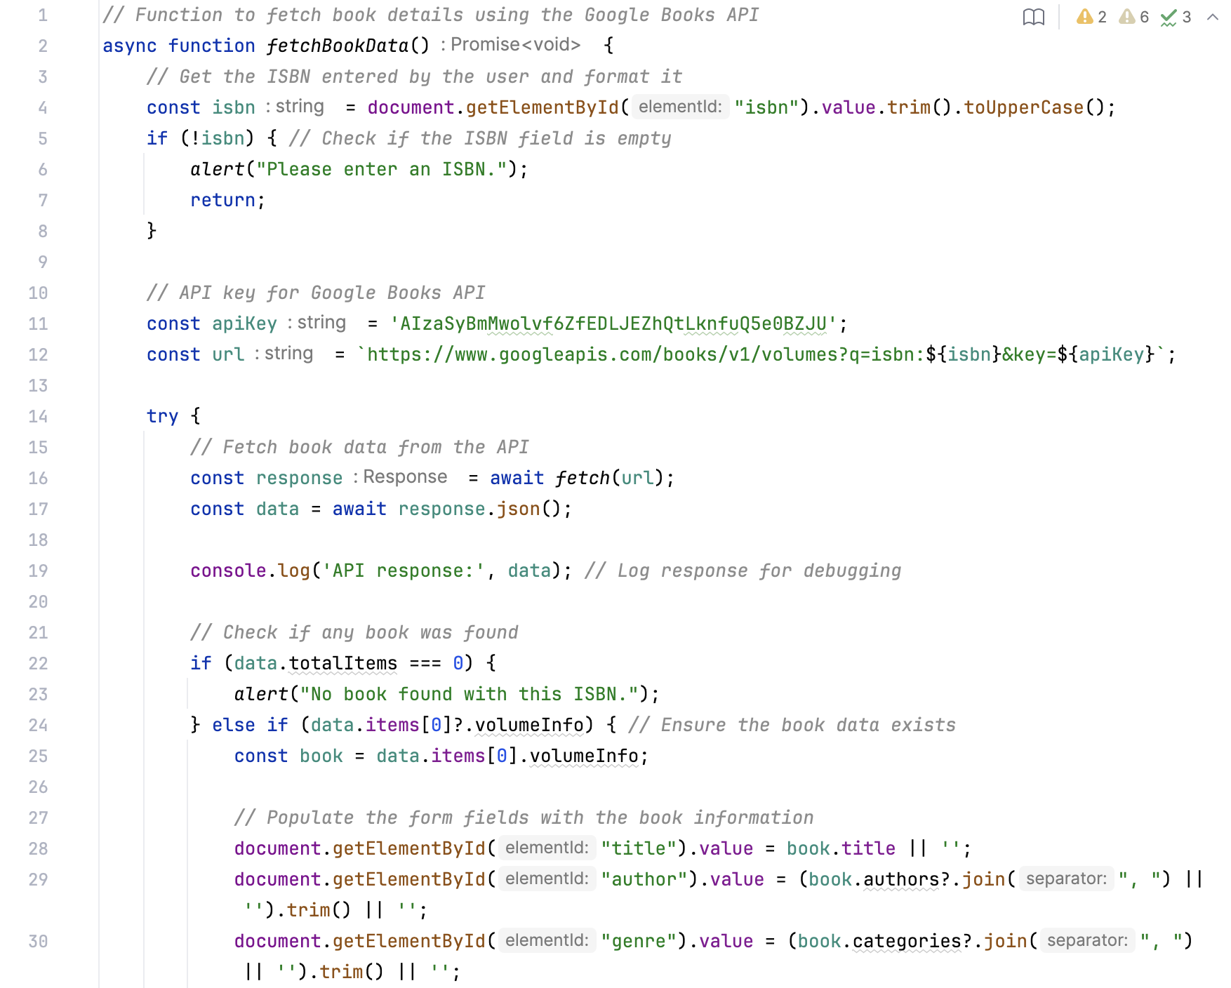 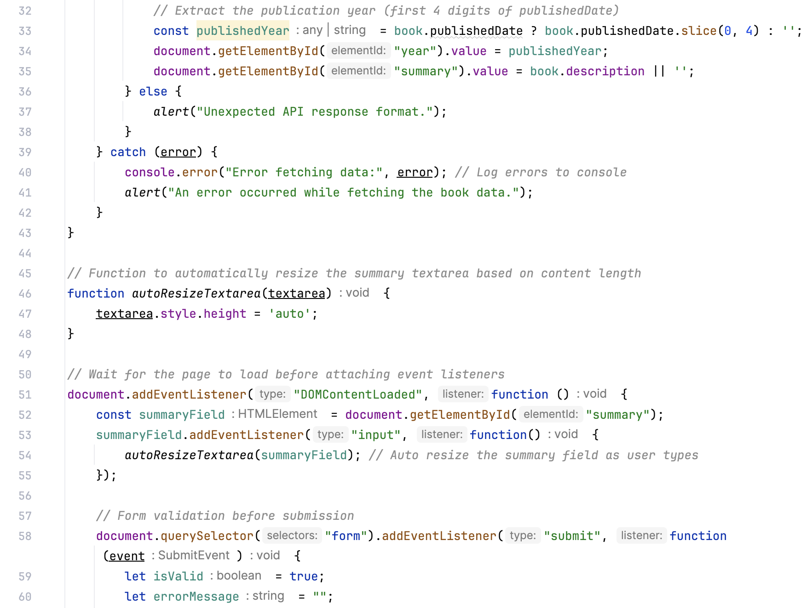 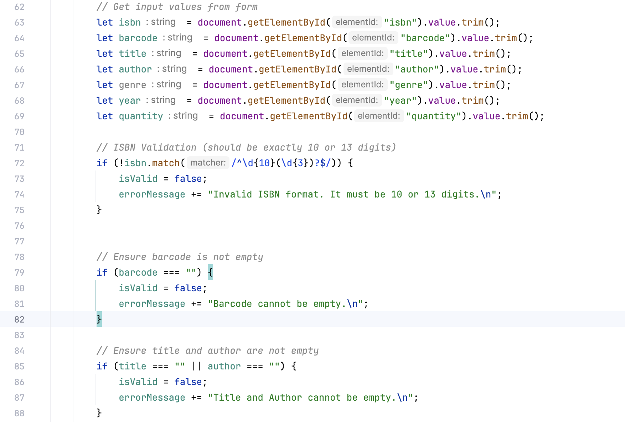 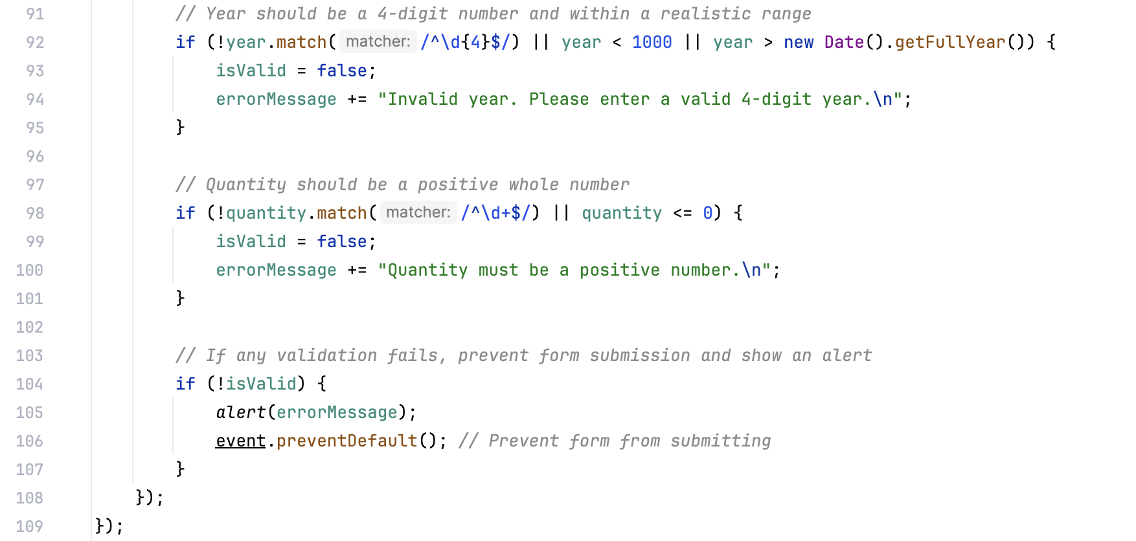

### rating.js

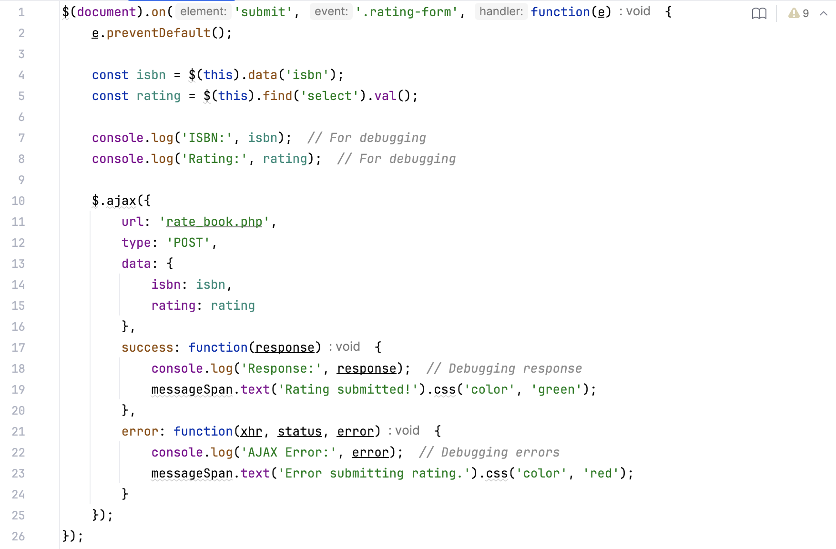

### returnbooks.js

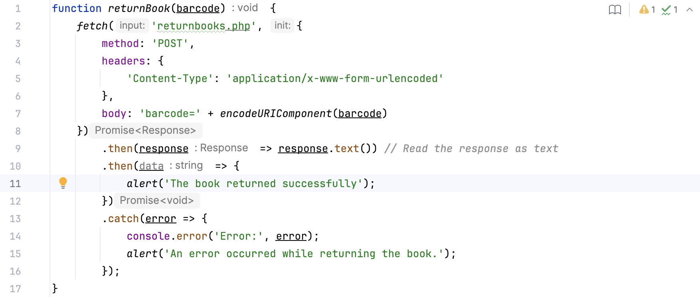

### scanner.js

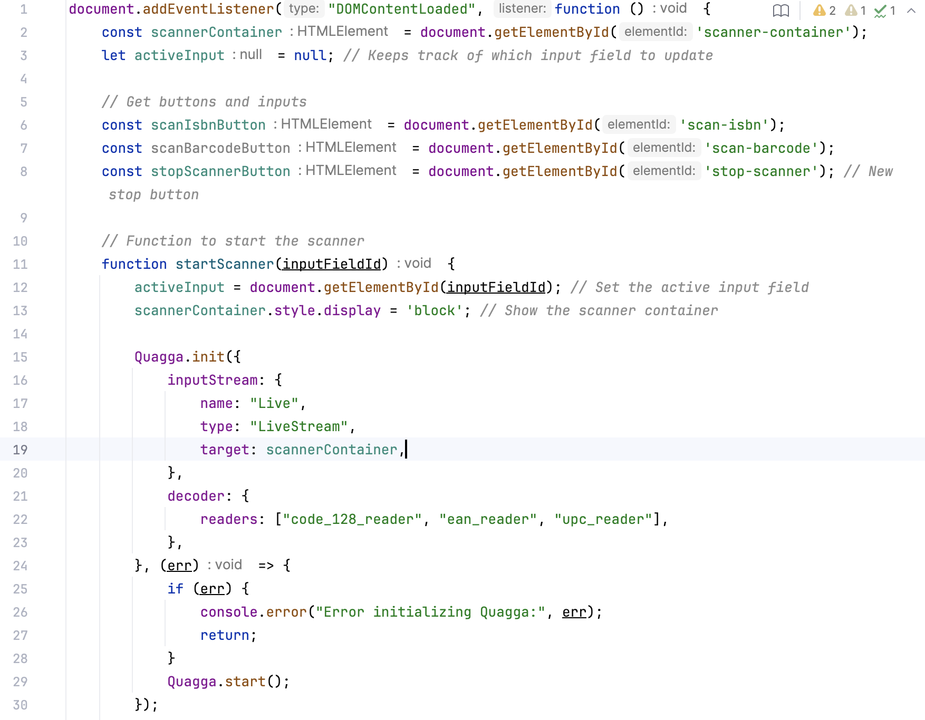 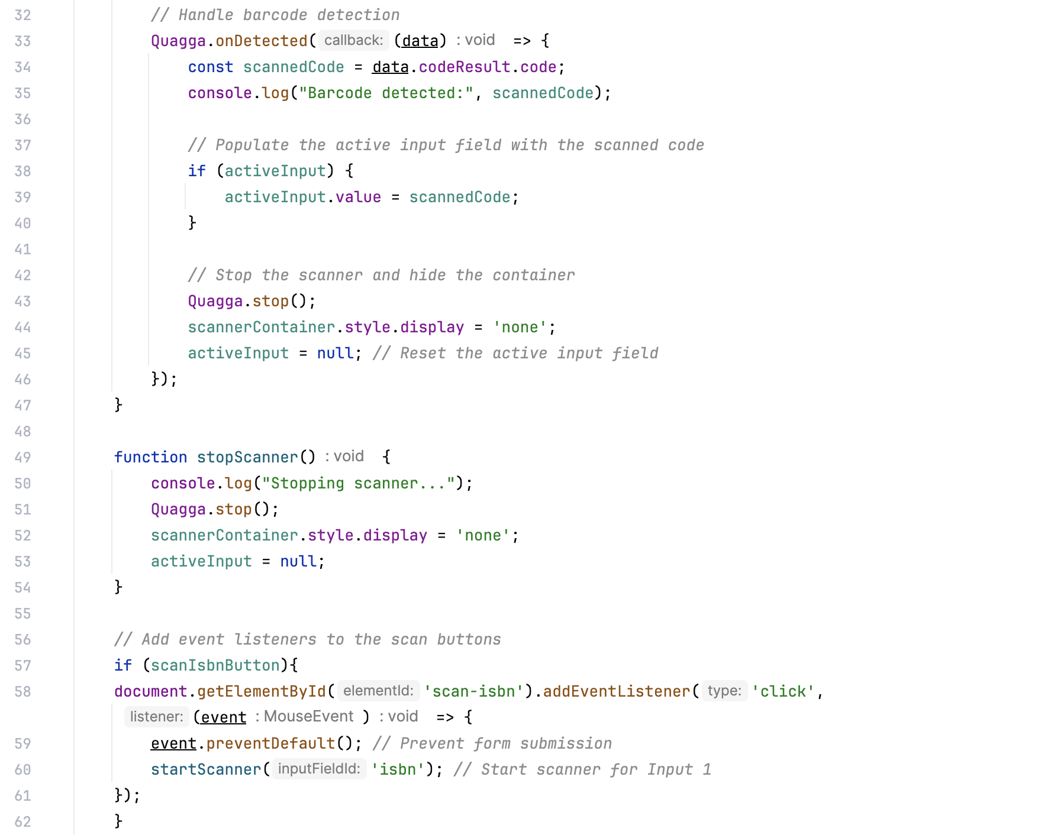 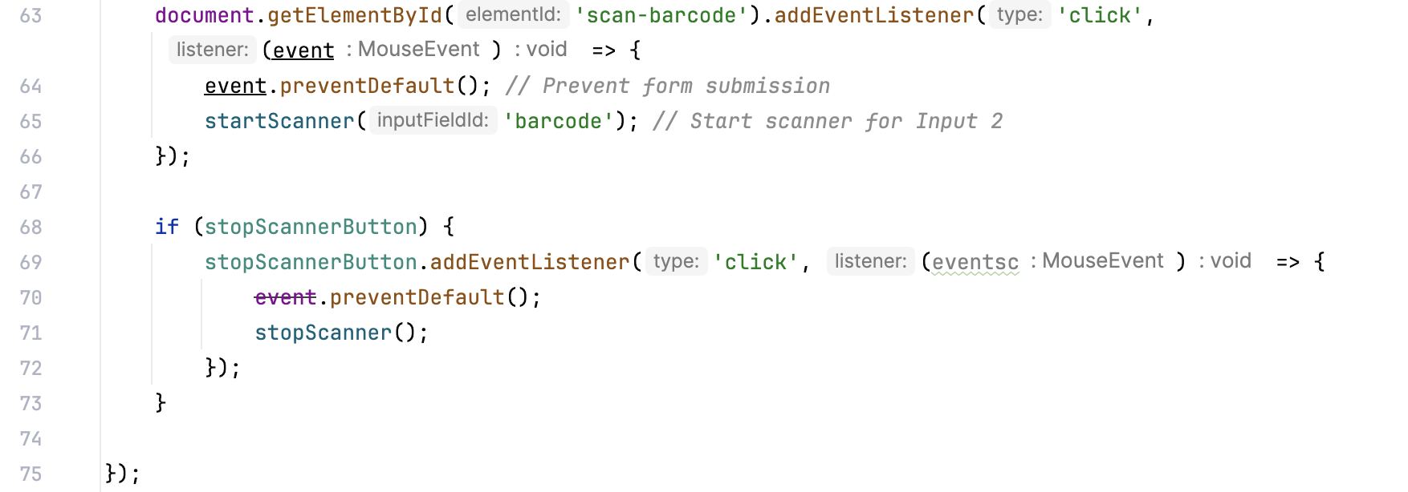

### show-more-less.js

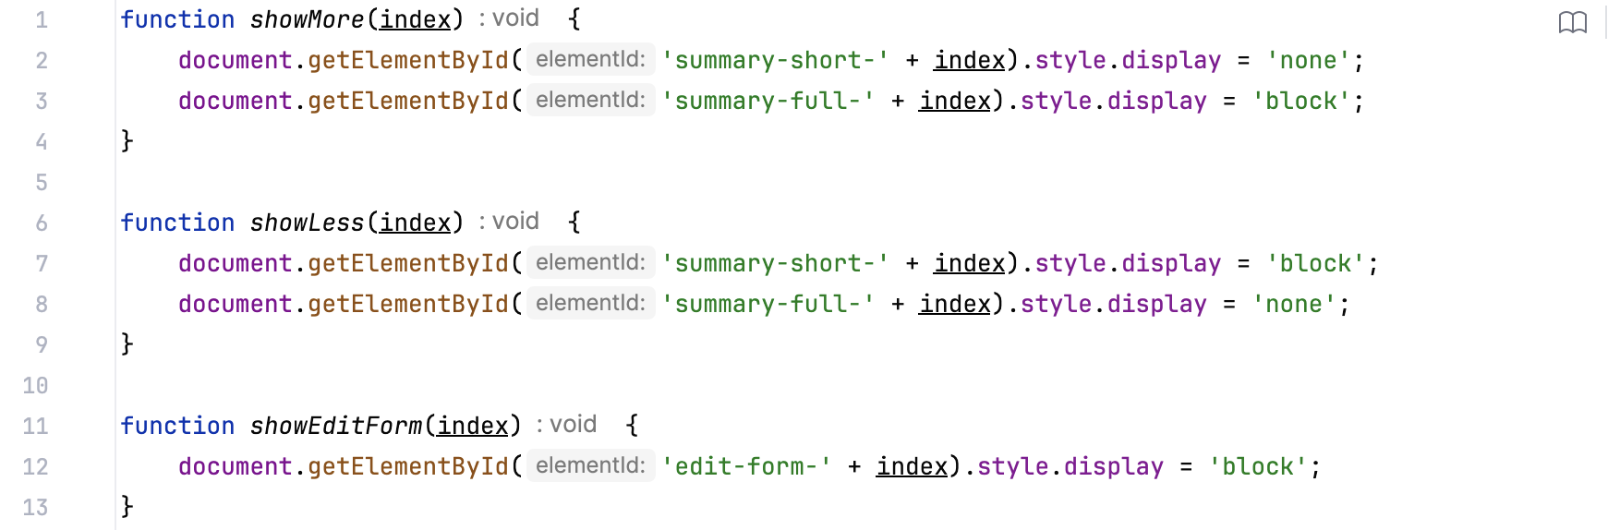

## Update existing books

### update-books.py

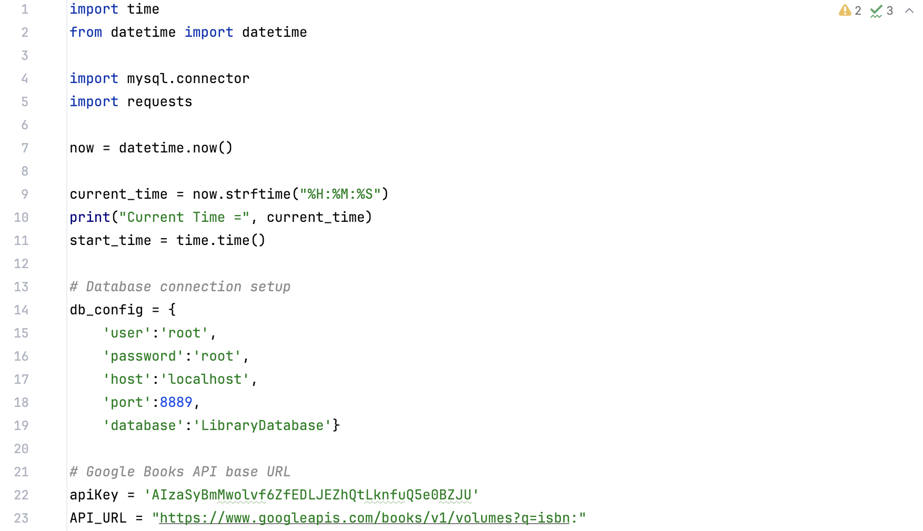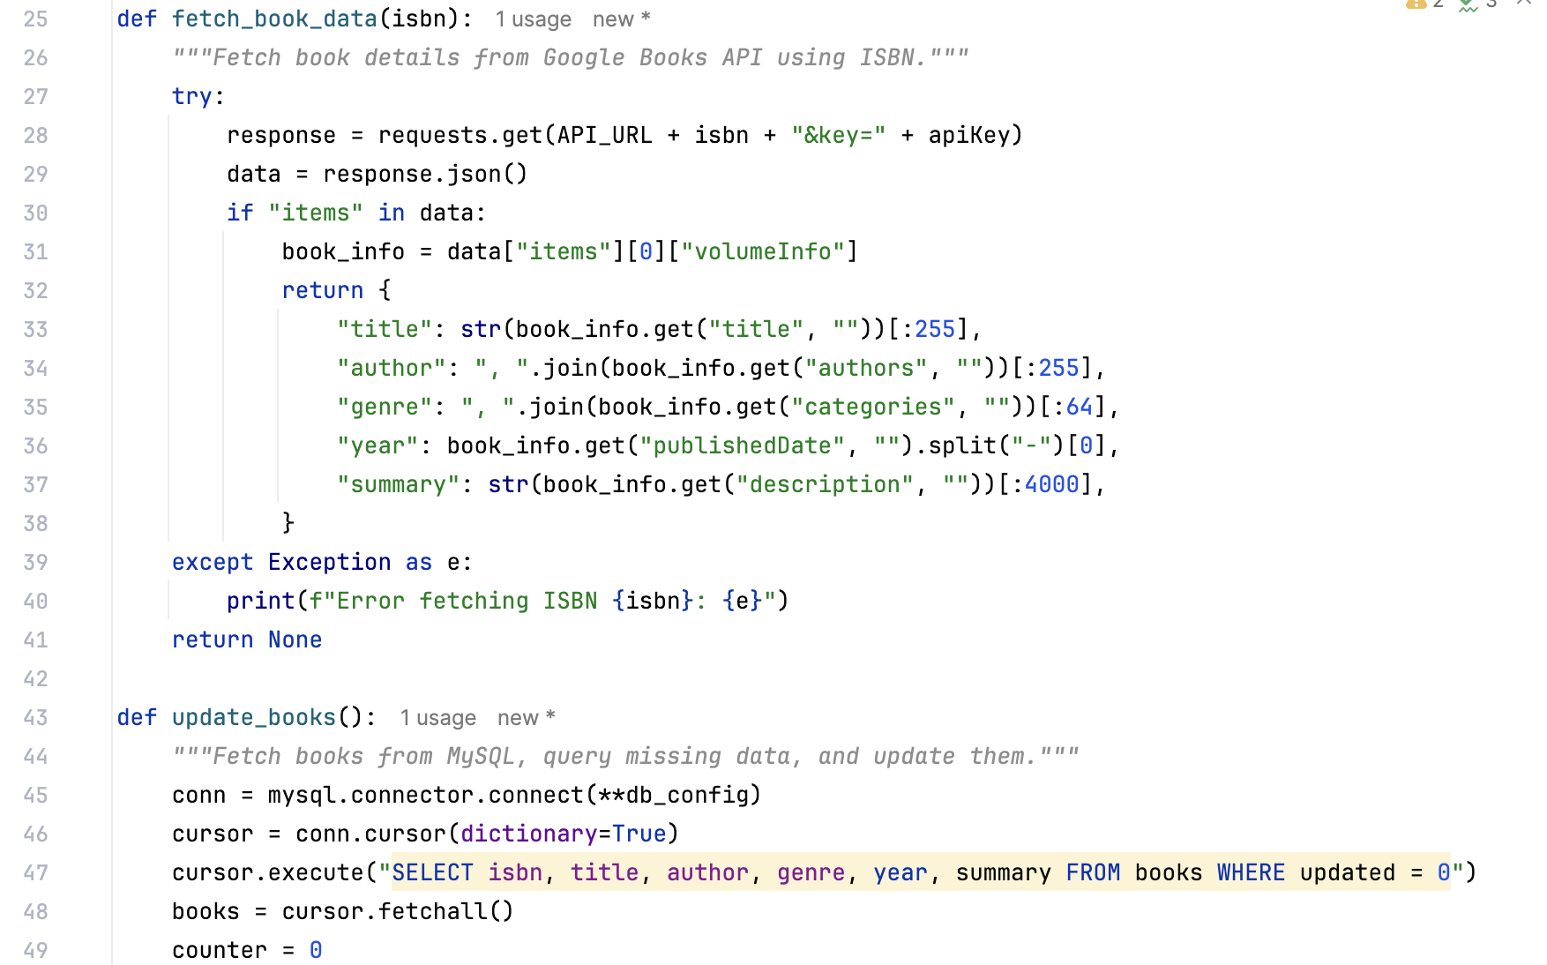 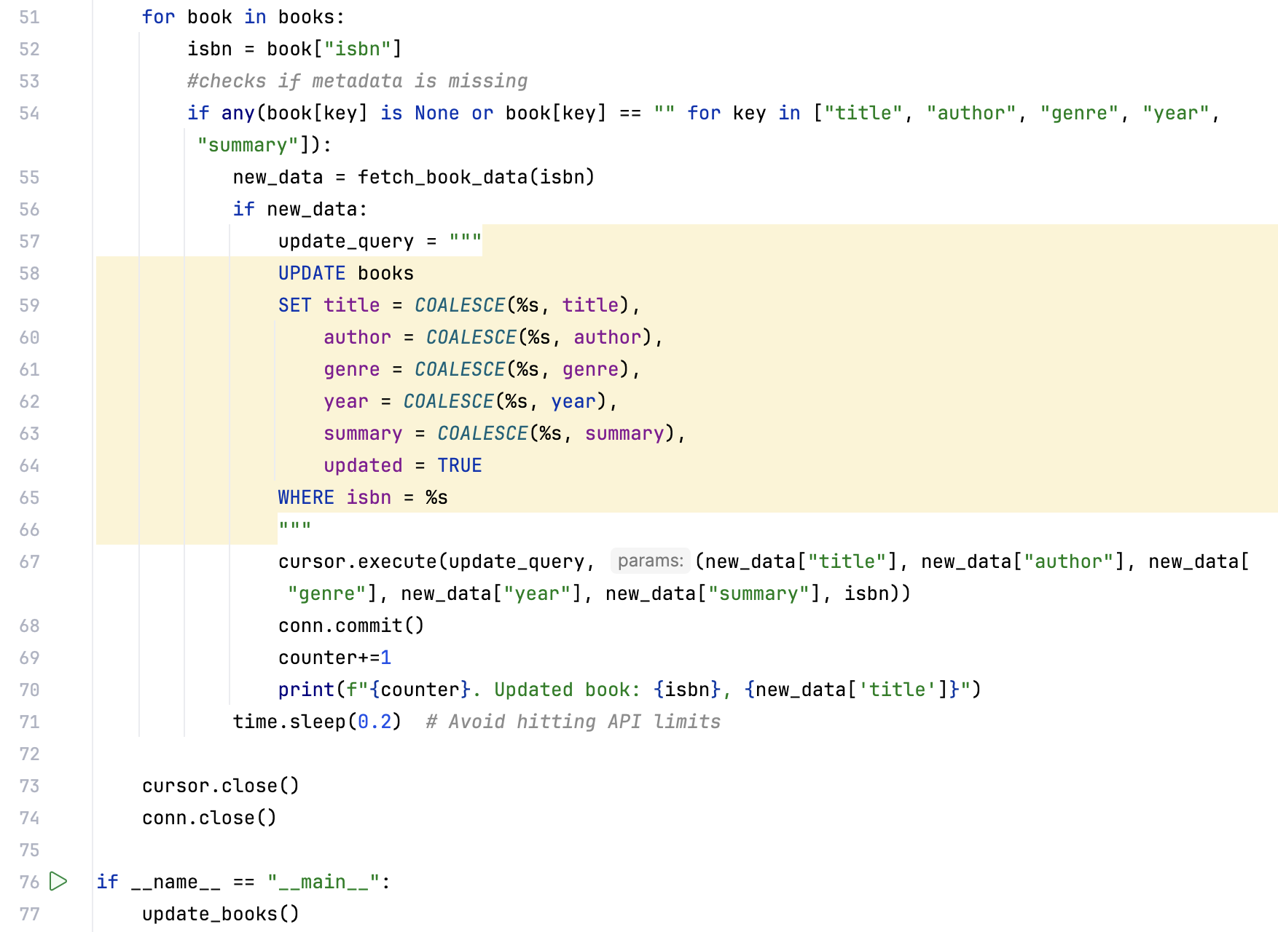

## Recommender

### connector.py

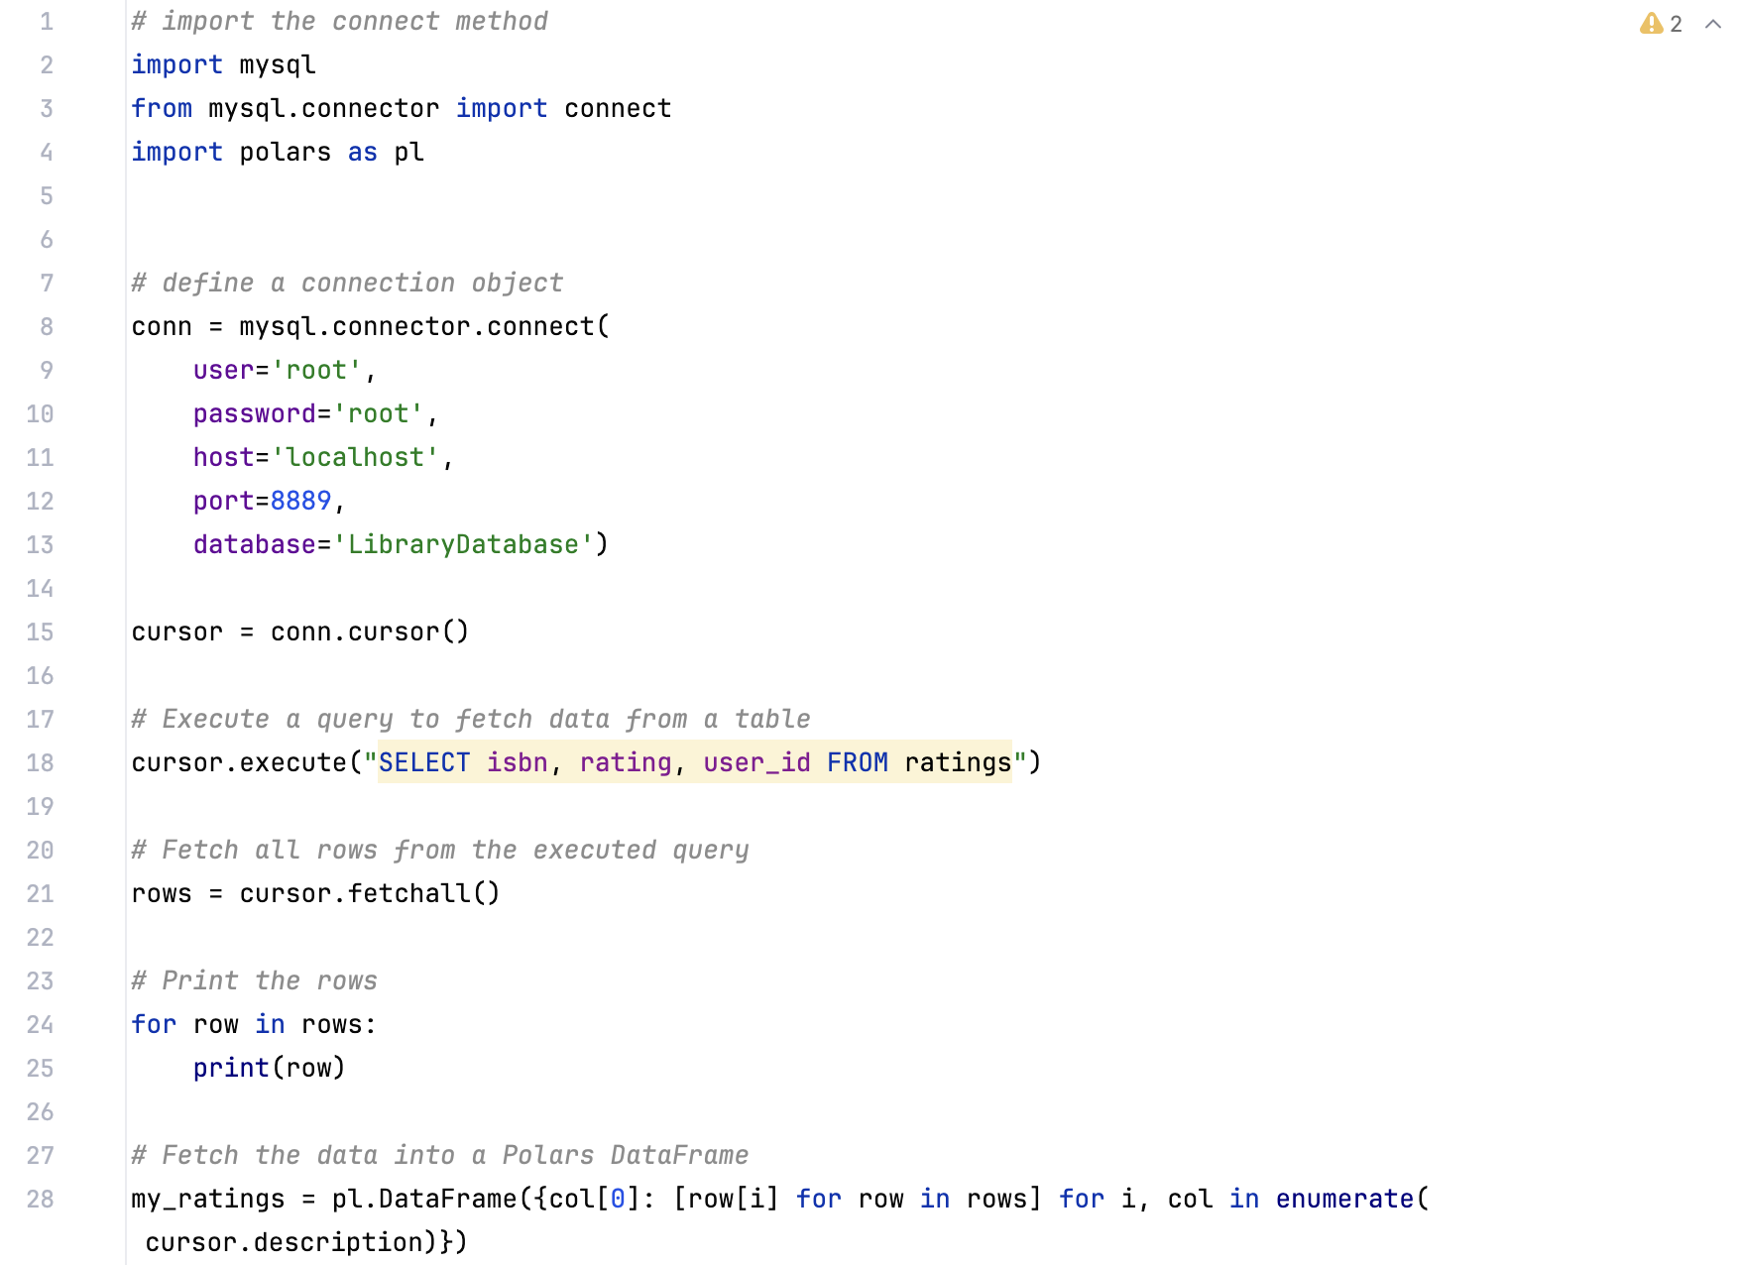 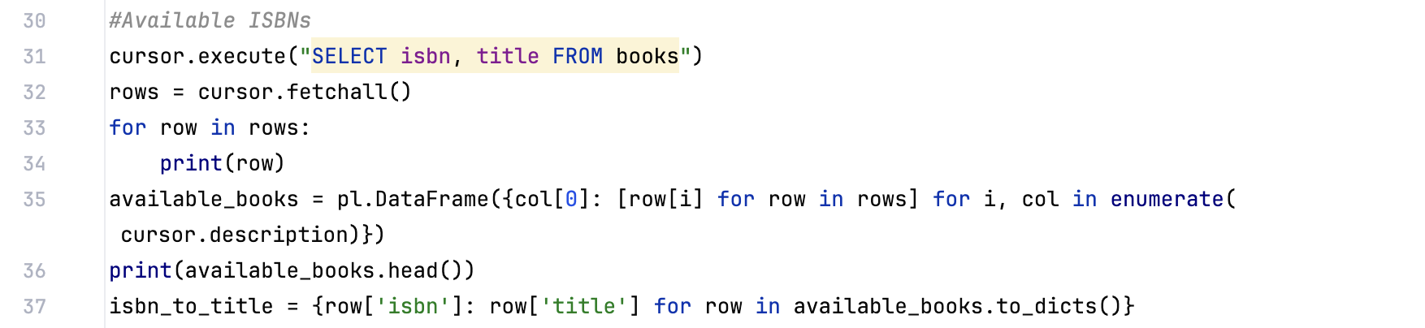

### filter.py

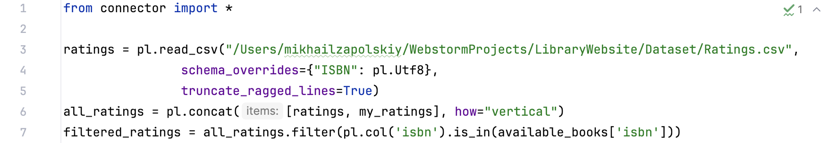

### get-recommedations.py

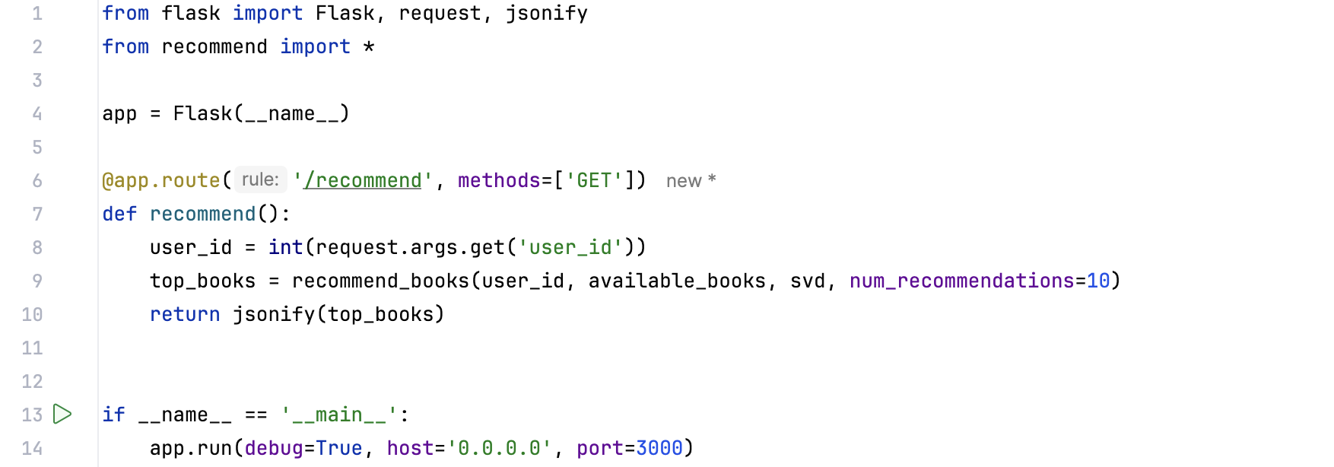

### recommend.py

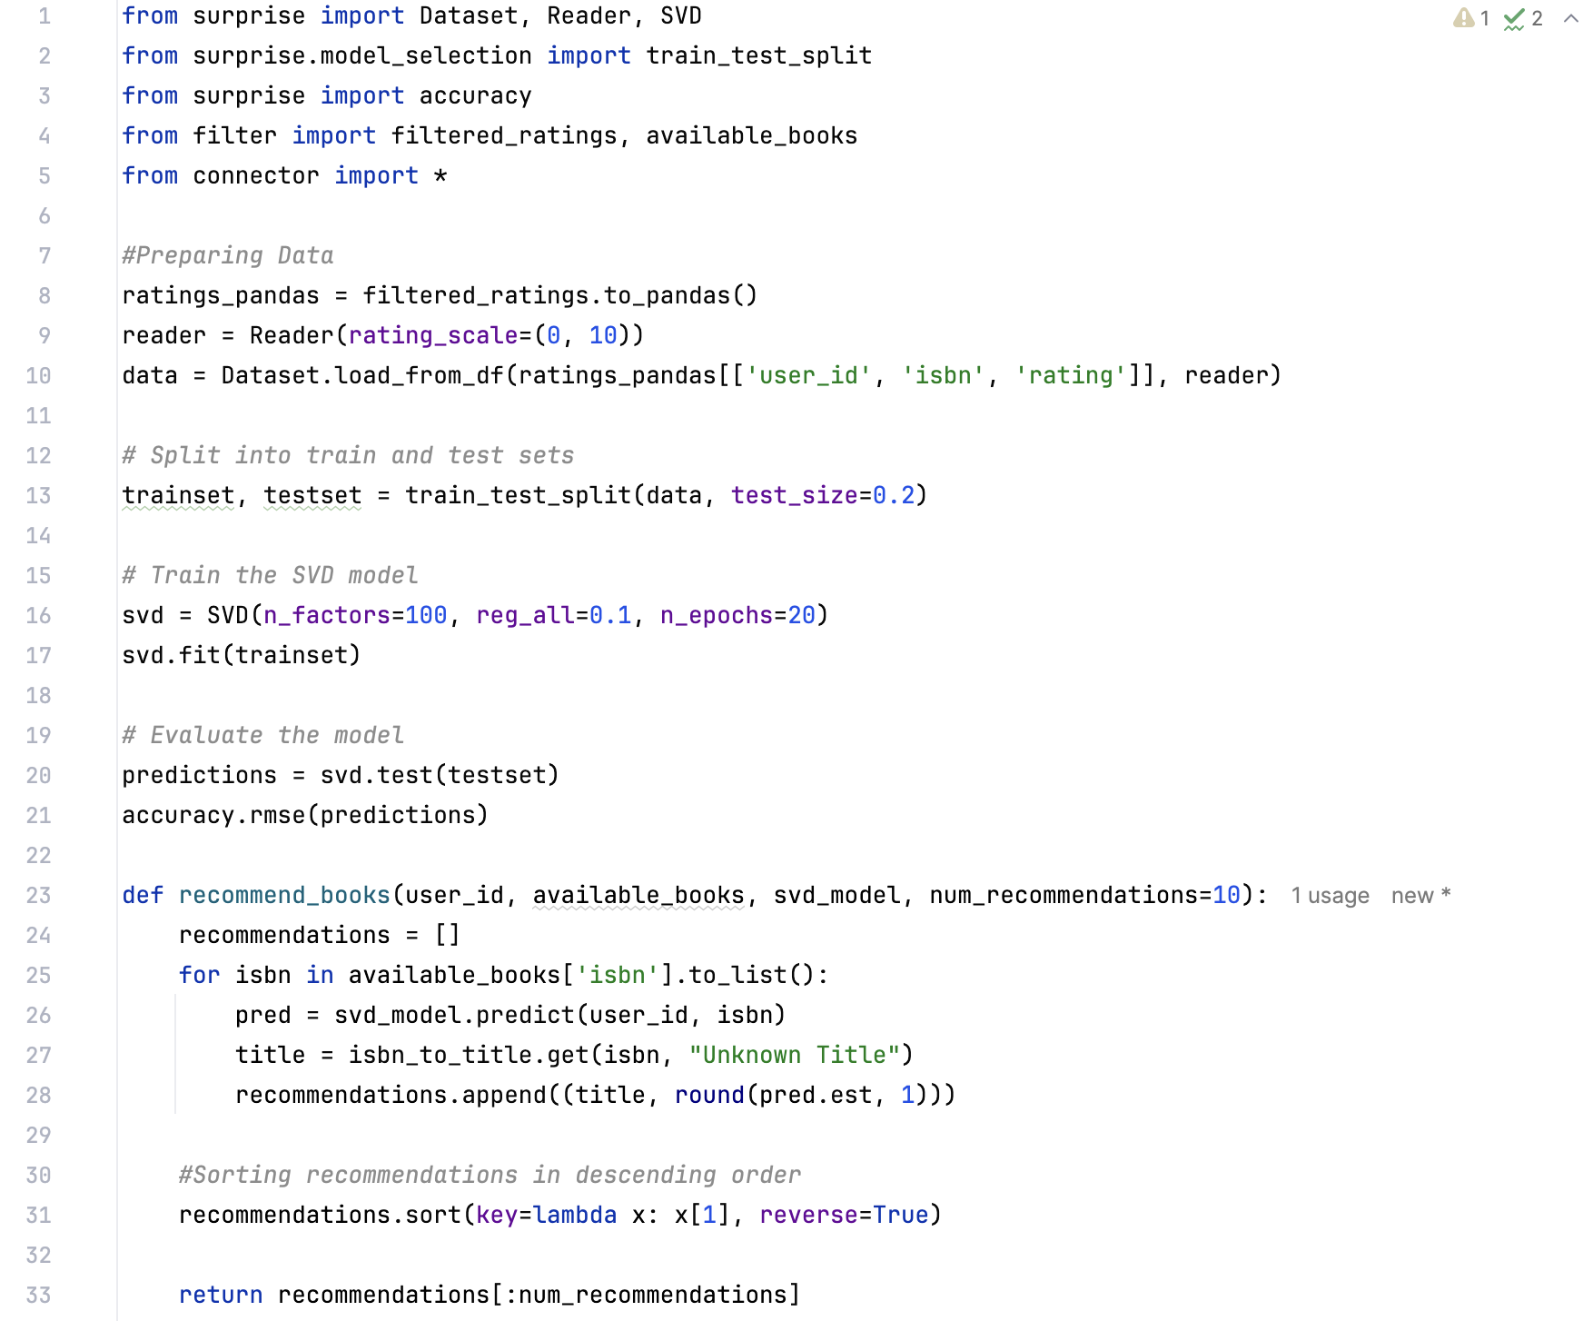

# SQL database structure

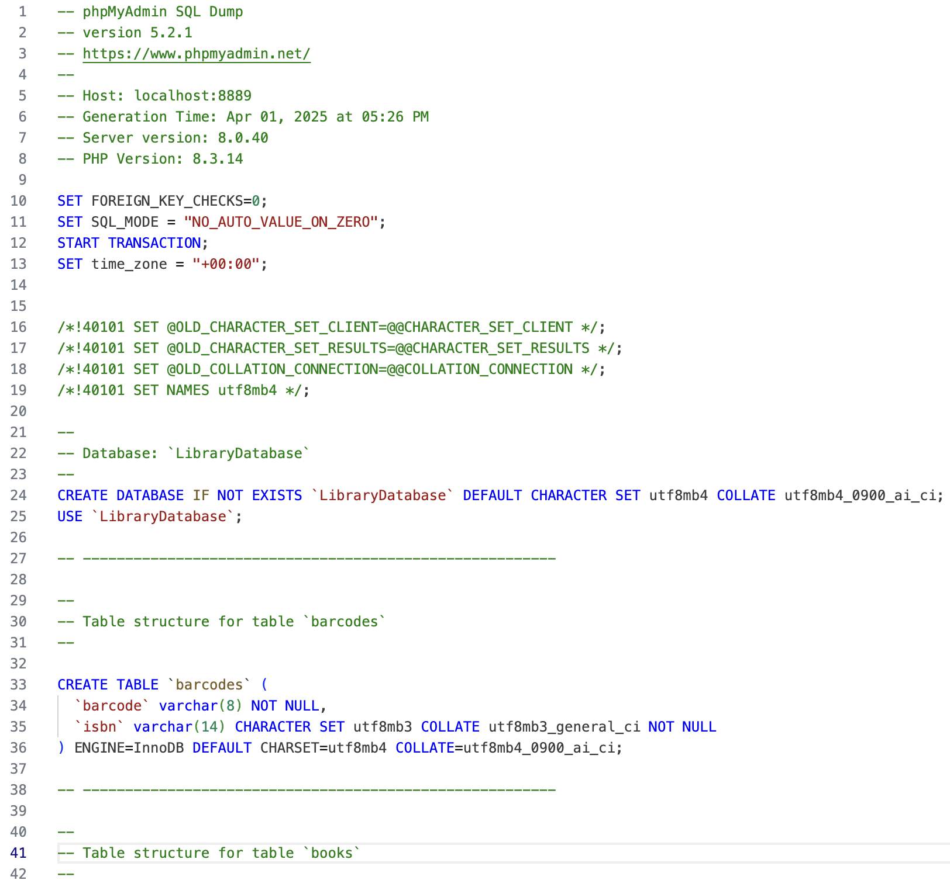 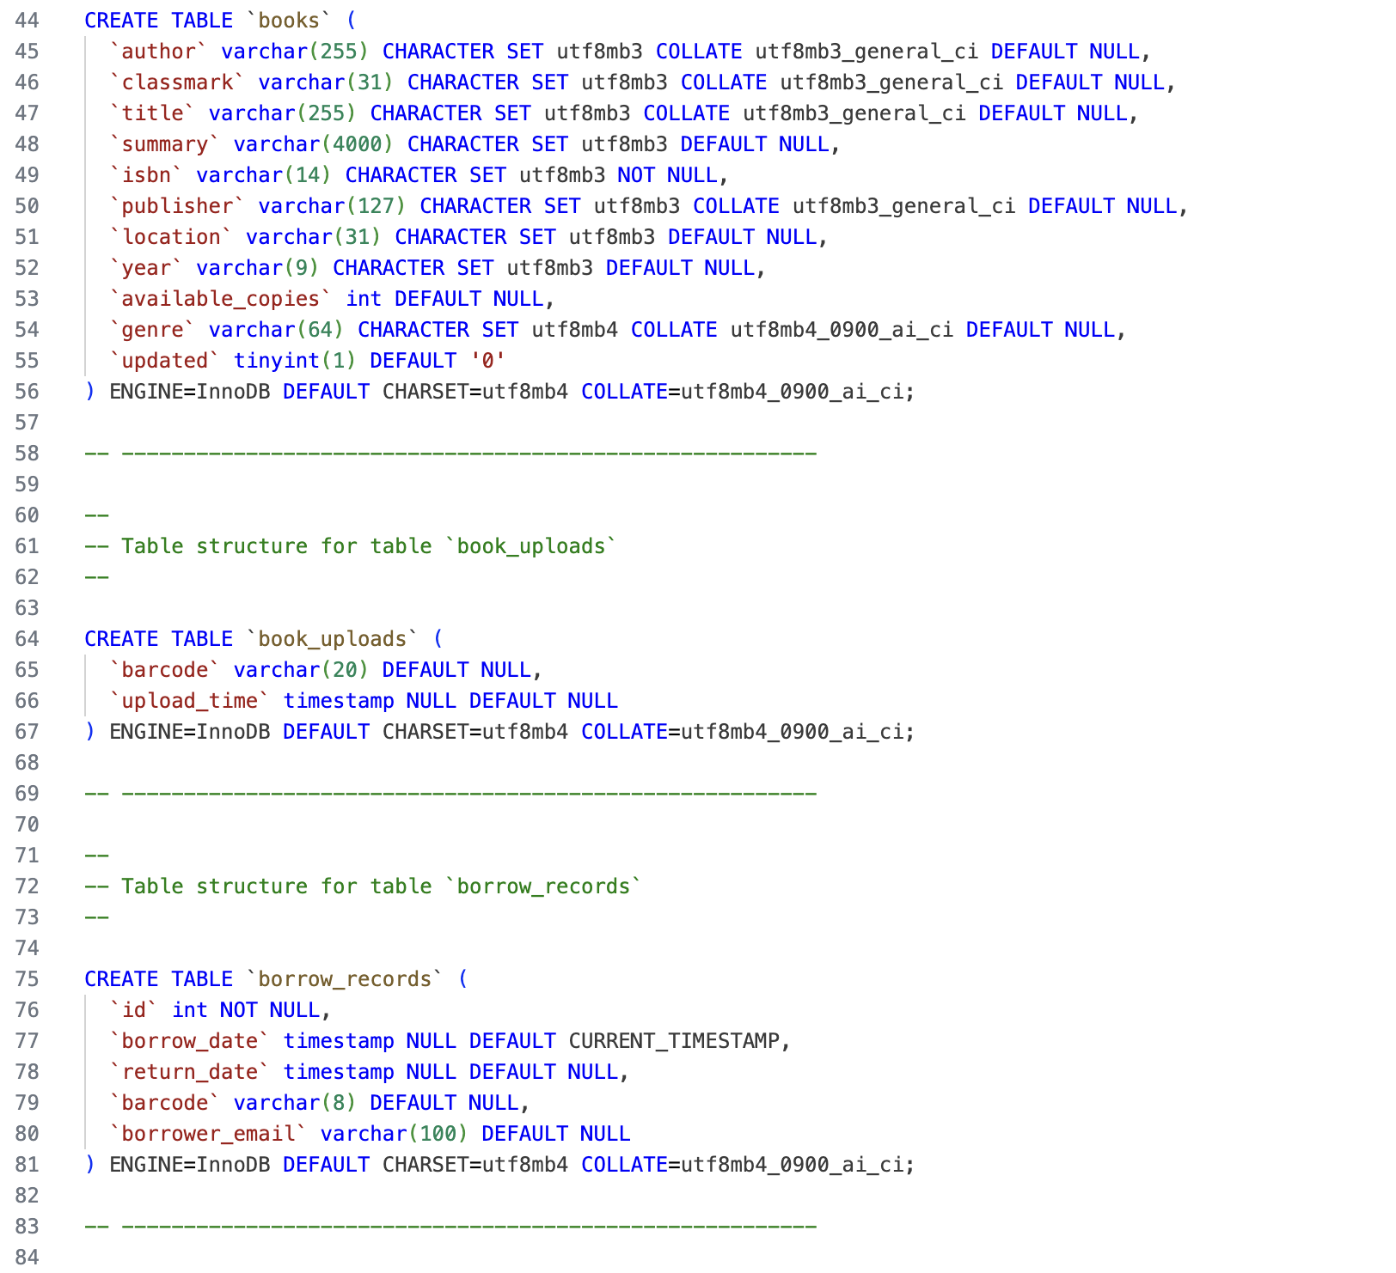 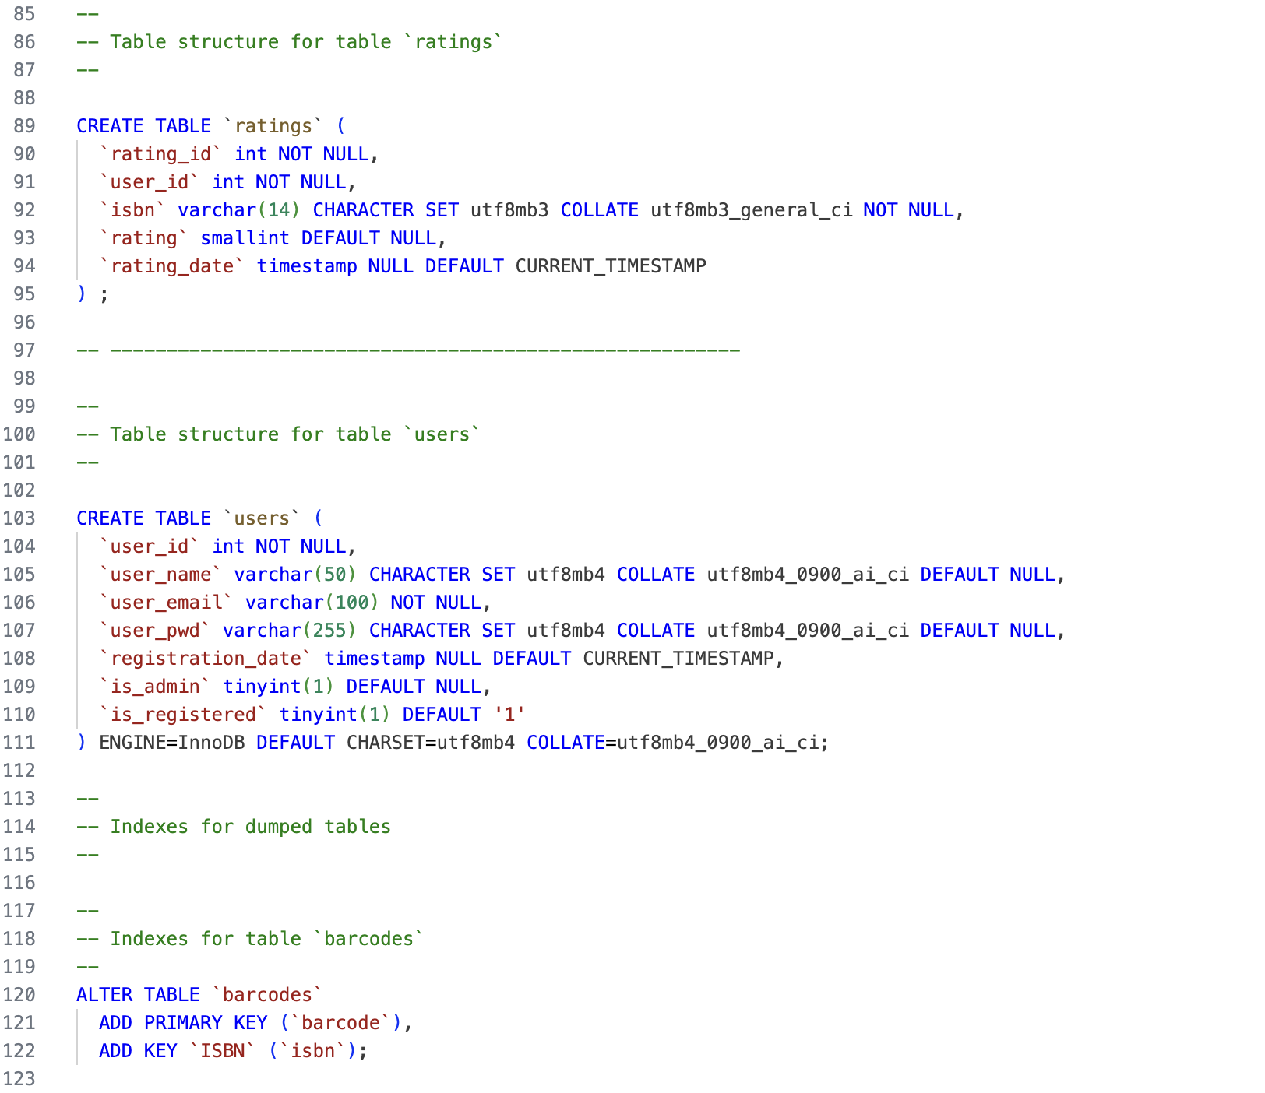 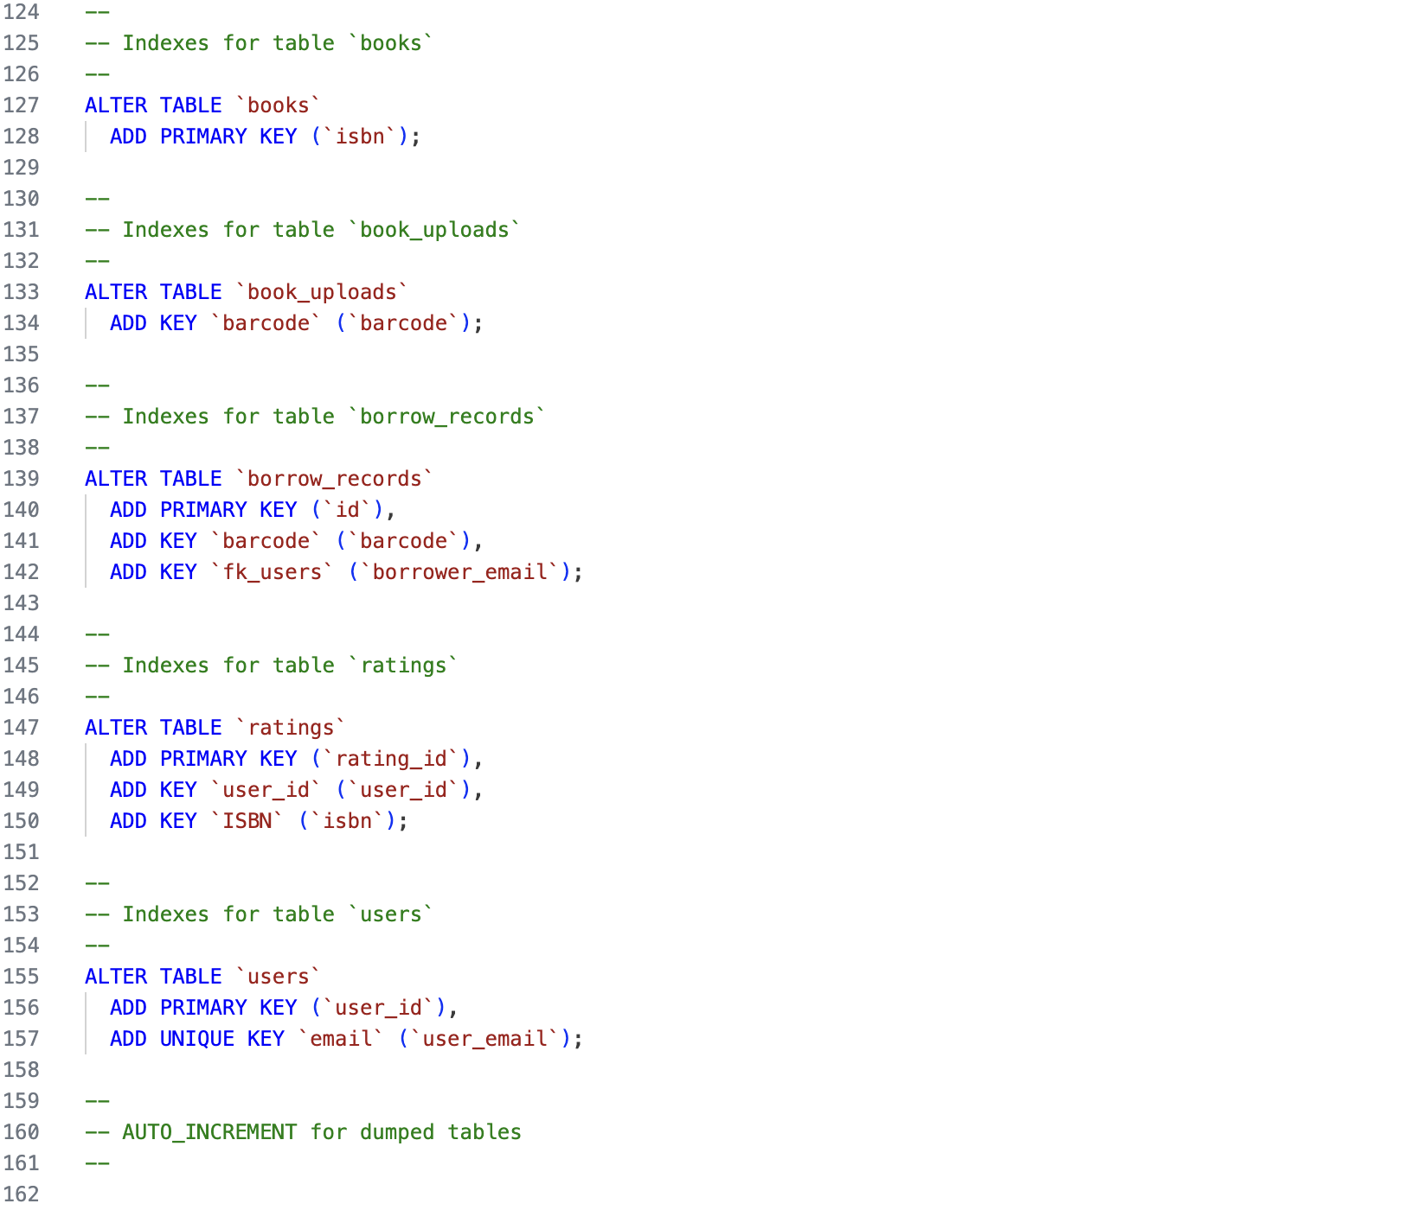 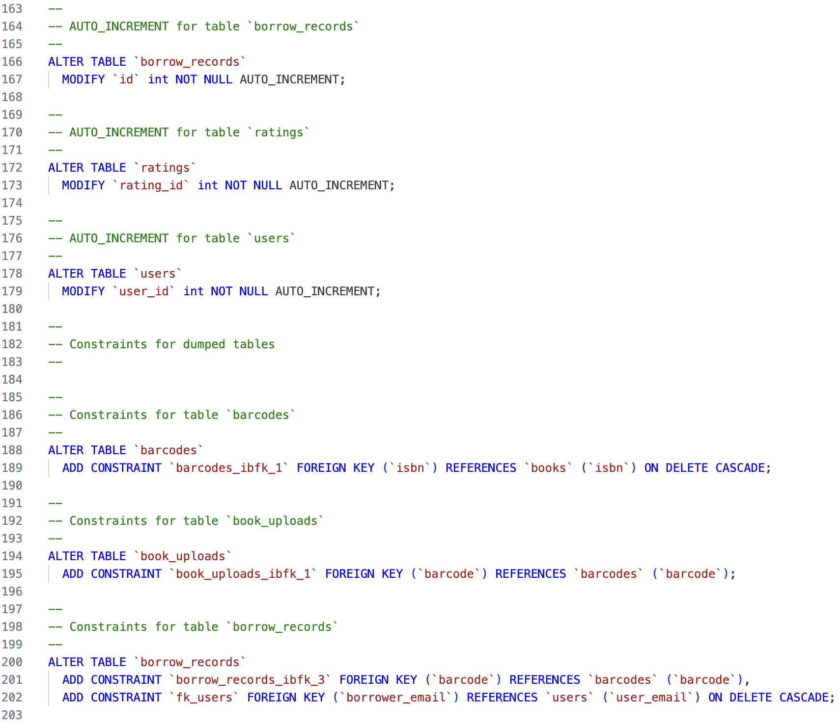 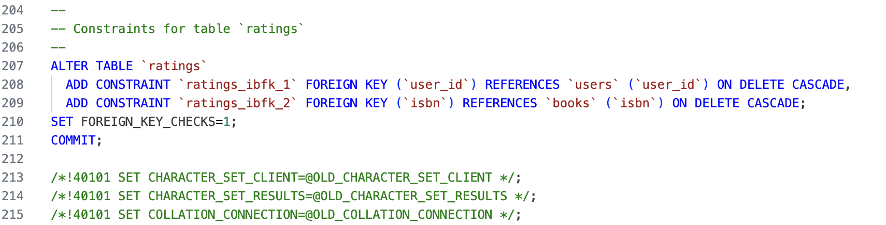

# References

## PHP documentation

### PHP manual

https://developer.mozilla.org/en-US/docs/Glossary/PHP

### Classes

https://www.php.net/manual/en/language.oop5.basic.php

### Sessions

https://www.php.net/manual/en/book.session.php

### Error handling

https://www.php.net/manual/en/language.errors.php

### Exceptions

https://www.php.net/manual/en/language.exceptions.php

### PHP Post

https://www.w3schools.com/php/php_superglobals_post.asp

### htmlspecialchars

https://www.php.net/manual/en/function.htmlspecialchars.php

### PHP Database interaction

https://www.w3schools.com/php/php_mysql_connect.asp

### Prepared statements

https://www.w3schools.com/php/php_mysql_prepared_statements.asp

## SQL manual

https://www.w3schools.com/sql/

## JavaScript

https://developer.mozilla.org/en-US/docs/Web/JavaScript

### DOM manipulation

https://developer.mozilla.org/en-US/docs/Web/API/Document_Object_Model

### Event Listeners

https://developer.mozilla.org/en-US/docs/Web/API/EventTarget/addEventListener

### Error handling

https://developer.mozilla.org/en-US/docs/Web/JavaScript/Reference/Statements/try...catch

## HTML Forms

https://developer.mozilla.org/en-US/docs/Learn_web_development/Extensions/Forms

## Password operations

### Hashing password

https://cheatsheetseries.owasp.org/cheatsheets/Password_Storage_Cheat_Sheet.html

### Verifying password

https://www.php.net/manual/en/function.password-verify.php

## Recommender system

### Theory

https://medium.com/analytics-vidhya/understanding-of-matrix-factorization-mf-and-singular-value-decomposition-svd-1a38c2d5bbaa

### Surprise documentation

https://surprise.readthedocs.io/en/stable/

## Bootstrap Modals

https://getbootstrap.com/docs/5.3/components/modal/

## QuaggaJS

https://github.com/serratus/quaggaJS

https://serratus.github.io/quaggaJS/

## Google Books API integration

https://developers.google.com/books/docs/overview

## Python

### Flask Documentation

https://flask.palletsprojects.com/en/stable/

### JSON module

https://docs.python.org/3/library/json.html

### Polars documentation

https://docs.pola.rs/

### MySQL connector

https://dev.mysql.com/doc/connector-python/en/